Pupil premium strategy statement - South Axholme
Academy
This statement details our school’s use of pupil premium funding to help improve the attainment of our disadvantaged pupils.
It outlines our pupil premium strategy, how we intend to spend the funding in this academic year and the outcomes for disadvantaged pupils last academic year.

School overview
Detail | Data
Number of pupils in school | 919
Proportion (%) of pupil premium eligible pupils | 20%
Academic year/years that our current pupil premium strategy plan covers | 2024-2027
Date this statement was published | November 2025
Date on which it will be reviewed | September 2026
Statement authorised by | Mrs S Hamilton
Pupil premium lead | Mr C Chancellor (Assistant Principal)
Governor / Trustee lead | Mrs Diane Barratt  Mrs Ellie Pearce

Funding overview
Detail | Amount
Pupil premium funding allocation this academic year | £ 212,800
Pupil premium funding carried forward from previous years (enter £0 if not applicable) | £ 0
Total budget for this academic year  If your school is an academy in a trust that pools this funding, state the amount available to your school this academic year | £ 212,800

Part A: Pupil premium strategy plan

Statement of intent
The South Axholme Mindset is at the heart of everything we do at South Axholme Academy.
We ensure every student Expects Excellence, is Respectful, Resilient and Ready to make a difference in the world. The South Axholme Mindset Curriculum has been designed to provide students with the core knowledge and cultural capital needed for further academic study, while enabling them to develop as citizens and engage effectively in the world beyond school. Our intention is to ensure students make outstanding progress and that the curriculum is ambitious in ensuring that all students follow the full breadth and depth of the National Curriculum and ensure that students can undertake studies in the EBacc and a full range of Option subjects.
The focus of our pupil premium strategy is to support disadvantaged students to achieve that goal.

Challenges
This details the key challenges to achievement that we have identified among our disadvantaged pupils.
Challenge Number | Detail of Challenge
1 | Cultural & Personal Development Experiences  Many of our students who are eligible for the disadvantaged student funding do not have a wealth of cultural & personal development experiences. The current cost of living crisis has accentuated this. Fewer disadvantaged students access extracurricular activities compared to non-disadvantaged students. Our semi-rural location and lack of public transport makes it difficult for many disadvantaged students to take advantage of cultural & personal development experiences beyond the school day.
2 | Reduce suspensions for Disadvantaged students.  Feedback from students, parents and teachers show that there is a need to continue to embed routines and high expectations with students who join the academy in Year 7, as well as in year transfers. The impact of the pandemic is still being felt with some students and families placing less importance on education.
3 | Closing the progress and attainment gap between disadvantaged and non-disadvantaged students  Although disadvantaged students at South Axholme Academy achieve higher than local and national (progress and attainment) there is still a significant gap between disadvantaged and non-disadvantaged students at South Axholme.
4 | Reduce Rates of Persistent Absenteeism and raising attendance  Attendance for 2024/2025 for disadvantaged was 88% vs non-disadvantaged 94% however national average for disadvantaged was 86% (2% lower than ours).  Persistent absences for disadvantaged for 2024/25 37% and non-disadvantaged was 16% (National for PA for disadvantaged is 37.5%)
5 | Curriculum Responding to Those Who are Not Thriving  We have a 2yr KS4 and have made strong strides in developing an excellent curriculum vision and planning across the academy. We need to continue to build on that to ensure that we have all students on the most appropriate curriculum for their needs and future aspirations, whilst ensuring that our approach responds to the needs of those who are not thriving.

Intended outcomes
This explains the outcomes we are aiming for by the end of our current strategy plan, and how we will measure whether they have been achieved.
Intended Outcome | Success Criteria
To reduce attainment and progress gaps for disadvantaged students. | - The progress of disadvantaged students is within 0.25 of non-disadvantaged students in all subject areas.  - GCSE outcomes for disadvantaged students are at least positive in all subject areas and working towards being in line with non-disadvantaged students nationally.  - Improving the proportion of students achieving a grade 5 plus in both English and Maths
To achieve and sustain improved attendance for all students, particularly our disadvantaged students. | • The attendance gap between SAX disadvantaged students is reduced when compared to all students nationally.
To improve the attendance of disadvantaged students at parents’ evenings. | • The engagement of disadvantaged students at parents’ evenings is in line with non-disadvantaged students.
To ensure that our KS4 curriculum remains broad and balanced, and that all disadvantaged students are able to | • All disadvantaged students are able to access the same curriculum as non-disadvantaged students.
follow a curriculum that allows them to access a wide range of post-16 opportunities. | • Ensure that all disadvantaged students are on the correct curriculum path (and are well informed) to allow them to access a wide range of post 16 opportunities.
To increase the cultural capital of disadvantaged students within the academy. | - All disadvantaged students have the ability to access a wide range of extra-curricular activities.  - All disadvantaged students have taken part in some form of cultural or personal development opportunity beyond their normal classroom experience.
To ensure a positive transition for all students, particularly disadvantaged students, from KS2 to KS3. | - Significant support is in place to facilitate the transition from primary to secondary and to reduce any barriers to learning to support the engagement of targeted families before they join SAX.  - Attendance for disadvantaged students in Y7 is in line with non-disadvantaged.  - The gap continues to close between the Behaviour points and suspension data for disadvantaged students v nondisadvantaged students in Y7.

Activity in this academic year
This details how we intend to spend our pupil premium funding this academic year to address the challenges listed above.

Teaching (for example, CPD, recruitment and retention)
Activity | Evidence that supports this approach | Challenge number(s) addressed

Implementation of the “Disadvantaged  First” Strategy to ensure all disadvantaged students academic attainment gap reduces.  The disadvantaged first strategy ensures that the disadvantaged students are at the forefront of teachers’ mind.  CPD on specific CPD linked to disadvantaged students. | Effective professional EEF development guidance report recommends support for embedding of practice alongside initial modelling of practice.  EEF Effective Professional Development | 3
Staff CPD on “Great Teaching @ SAX” based on Rosenshines principles in order to support our teachers to engage further in research and bridge the gap between research and classroom practice this will ensure consistency of approach, which research shows is most effective.  (Learning communities.) | Effective professional EEF development guidance report recommends support for embedding of practice alongside initial modelling of practice.  EEF Effective Professional Development  Teaching and Learning Toolkit | EEF | 3
Bespoke in house training for ECTs (Early Career teachers) in addition to statutory support from Ambition and Subject Mentor.  To further support Quality First Teaching. | Effective professional EEF development guidance report recommends support for embedding of practice alongside initial modelling of practice.  EEF Effective Professional Development | 3
Ensure that all students have access to the full range of options subjects and that disadvantaged students receive 1:1 guidance and support throughout the options process to ensure that they are selecting the correct students to allow to progress on an appropriate post-16 route. | ‘High ability disadvantaged students are less likely to take GCSEs in History,  Geography, Triple Science and Languages than non-disadvantaged students.’  The Sutton Trust Press Release | 5
Focussed deployment of assistant teachers in core subjects (Mathematics, | The average impact of the deployment of teaching assistants is about an additional | 2, 3
English and Science) to improve the attainments of disadvantaged students in core subjects. Assistant teachers given additional training on how to effectively support students.  Teachers given additional training of the use of assistant teachers.  Tutor time intervention with use of targeted tutor group for PP boys in year 11 | four months’ progress over the course of a year when deployed effectively.  EEF Teaching Assistant Interventions
Student Wellbeing and Personal  Development Champions appointed to ensure opportunities for cultural capital. | Cultural capital is a key element in early years education, essential for helping  children succeed in the future. It's about providing children with diverse  experiences and knowledge that enrich their learning and development.  EEF Learning About Culture | 1
Fixed KS3 progress and achievement leader who has extended visits to all primary feeder schools to support the transition of disadvantaged students. | ‘... schools boost the self-esteem, aspirations and work ethic of more  vulnerable children, many of whom are on Free School Meals’ Linsell (2012).  Alexander et al (2007) highlighted,  ‘students lose a month’s learning over the summer break. And while this “summer slide” is likely to affect most students, it was estimated as being three times as severe for students from disadvantaged  families.’ | 2

Targeted academic support (for example, tutoring, one-to-one support, structured interventions)
Activity | Evidence that supports this approach | Challenge number(s) addressed

Senior Leadership team to deliver Mentoring Programme.
Training and resources for delivery of Fresh Start Programme.

Identification of students who need more support accessing and completing home learning. Offering of lunchtime access to Computers to support access to online homework and learning | Effective home learning has a positive impact on the progress made by students (+5 months).  EEf Home Learning | 3
Easter and May half term intervention groups for targeted disadvantaged students at Key Stage 4. | Tuition targeted at specific needs and knowledge gaps can be an effective  method to support low attaining pupils or those falling behind, both one-to-one and in small groups.  EEF 1:1 Tuition  EEF Small Groups | 3
Additional Maths and English  Intervention sessions to support increase in Grade 5+ in both Maths and English | Tuition targeted at specific needs and knowledge gaps can be an effective  method to support low attaining pupils or those falling behind, both one-to-one and in small groups.  EEF 1:1 Tuition  EEF Small Groups | 3
CIAG programme for KS4 to ensure no NEET disadvantaged students and wider  destination opportunities for disadvantaged students. All Y9-Y11 disadvantaged students to receive 1 to 1 careers advice (from a commissioned independent and impartial careers advisor) where parents are informed and | EEF Aspiration Interventions  The DFE report on Strategies to raise  Aspirations in Disadvantaged students  (2014) suggested that pro-active work to develop partnerships and links with universities and other external | 1,5
encouraged to attend the meetings. HEI visit – all disadvantaged have the opportunity to visit a university. | organisations (e.g. local employers) that  can provide support for aspiration-raising and career development activities.  The Gatsby Benchmark Toolkit identifies that successful schools have ‘a clear  strategic overview of a student’s career  needs, knowledge and skills at each stage of their learner journey, as well as the  decisions they are likely to face. This  information sets a progressive framework of learning goals and includes contextual  factors, such as parental aspirations and family backgrounds. It recognises the scope of improving social mobility by  identifying the student’s barriers to  overcome and the bridges of support they need to maximise their life chances.’
Portion of budget reserved to meet individual student need as it arises in a more responsive way. | Our own experience over several years is that we have had to rely on a contingency to meet one-off or unplanned for student need. Not having a contingency in place would mean we are likely to fail to meet pupil need as it arises. | All

Wider strategies (for example, related to attendance, behaviour, wellbeing)
Activity | Evidence that supports this approach | Challenge number(s) addressed
Attendance and Support Officer and additional administrative support for attendance. First day call and home visits targeted towards FSM (Free School Meals) and disadvantaged students. Target rewards for attendance.  Attendance champion in post to work with disadvantaged students at  risk of persistent absenteeism. | Embedding principles of good practice set out in the DFEs improving school attendance advice. | 5
Parental communication of Mindset days  (to support with attendance and cultural capital) | Parental engagement has a positive impact on average of 4 months’ additional progress.  It is crucial to consider how to engage with all parents to avoid widening attainment gaps. There is some evidence that | 1, 5

Parental communication for parents evening. Priority communication, support and follow up | Parental engagement has a positive impact on average of 4 months’ additional progress. It is crucial to consider how to engage with all  parents to avoid widening attainment gaps. There is some evidence that personalised messages linked to learning can promote positive interactions.  EEF Parent Engagement | 3, 4
To ensure all disadvantaged students have equal access to extracurricular activities and financially dependent curriculum activities. | Cultural capital is a key element in early years education, essential for helping  children succeed in the future. It's about  providing children with diverse experiences and knowledge that enrich their learning and development.  EEF Learning About Culture | 1
To reduce barrier to learning for all students allowing them to access funding to ensure that they are not disadvantaged with school uniform and equipment. |  | 2, 3
To develop the SAX Mindset days to further develop skills and personal qualities. | Cultural capital is a key element in early years education, essential for helping  children succeed in the future. It's about  providing children with diverse experiences and knowledge that enrich their learning and development.  EEF Learning About Culture | 1
Year 6 SAX Mindset  familiarisation visits for  vulnerable disadvantaged students. The focus is to support transition and reduce barriers to learning and improve engagement of targeted families. | ‘... schools boost the self-esteem, aspirations and work ethic of more  vulnerable children, many of whom are on  Free School Meals’ Linsell (2012). Alexander et al (2007) highlighted, ‘students lose a  month’s learning over the summer break.  And while this “summer slide” is likely to affect most students, it was estimated as  being three times as severe for students from disadvantaged families’ | 2

Part B: Review of the previous academic year

Outcomes for disadvantaged pupils
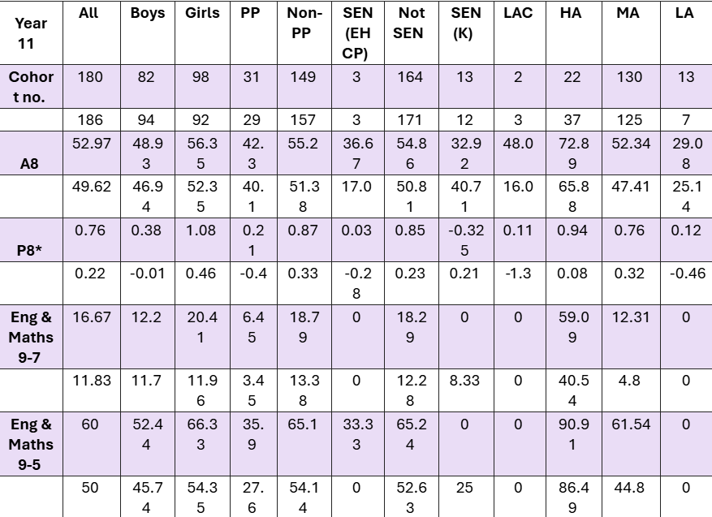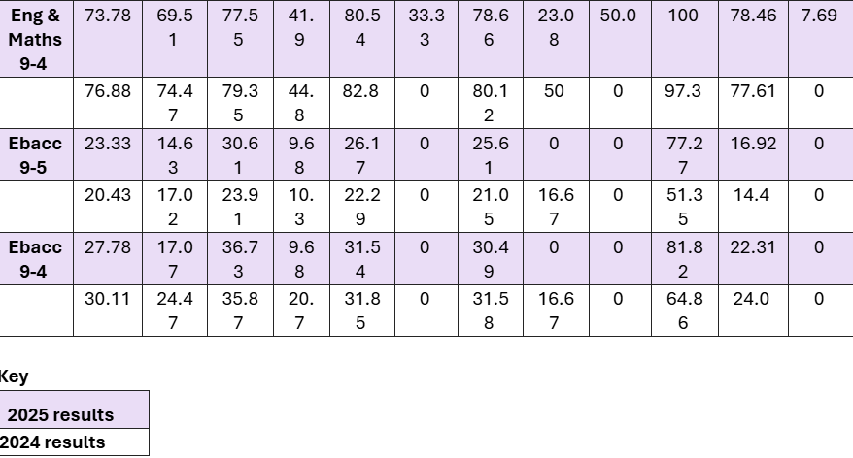
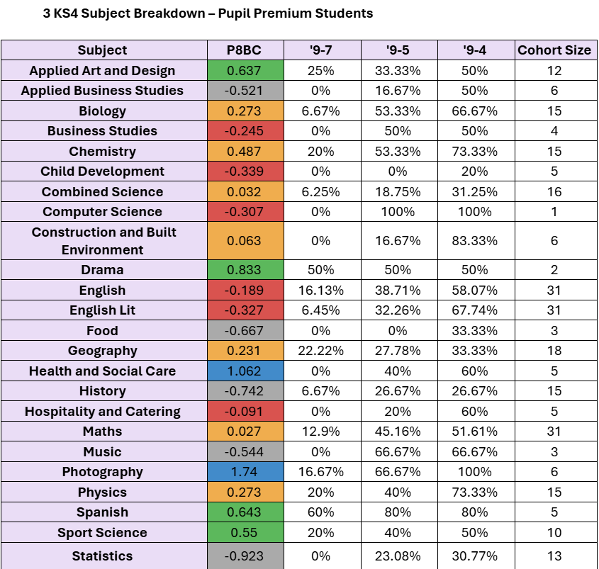 Subjects/Areas of strength Increase in both progress 8 and attainment 8 for Pupil Premium students, with this group achieving a positive progress 8 score of +0.21 (NA for this group in 2024 was -0.9) Pupil Premium students made positive progress in 13 subjects in 2024/25 compared to only 11 in 2023/24. Pupil Premium students made above average progress (green and blue) in six subjects in 2024/25 compared to only five in 2023/2024. There were notable improvements from 2023/24 (more than +0.2) in Combined Science, Geography, Health and Social Care, Physics and Spanish
Areas for development The attainment 8 gap between Pupil Premium students and their non-Pupil Premium peers widened by 1.53 (gap 12.92 in 24/25 versus 11.33 in 23/24). Pupil Premium students in History made significantly less progress than Pupil Premium students in Geography and progress fell by from 2024/24 by 1.16. Pupil Premium students achieved 10% fewer 9-7 grades in English Literature than Language. Nextsteps/actions Sixteen Pupil Premium students are being mentored by SLT on a weekly basis. Students have been strategically placed with SLT to improve their English and/or Maths grade and support with study skills. This group of students are now a standing agenda item at SLT meetings. Thirty students have been selected for additional English and Maths lesson every week in PE/tutor time to ensure an increase in matching of grade 4 basics in English or Maths. Students will be reviewed after first assessment point (October) with intervention groups fluid throughout the year. Increase attendance of Pupil Premium students at holiday revision sessions for History by providing incentives to attend (i.e. offering food and rewards). Hard copies of all revision materials will be given to all Pupil Premium students unable to attend, with session also streamed and recorded on Teams for the first time to allow Pupil Premium students access to the sessions at home and/or in school. Pupil Premium students receiving SLT mentoring to get Literature specific help during mentoring sessions from SLT who English specialists are (Principal and Assistant Principal: Teaching and Learning).

