AQA English Literature
A CHRISTMAS CAROL
REVISION
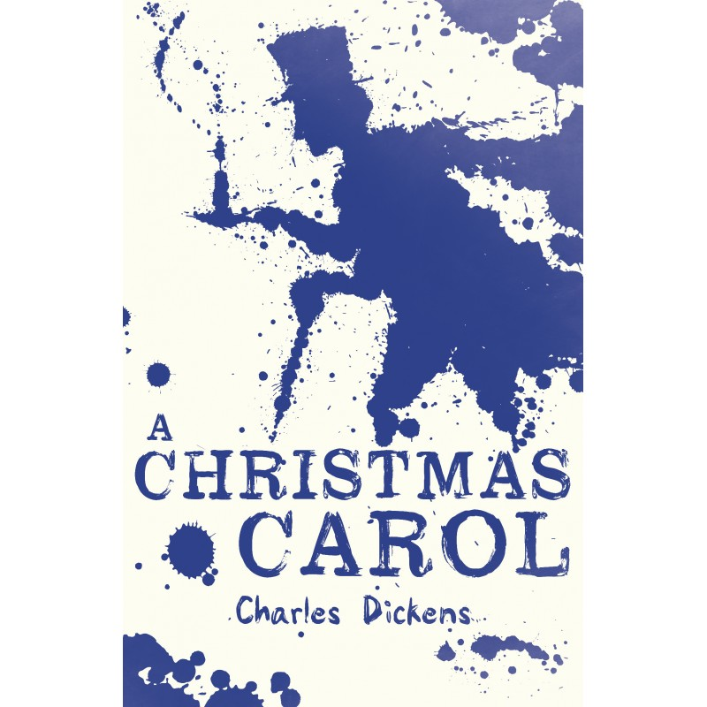

NAME: ___________________

A Christmas Carol: Plot summary
The novella begins on Christmas Eve with Scrooge, a mean and miserly man working in his counting-house. His clerk, _______________________, is working hard and trying to warm himself over a candle as Scrooge refuses to give him more coal.
Scrooge's cheerful nephew, ________, arrives to wish him a Merry Christmas and to invite his uncle to a Christmas dinner. Scrooge responds with a grumpy 'Bah!' followed by ‘_______________!' He belives that ‘"every __________ who goes about with 'Merry Christmas' on his lips, should be boiled with his own pudding, and buried with a stake of __________ through his heart.’
Two gentlemen enter the office as Scrooge's nephew leaves. They are collecting for the poor and homeless. Scrooge refuses to give them a donation, claiming that the ____________ and __________ should provide for such people. He declares that if they cannot go to prison or the workhouses the poor should ‘die and decrease the _______________________ ______________________'.
Back at home, Scrooge has strange visions of the door knocker and tiles bearing the face of his old business partner, _____________. In contrast to Scrooge, Marley says the common welfare was ‘_____ ______________’. He refuses to believe his eyes, but then Marley's ghost appears and frightens Scrooge by rattling his chains. He tells Scrooge he will be haunted by three spirits.

The Ghost of Christmas Past
Scrooge is visited as the bell tolls one o'clock by the first of three spirits: the Ghost of Christmas Past. The apparition is 'a strange figure' seeming to be both an old man and child.The ghost shows Scrooge scenes from his childhood and a lively scene with his cheerful old boss, __________. He is he _________ to how Scrooge treats Bob and Scrooge. Next he takes Scrooge to a time where his younger self is with his fiancée, ____________.
She is telling the younger Scrooge how she must leave him because he has changed and seems to love ______________ more than her. Then they see the girl become a woman, with her happy family. Scrooge is upset and the ghost returns him to his bed.

The Ghost of Christmas Present
The second spirit is the Ghost of Christmas Present who takes Scrooge to the Cratchit family where he sees the humility with which the family tolerates its poverty. The sight of Tiny Tim, who is sick and weak, _____________ him. Next the spirit shows Scrooge his nephew and friends as they celebrate and joke about how Scrooge is a 'ridiculous fellow' but they still raise a ________ to him. The ghost also shows Scrooge poverty in distant areas such as the miners, ship workers and lighthouse workers. We see how people we cannot see are suffering but come together.
Lastly, the ghost shows Scrooge two poor children, ________ and __________ and quotes Scrooges words back to him. The ghost disappears and a dark hooded phantom comes towards Scrooge.

The final spirit
The final spirit is the Ghost of Christmas Yet to Come who leads Scrooge through scenes relating to a man's death. He shows him the Cratchits whose son, Tiny Tim, has also _______. He also sees Joe and Mrs Dilber steal from him and _________ and her husband rejoicing at his death.
Finally, the ghost shows Scrooge the gravestone of the man the people have been talking about. It bears the name: Ebenezer Scrooge. Scrooge is horrified and says ‘"I will ________ Christmas in my heart, and try to keep it all the year. I will live in the ______, the ____________, and the __________. The Spirits of all Three shall ________ within me. I will not shut out the lessons that they teach. Oh, tell me I may sponge away the writing on this stone!"

Scrooge awakes on Christmas Day
Scrooge wakes up full of a zest for life. He presses the bed to check it is real and then laughing, proclaims himself as 'giddy as a ____________ _________. He calls out of the window to a boy who tells him it is Christmas Day and Scrooge is delighted to find the spirits have done all their work in one night.
He gives the boy half a crown to buy the prize _________ from the butchers and have it delivered to the Cratchits. Then he dresses and goes out into the street where he meets one of the charity collectors from the previous day. Scrooge whispers his donation to the man, who is very grateful. Then Scrooge goes to church and at last to his nephew __________ for Christmas dinner. Fred is _________ to see him and it was a ‘_____________ he didn’t shake his arm off’.

Scrooge knows how to celebrate Christmas
The next day, Scrooge offers Bob Cratchit a pay-rise and promises to help look after his family. He learns how to laugh at himself and eventually becomes known as a man who knows how to celebrate Christmas.

A Christmas Carol - Revision Priorities
Key moments: Stave 1 –
- initial description of Scrooge (‘solitary as an oyster’ etc)
- conversation with Fred (contrast between them – the ‘good afternoon’ bit)
- charity workers visit – ‘if they
- Scrooge’s house and the door knocker
- Marley’s ghost ‘I wear the chain I forged in life’ (Marley is meant to be what Scrooge will become if he does not change his ways)
Stave 2
- The Ghost of Christmas Past – ‘Your lip is trembling, and what is that upon your cheek?’ (Scrooge starts to tear up at the memory of his childhood – is this the beginning of his transformation?)
- Little Fan – ‘home, little Fan?’ – our first proper indication of why Scrooge may have become the man he is in the present – father was harsh, Scrooge is away at school etc.
- Fezziwig’s party – Scrooge begins to regret how he treats Bob – ‘I should like to say a word or two to my clerk just now’
- Belle – split up because of Scrooge’s obsession with ‘Gain’ – notice the capital ‘G’ – is this a link to religion and the seven deadly sins?
- Belle with new husband – Scrooge ends the stave distraught – the beginning of his change? ‘Spirit, remove me from this place!’ – the spirit doesn’t do as he’s told immediately – is this why Dickens uses ghosts to teach Scrooge his lesson, because he cannot control the supernatural?
Stave 3
- The Ghost of Christmas Present – jolly, sprinkles Christian cheer
- The Cratchits – ‘they were not a handsome family’ – GoCPr purpose is to illustrate the poor and struggling that Scrooge is surrounded by in his everyday life – these are the things he can have an effect on (he must learns from his past – he cannot change these, but he can change what this ghost shows him – is this why he seems harsher on Scrooge in some ways? ‘I seek!’)
- ‘If these shadows remain unaltered by the Future, the child will die!’ – Scrooge begs for this not to happen.
- The miners and the poverty in London
- Fred’s party – Fred’s friends mock Scrooge (the game)
- Christmas Present is all about Christmas – how everyone loves and celebrates it. The ghost shows a wide range of people, including those with nothing, to show Scrooge what should be.
Stave 4
- The Ghost of Christmas Yet to Come – only one called a ‘phantom’ – links to death
- Mrs Dilber stealing the curtains and clothes – no one cares that Scrooge is dead, no one goes to his funeral
- ‘The couple who celebrate that Scrooge is dead because of their debt
- Tiny Tim is dead
- The gravestone and the corpse on the bed – ‘I will honour Christmas in my heart’
Stave 5
- Scrooge has changed – ‘To Tiny Tim, who did not die, he was a second father’
- ‘He became as good a friend, as good a master, and as good a man, as the good old city knew’ – Contrast to the beginning, parallel syntax used again to mirror (link to ‘no warmth could warm’ etc)
Key Revision Points/questions:
- Ghosts – why past, present and future? Why do you think Dickens used ghosts? What do they each teach him?
- Fred – contrast to Scrooge, family, Christmas
- Family – Fred, Little Fan, Cratchits – What do they symbolise? Why does TT NOT die at the end?
- How do ideas about Christianity link to ACC?
- Why did Dickens set it at Christmas? What his message about the Christmas spirit?
- Why are so many references made to rich and poor? What is Dickens’ message to his readers about poverty?
- Why was it written at all? What are the messages?

Why did Dickens choose to write about his characters and themes? Use these comments in your introductions!
Scrooge
Dickens was angered by the wealthy mid-upper classes who were ignorant to the struggles of the poor. Scrooge represents all of the qualities that these people had that frustrated Dickens. Dickens exaggerates him and makes him truly grotesque and detestable character at the start, to demonstrate to his readers that even the most ignorant and heartless in society can change and seek redemption.
Fred
Dickens created Fred to be the archetypal (stereotypical) Victorian gentleman and the complete contrast to Scrooge. He is there as a role model to both Scrooge and the reader – he is what Scrooge could have been, had he not become obsessed with money, but is also there to remind Scrooge that he has a family and is loved – it’s not too late.
The Cratchits
Dickens uses the Cratchits to show Scrooge and the reader what life was like to be poor and destitute. They are there to show Scrooge that, regardless of the fact they have no money, they are happy because they are a family – Scrooge does care about Bob, and particularly Tiny Tim, so it helps him to see the people affected by his ‘are there no workhouses?’ comments.
Marley’s Ghost
Dickens’ message with Marley’s ghost is that your sins in life punish you in death – he has not been able to enter Heaven, but instead must wander the Earth forever more, weighed down by the chains (a physical representation of the burden of his sins).
The Ghost of Christmas Past
Dickens shows the GoCP as being associated with light to represent the idea that the knowledge of Scrooge’s past is what will help him to change his present and future. He reminds the reader that our pasts make us who we are, and we cannot truly change unless we face up to our past errors. The light can also be seen to represent enlightenment (finding the path to God).
The Ghost of Christmas Present
Dickens uses the GoCPr to represent generosity. He also bears a torch, which represents the idea that he is going to ‘open Scrooge’s’ eyes to the society around him – he is there to force Scrooge to see past his ignorance. He shows Scrooge what he can have, if he changes his ways.
The Ghost of Christmas Yet to Come
Dickens uses the GoCYtC to show Scrooge what his future holds if he does not redeem himself – a lonely death. He gives a final message that Scrooge must act on his desires to change – it is not enough to regret, he must now commit to changing his behaviour once and for all.
Christmas
Dickens set his novella at Christmas time as it is the ‘most’ Christian time – a time for giving, family and love – all things that Scrooge is shown to struggle with. It is also a time for forgiving, which is perhaps why he has Scrooge redeem himself on Christmas Day, with a new year about to start. The Victorians also loved Christmas, so theming his novella at Christmas time, and giving it ghosts (also very popular) would have helped to make his readers intrigued and receptive to the moral messages.
Family
The Victorians had very strong family values – they believed that family was more important than anything else. Many of his readers would have been terrified at the thought of losing their family and ending up alone like Scrooge.
Poverty
Dickens was angered by the amount of poverty in Victorian Britain that was going unnoticed by the wealthy. He warned (through the children of Ignorance and Want) of the dangers of being ignorant to the ‘want’ of the poor – he hinted at the threat of revolution and uprising. When Scrooge changes, Dickens ensures he gives money to the charity workers and raises Bob’s wages – a message to the wealthier readers that it is down to them to change society for the better.
Redemption
In order to avoiding ending up with a punishment like Marley’s, Scrooge must change his ways in life – a message to the readers about seeking redemption for their sins, and following the moral, Christian path from then on.
A Christmas Carol Exam Q Planning
Possible Topic | Revision Ideas – key words, quotes, scenes, characters
Family
- What was Scrooge’s family life like as a child? How does Fan save him?
- How do the Cratchits represent Victorian family spirit? What morals and values do the have?
- How does Scrooge get involved in family at the end (think Fred and TT)?

Poverty and Social Responsibility
- Why is Scrooge so dismissive at the start? What does this symbolise?
- What is Marley’s message about helping others and social responsibility?
- How is poverty affecting the Cratchits? Or, how do they respond?
- What do Ignorance and Want symbolise? Why can’t Scrooge be dismissive of them? Why are his words quoted back to him?
- How does Scrooge respond at the end and what is Dickens’ message?

Redemption

- How does Scrooge behave at the start?
- What do each of the ghosts (starting with Marley) teach him?
- What does Scrooge realise at the end?
- What imagery is used to show his transformation?
- What impact does his change have on the lives of others? Link to Dickens’ message!

The Christmas Spirit
- How does Fred / Charity workers embody the Christmas spirit in Stave 1? Why is Scrooge so dismissive of it?
- How does Fan / Fezziwig embody the Christmas Spirit? How does Scrooge feel about his actions after seeing how Fezziwig previously treated him?
- How do the Cratchits embody the spirt even though they are in the depths of poverty? Dickens’ message?
- What does Scrooge realise at the end?
- How does he embrace the Christmas spirit in the final stave?
The Ghosts
- What do each of the Ghosts teach Scrooge? Consider Marley’s ghost.
- Why does the Ghost of Christmas present quote Scrooge’s words back to him and show him the reality of poverty?
- What does Scrooge realise at the end?
- How does he embrace the Ghosts’ message in the final stave?

Greed
- Why is Scrooge greedy at the start? Consider how he is ‘tight fisted’ and doesn’t help Bob / sees Christmas as an expense and doesn’t give to charity
- How does greed affect his relationship with Belle?
- What is the impact of greed? Consider the Cratchits and TT death.
Consider Ignorance and Want and Dickens’ message
- How does Scrooge change at the end and what is the impact – e.g. TT, who did NOT die’ etc.
Minor Characters
- How does Fred have an impact on Scrooge?
- What message does seeing his relationship with Belle teach him?
- What do Ignorance and Want symbolise?
- How does Tiny Tim affect Scrooge – why is it significant that Scrooge saves him at the end?

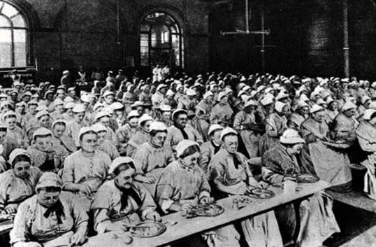
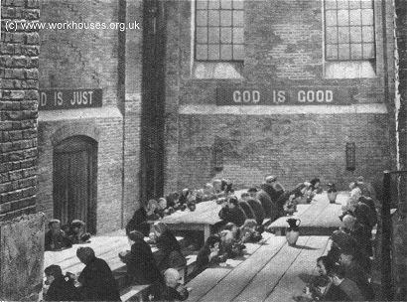
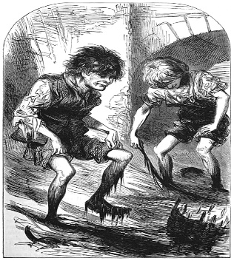
A Christmas Carol Context – Remember, this drives your points and analysis!
The Workhouse
Poverty
On the streets boys could hold horses’ heads while the driver took a break, or sell newspapers or fast food in the streets. The ‘mudlarks’ of both sexes and all ages waded thigh‐deep in the filthy toxic Thames mud to retrieve anything they could sell. Dogs’ turds could be collected and sold to the tanneries. Discarded cigar butts could be recycled and marketed as new.
Sweeping a path across the filthy streets for a well‐dressed pedestrian could earn a few pennies, legally. Begging might make more illegally, especially if the beggar woman could use – even hire – a small child. Sometimes the children were blinded or maimed, to loosen the purse‐strings of passers‐by.

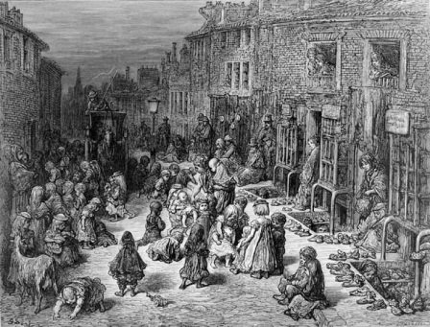
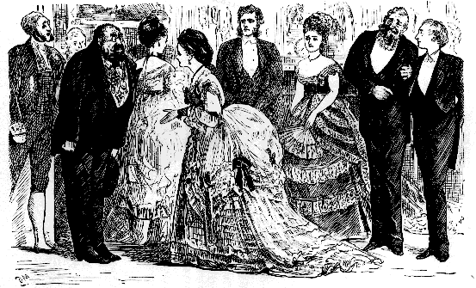
The Workhouse (also known as The Poor House) was where many poverty-stricken Victorians were sent if they couldn’t afford to support themselves and their families. The Workhouse offered somewhere to live but it came with the requirement that its inmates had to work without receiving a wage! Many people (such as famous novelist Charles Dickens) felt this was incredibly unfair and that these members of society were being taken advantage of.

Entry to the workhouses was voluntary, but it was certainly the last choice for people. People ended-up in the workhouse for a variety of reasons.
- Usually, it was because they were too poor, old or ill to support themselves. This may have resulted from such things as a lack of work during periods of high unemployment, or someone having no family willing or able to provide care for them when they became elderly or sick.
- Unmarried pregnant women were often disowned by their families and the workhouse was the only place they could go during and after the birth of their child.
- Before mental asylums (for the criminally insane) were created in the mid-nineteenth century, the mentally ill poor were often committed to the workhouse.
A mudlark is someone who scavenges in river mud for items of value
What was Victorian London like in the 19th century?
Dickens lived his life in 19th century London. He explored its underworld, walking the streets up to twenty miles at a time, and his descriptions of 19th century London allow readers to experience the sights, sounds, and smells of the old city. Victorian London was the largest, most spectacular city in the world. While Britain was experiencing the Industrial Revolution, London was both benefitting and suffering the consequences. In 1800, the population of London was around 1 million. That number exploded to 5 million by 1900. This population explosion caused untold poverty, squalor and filth. In early 19th century London, rich and poor alike were thrown together in the crowded city streets.
Crime, especially street robbery and pickpocketing, was common in the dark and in the crowds. Thousands of chimney pots belched coal smoke, and black soot settled everywhere. Raw sewage flowed into the River Thames. Street sellers, pickpockets, gangs, drunks and beggars roamed the streets. Many drank water from the very same parts of the Thames that the open sewers flowed into.

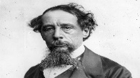
Victorian Family and Christmas

Dickens
Why such big families? Many women had lots of babies. Birth control was not widespread, and few couples used any means of contraception. Child-bearing could be dangerous, and many women died in childbirth. Many babies also died, from childhood diseases. Queen Victoria had nine children. The royal family became a model for other families.
Fun at home
Victorians made their own entertainment at home. They had no radio or TV. They enjoyed singing, and a rich family would sing around the piano, while poorer families enjoyed tunes on a pipe or a fiddle. Families played card games and board games, and acted out charades.
Turkey Time - When Victoria first came to the throne, both chicken and turkey were too expensive for most people to enjoy. Many poor people made do with rabbit. On the other hand, the Christmas Day menu for Queen Victoria and family in 1840 included both beef and of course a royal roast swan or two. By the end of the century most people feasted on turkey for their Christmas dinner.

The holidays - The wealth generated by the new factories allowed middle class families in England and Wales to take time off work and celebrate over two days, Christmas Day and Boxing Day. Boxing Day, December 26th, earned its name as the day servants and working people opened the boxes in which they had collected gifts of money from the "rich folk".
Dickens and Poverty
Dickens experienced prison and poverty in his own childhood. In 1824, London, John Dickens was locked in debtor’s prison for failing to pay his debts. Aged 11, Charles was sent away to a blacking factory, covering and labelling pots of shoe polish in appalling conditions as well as loneliness and despair. He lived separated from his family, as his younger sister and mother were put in prison with his father. After three years he was returned to school, but the experience was never forgotten. Dickens lived just nine doors down from the workhouse until 1831, when he was 19.

A Victorian Christmas. In Victorian England there was a tradition in which groups of singers travelled from house to house, singing carols or songs, for which they were often rewarded with money, mince pies, or a glass of a warm drink. Often money was collected and given to charity.

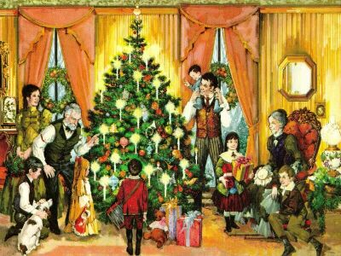
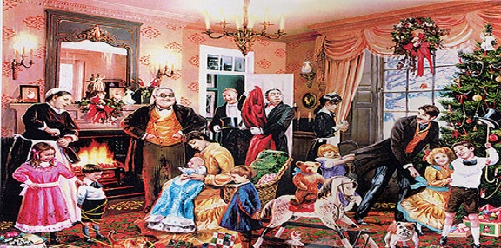
What did Dickens think of the law – and the poor – in England?
When Dickens wrote in 1830s London, English law was based on the idea of justice and a fair trial. However, Dickens found the law did not always practice what it preached. His father had been imprisoned in a debtor’s jail and Dickens separated from his family and sent to work in miserable conditions and lonely isolation when he was 11. Injustice, more often, was what Dickens experienced from the law for those in poverty. Dickens became a lifelong supporter of the poor. He went out of his way to help victims of the law, who were punished for being poor, even though he was under huge pressure himself to write and earn a living, to avoid debt and the debtor’s prison. Dickens likened the workhouse to a prison, commenting that the meagre rations for inmates had created a primitive and bestial youth who had little to offer civilised society: “In one place, the Newgate of the Workhouse, a company of boys and youths were locked up in a yard alone; their day-room being a kind of kennel where the casual poor used formerly to be littered down at night. Divers of them had been there some time. “Are they never going away?” was the natural inquiry. “Most of them are crippled, in some form or another,” said the Wardsman, “and not fit for anything.”

What did Dickens think of religion?
Christianity had a strong influence on Victorian society: people believed living by a strong moral code – attending church regularly, abstaining from alcohol and exercising sexual restraint – would make them good Christians. However, Dickens believed being a good Christian was more practical. For Dickens, it meant doing good deeds for other people; being humble, charitable, and forgiving to others rather than appearing religious, but ignoring those in need.

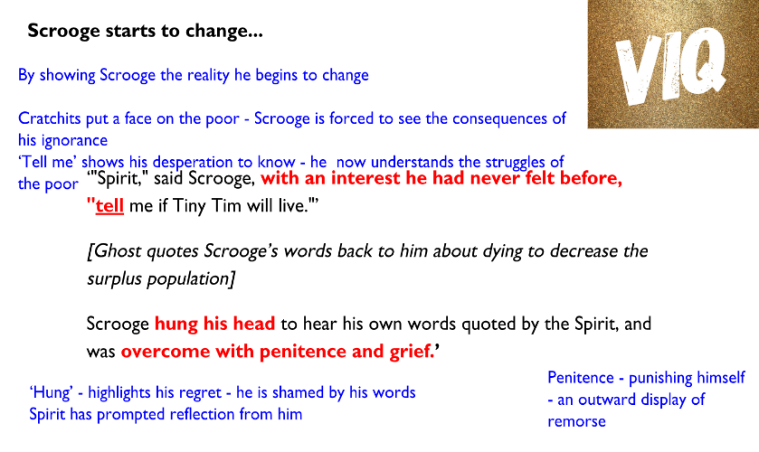
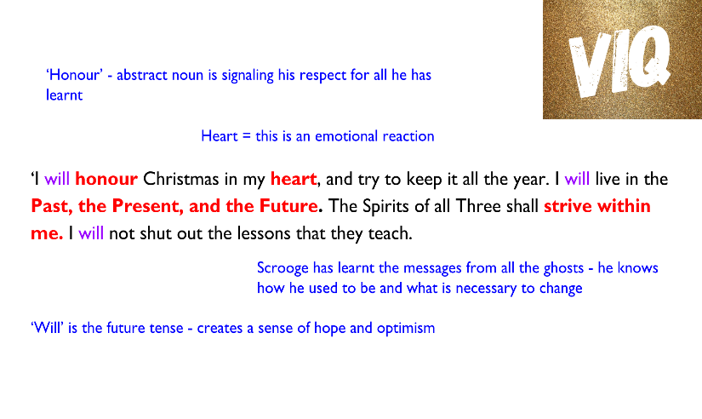
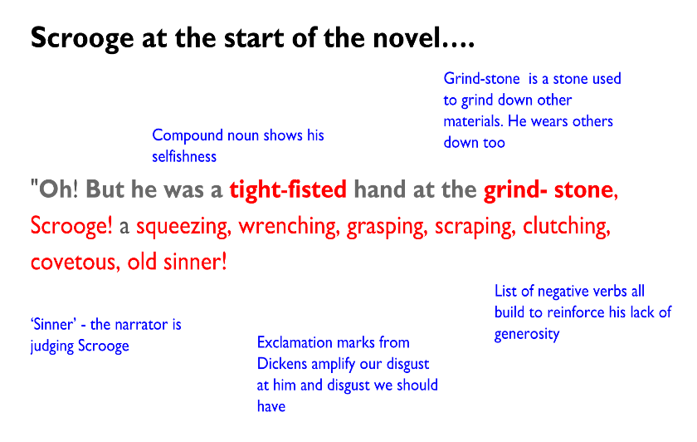
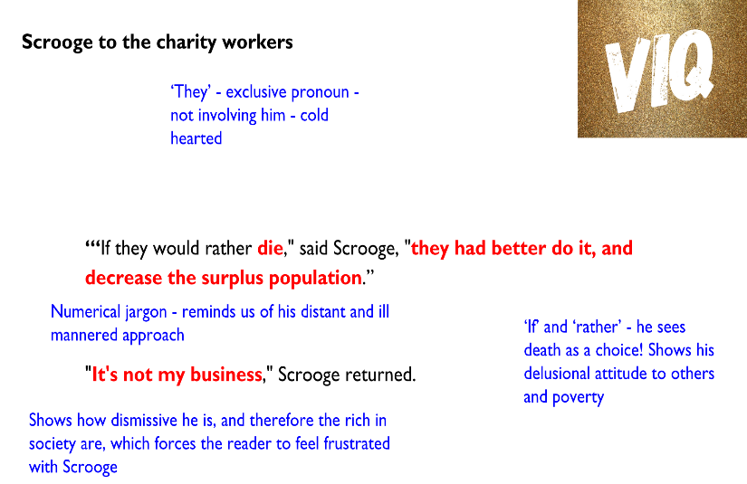
Character Analysis: Scrooge
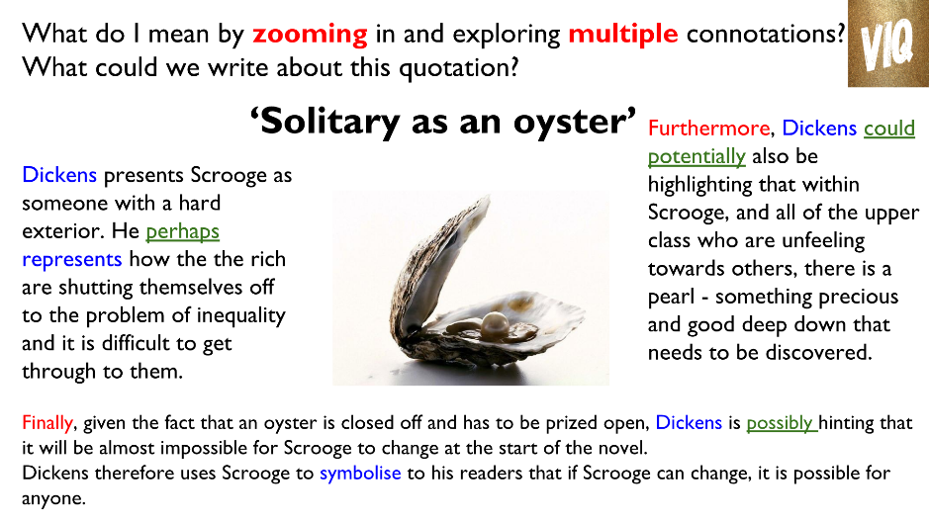

- Scrooge was better than his word and ‘infinitely more’ - changed beyond all belief and recognition. Dickens highlights how this transformation deserves our respect
- He was a ‘second father to Tiny Tim’ who ‘did not die’. Dickens shows us the power that actions can have. Scrooge’s transformation has seemingly saved his life. A clear signal to the rich of the power that they have
- Dickens highlights how if Scrooge can change, anyone can
- Forces the readers to question their own social responsibility and morals

Character analysis: The Ghosts
- The supernatural is used as a structural device to encourage change in society
- Dickens uses the ghosts to show the rich and ignorant in society that, like Scrooge, they need to reflect on their own lives and see the error of their ways
- Scrooge’s character shows this transformation is possible
- The ghosts, as individuals, show Scrooge different aspects of his life yet they all encourage change
- The Ghost of Christmas Past highlights what Scrooge’s life was like and Dickens highlights that being greedy is a choice
- The Ghost of Christmas Present shows how generosity can affect people
- The Ghost of Christmas Yet to Come shows the consequences of actions
- All the ghosts teach Scrooge the error of his ways and his desire for change within himself grows as the visits go on
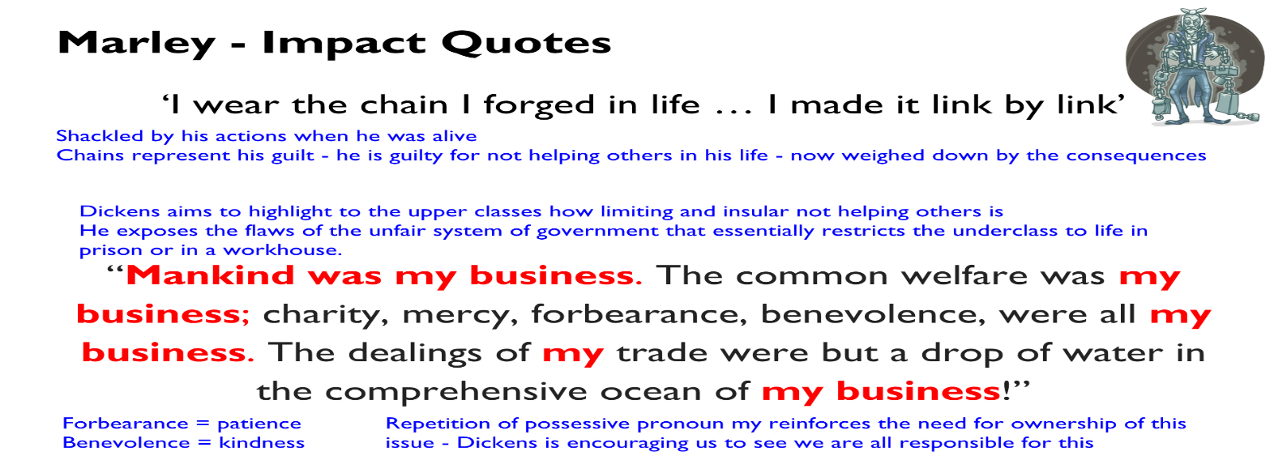
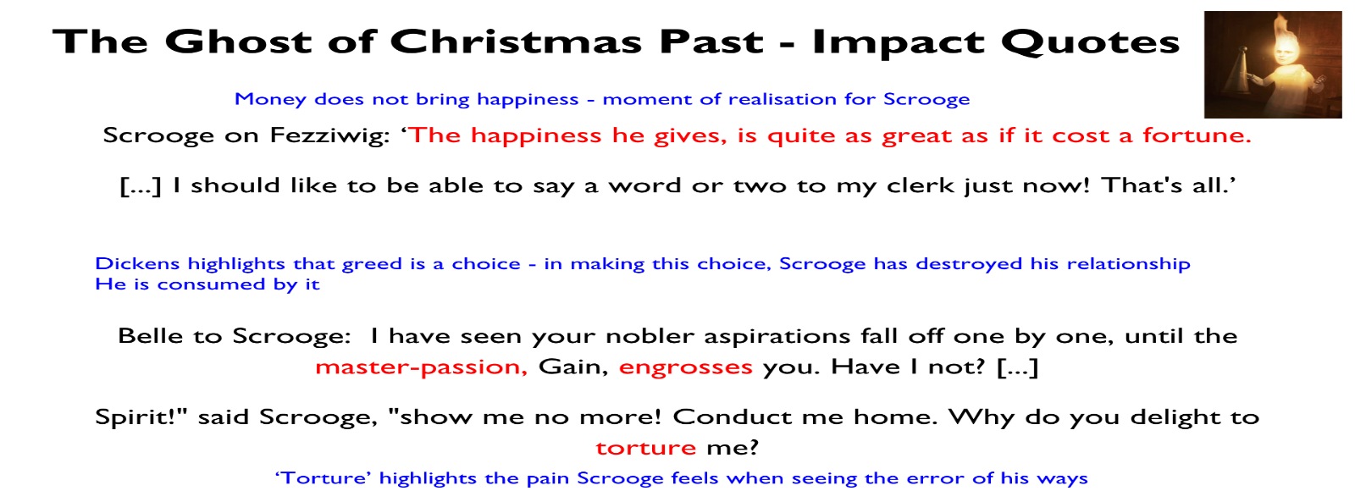
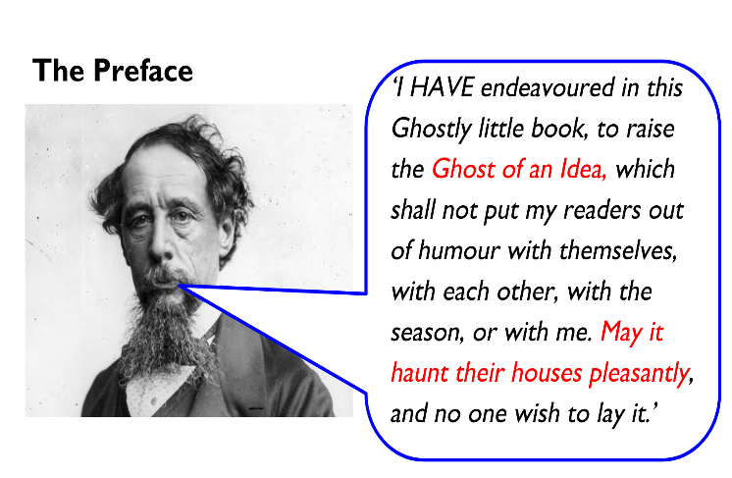
- Idea is meant to haunt and stay with you - whilst it is not a physical change it is something that is there and can acted on
- It is not a threat but he is urging people to consider his message - remember his is a social activist and campaigner for social justice - he is critical of people who exploit the poor and the way that they are treated in society.
- A riddle to engage the reader and draw them into reading the book to discover the solution

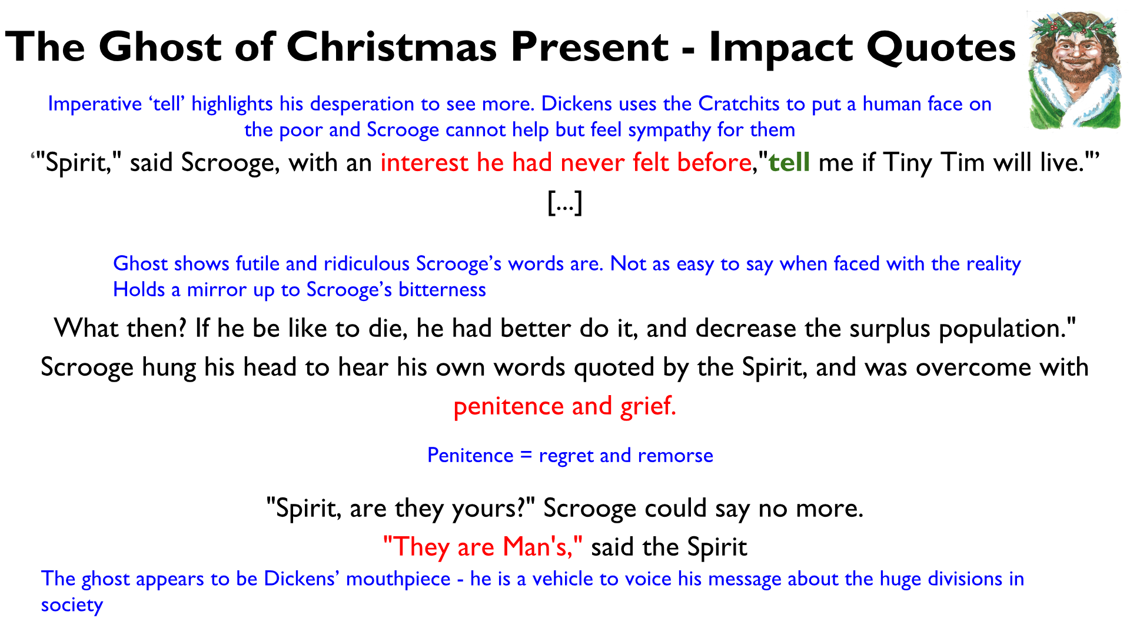

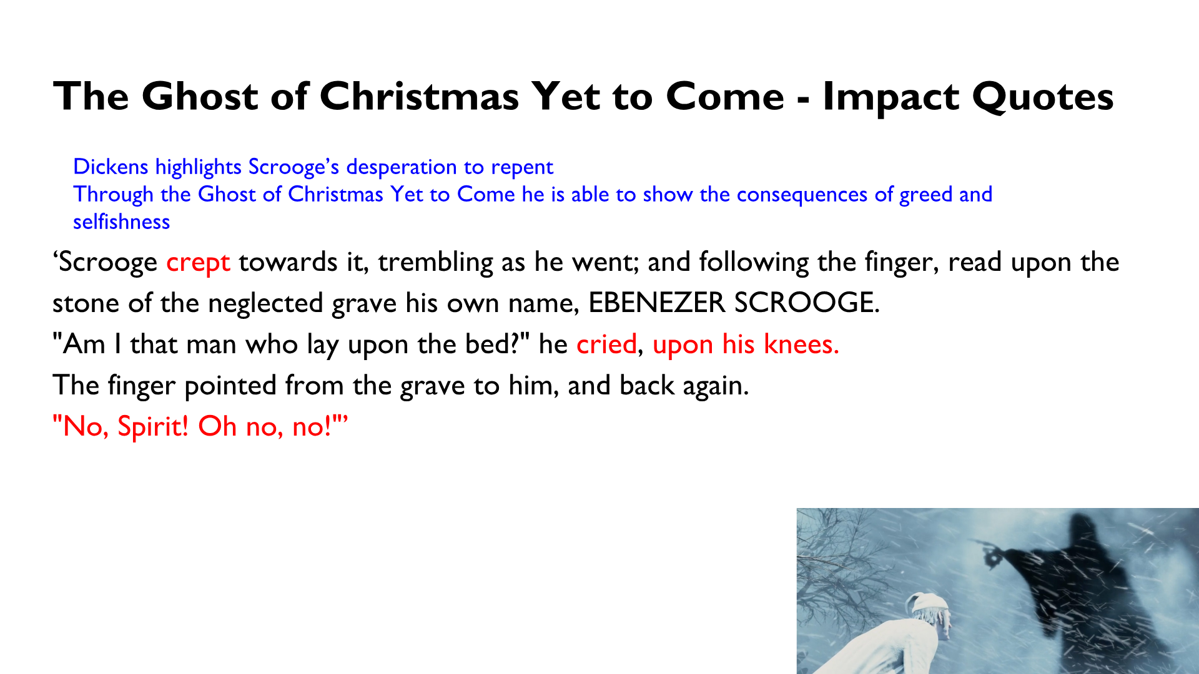

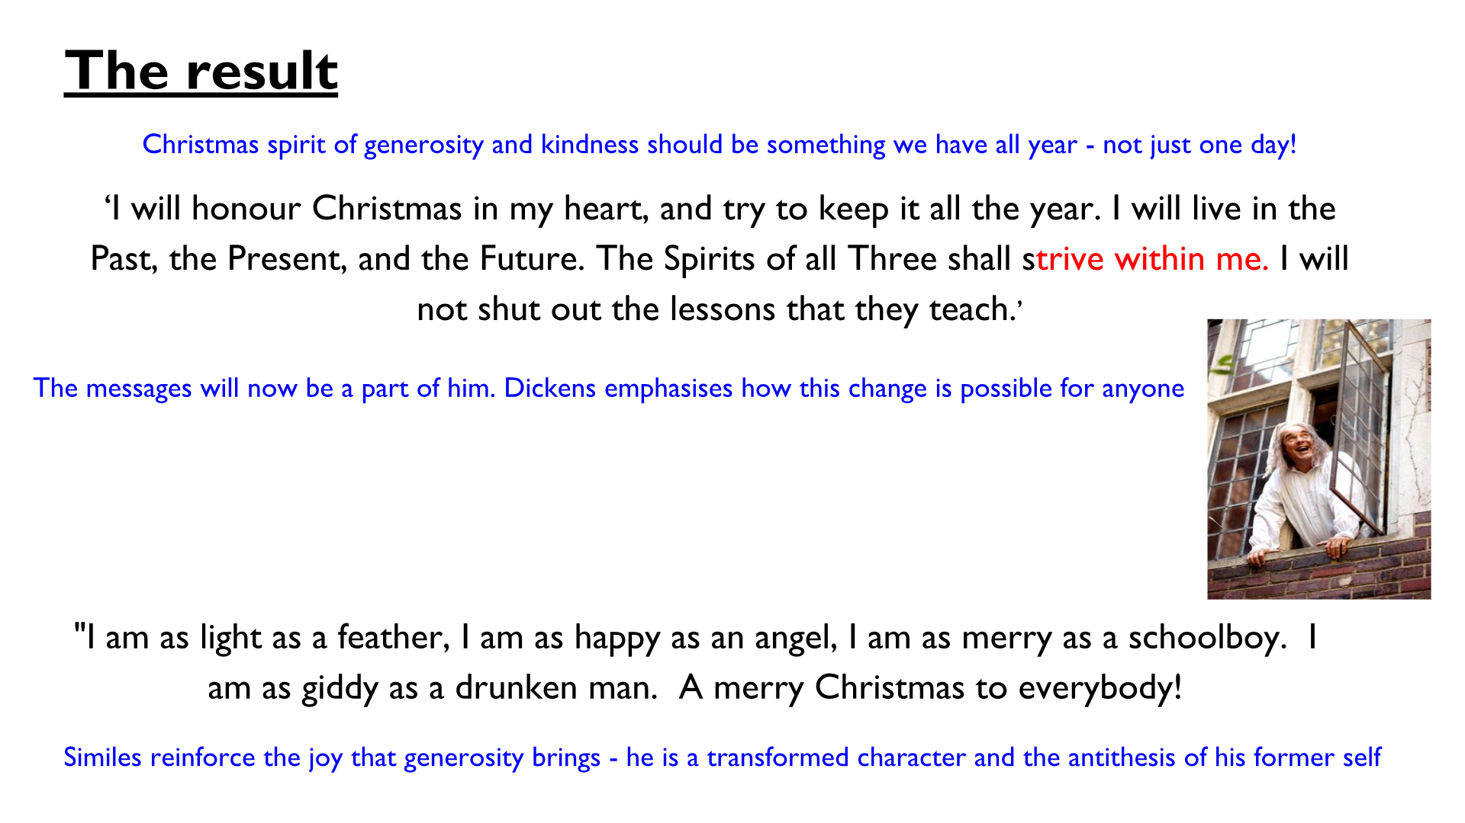

Character Analysis: Fred
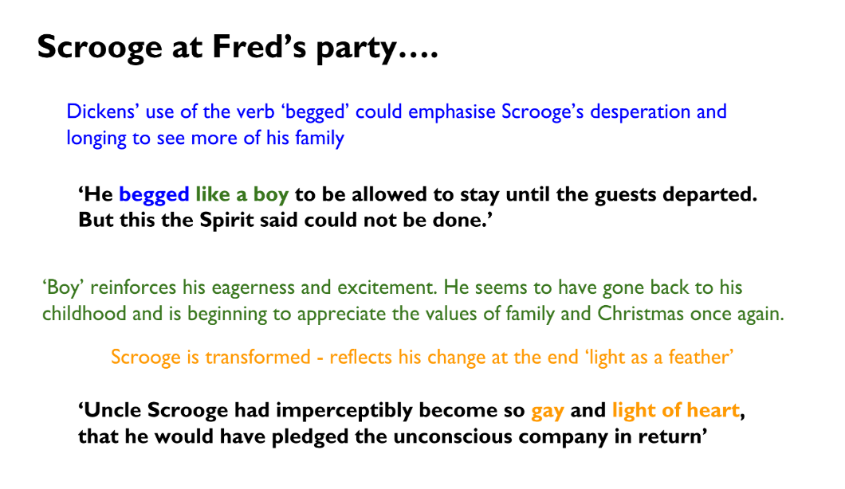
Fred functions as the model for how we should behave to one another. He is persistent and never gives up on his uncle. He is a symbol of the true family spirit and he welcomes his uncle with joy and without recrimination at the end.
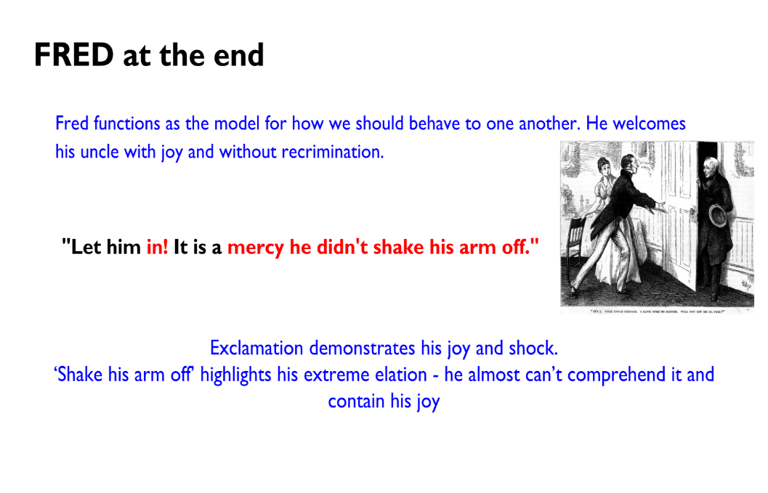
Character Analysis: The Cratchits
- The Cratchits put a moral face on the poor. They are a message to the reader to show how greatful, unified, loving and caring the poor are.
- In Stave 3 the Cratchit family are presented as virtuous even in the face of poverty and illness
- Dickens contrasts Bob, who he described as a brilliant father, with Scrooge’s father. It is evident that Scrooge was neglected by his own father while Bob is kind and gracious. He points out the importance of family, morals and unity amongst the lower classes.
- Dickens is often cited as being a key player in the way we perceive Christmas. Family is at the heart of his novella and contrasts to Scrooge’s selfishness
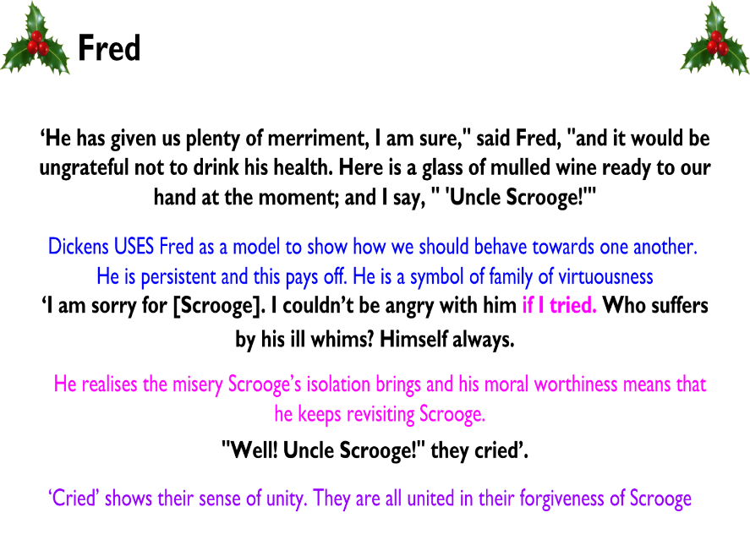
- Dickens stresses to the reader that the past can be triumphed and made better. Dickens himself had a difficult childhood and was neglected when his own father fell into poverty. This could be a cathartic (giving psychological relief) experience for Dickens.
- Dickens highlights the benefits of a loving and close family
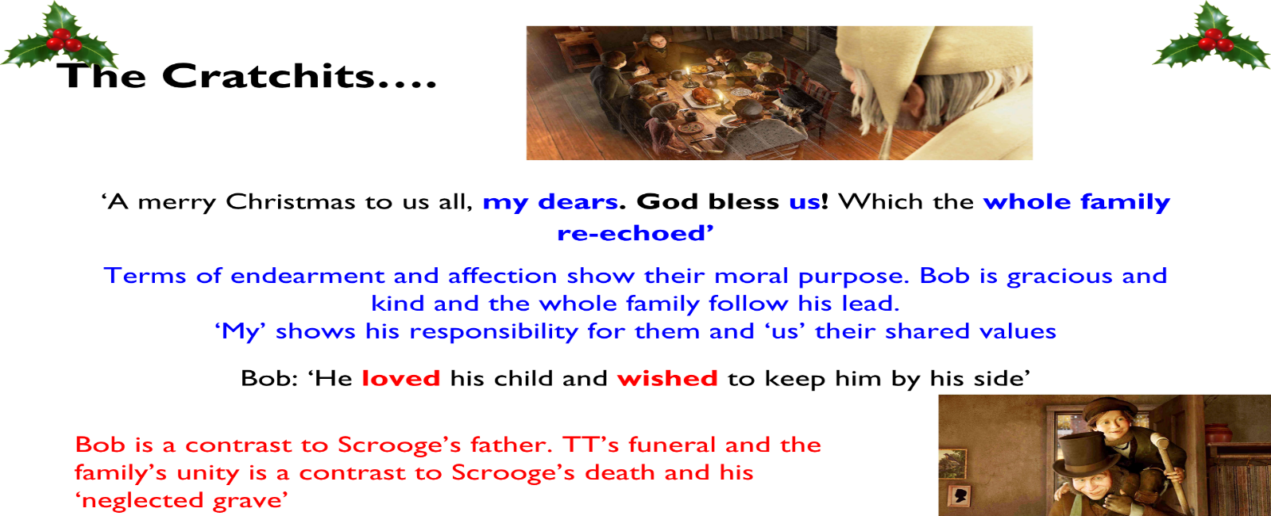

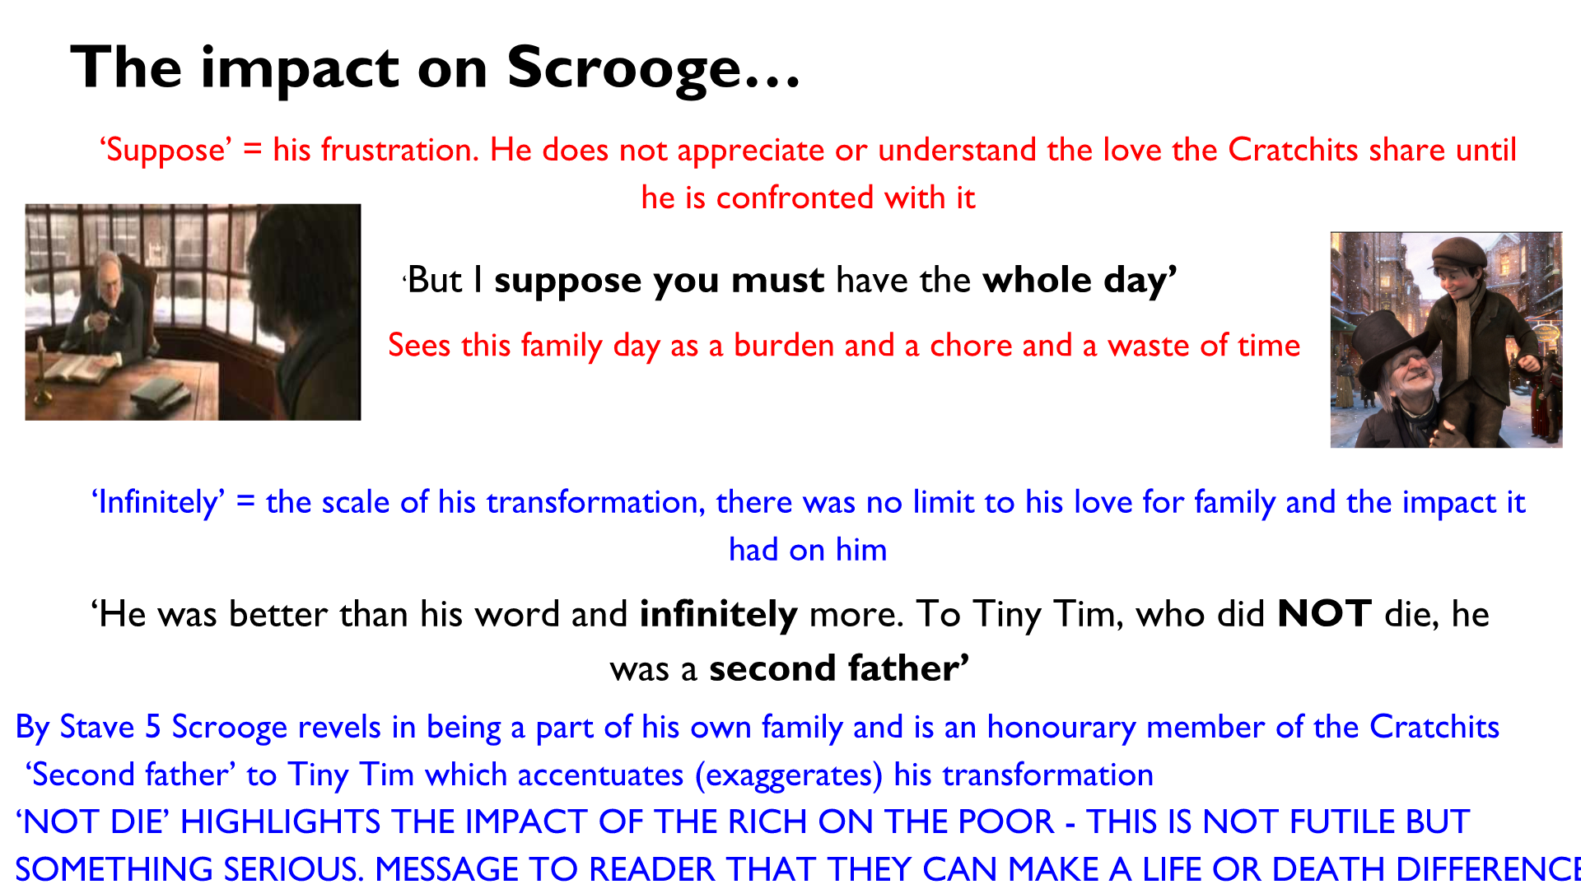

Character Analysis - Minor Characters
- As a social activist, Dickens uses his minor characters to criticise how dispassionate the rich were towards the plight of the poor.
- Dickens, who cared passionately about the unfairness and injustice in society, uses his minor characters to highlight the moral worthiness of the poor. They are all presented as hard working and obedient characters, which challenges the views of the social elite and encourages them to sympathise with the poor rather than persecute them.
- The range of characters Dickens presents emphasises not only the ubiquity of poverty, but also the universal nature of his message: everyone, who ever they are, can choose to be socially responsible.
- Dickens, who had a supportive family himself, uses the minor characters to praise the importance of having a loving family on individual and societal happiness.

Ignorance and Want – Model
In this extract, Dickens uses Scrooge’s response to highlight how when the upper classes are confronted with the reality of poverty, it is difficult to ignore and dismiss this issue. This is clear when Scrooge ‘tried to say they are fine children but the words choked themselves’. The verb ‘choked’ here has connotations of pain and perhaps suggests how it is for Srooge to lie and ignore the issue here. Upon seeing the scale of poverty he previously dismissed, Scrooge cannot comprehend it and struggles to come to terms with it. The fact that he ‘startled back, appalled’ also reinforces his horror: he seems to be stunned by what he has seen as if he never imaged the scale of poverty to be this bad. Furthermore, the verb ‘cried Scrooge’ exaggerates his sense of panic here and he seems desperate to seek out help for them. Given that Dickens saw this first hand in many workhouses and the fact that his own father went to one, he was perhaps trying to force his readership to see the damning impact of ignoring the issue.

Other Quotes:
‘Where angels might have sat enthroned, devils lurked, and glared out menacing.’
‘Is it a foot or a claw?"

SENTENCE STARTERS
Dickens introduces the character as…
Dickens uses…
Dickens wants to….
Dickens communicates…… / highlights / praises / criticises / reinforces
Dickens intends to….
Dickens decided to start with…. This character is first presented as…. / used as a symbol for….
This is a turning point because……
Dickens may be trying to/ could be trying to show…
Dickens presents Macbeth as…
The novel closes/opens with….
Dickens wants to audience to think that….. Dickens is influenced by….
The reader may interpret this as….
Dickens challenges his readers to…. When the reader discovers
The character is presented as…..by the Dickens to…..
Dickens uses negative language because he wants to show……
Dickens want the audience/reader to understand….
The character embodies/ represents/ symbolises….
Dickens illustrates the idea through…
The idea of….is presented by Dickens through….
The concept is explored through the use of….
When Dickens uses……..he wants to convey the idea that……
X is portrayed as…….
A sense of………….is created by Dickens by…….
The entrance of X symbolises…..
We already know that……..because…..
The audience is aware of…
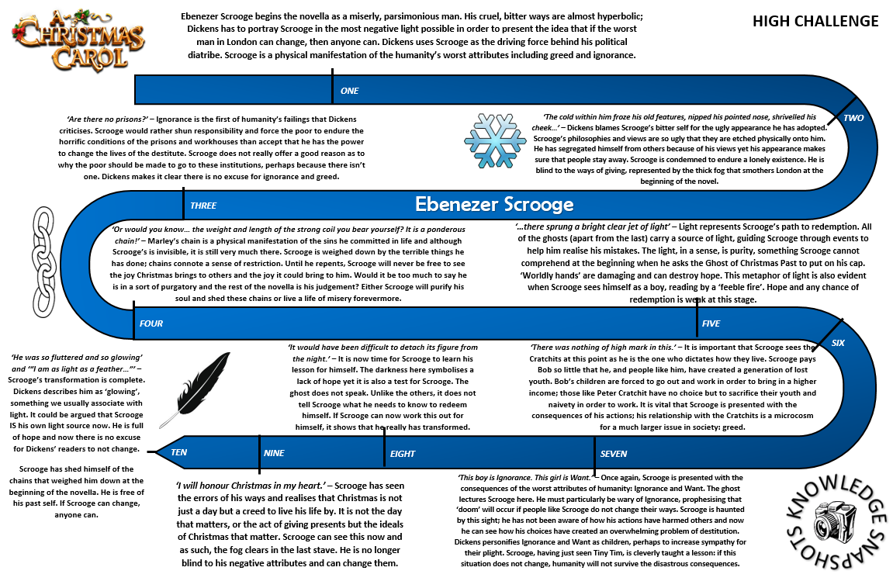

ACC VIQs – You must know these 12 as a minimum!
Scrooge (start) | ‘hard and sharp as flint’… ‘solitary as an oyster’
Scrooge (start) | ‘if they had rather die, they better do it, and decrease the surplus population’
Marley | ‘Mankind was my business. The common welfare was my business’
Marley | ‘I wear the chain I forged in life…’I made it of my own free will’
Scrooge (past) | ‘A solitary child, neglected by his friends’
Fezziwig (past) | ‘The happiness he gives is quite as great as if it cost a fortune’
Belle (past) | ‘I have seen your nobler aspirations fall off one by one, until the master-passion, Gain, engrosses you’
GoCPresent | ‘A place where miners live, who labour in the bowels of the earth. They were all decked out gaily in their holiday attire’
GoCPresent | ‘Then all the Cratchit family drew round the hearth, in what Bob Cratchit called a circle’
GoCPresent | ‘This boy is Ignorance and this girl is Want. Beware them both. But most of all, beware this boy, for on his brow is written Doom.’
Scrooge (YtC) | ‘”Am I that man who lay upon the bed?” he cried upon his knees.’
Scrooge (end) | ‘I am as light as a feather, I am as happy as an angel, I am as merry as a schoolboy, I am as giddy as a drunken man’

Essay Qs
At this point in the novel, two charity workers have visited Scrooge to ask for a donation to the poor at Christmas time.
"At this festive season of the year, Mr. Scrooge," said the gentleman, taking up a pen, "it is more than usually desirable that we should make some slight provision for the Poor and Destitute, who suffer greatly at the present time. Many thousands are in want of common necessaries; hundreds of thousands are in want of common comforts, sir."
"Are there no prisons?" asked Scrooge.
"Plenty of prisons," said the gentleman, laying down the pen again.
"And the Union workhouses?" demanded Scrooge. "Are they still in operation?"
"They are. Still," returned the gentleman, "I wish I could say they were not."
"The Treadmill and the Poor Law are in full vigour, then?" said Scrooge.
"Both very busy, sir."
"Oh! I was afraid, from what you said at first, that something had occurred to stop them in their useful course," said Scrooge. "I'm very glad to hear it."
"Under the impression that they scarcely furnish Christian cheer of mind or body to the multitude," returned the gentleman, "a few of us are endeavouring to raise a fund to buy the Poor some meat and drink and means of warmth. We choose this time, because it is a time, of all others, when Want is keenly felt, and Abundance rejoices. What shall I put you down for?"
"Nothing!" Scrooge replied.
"You wish to be anonymous?"
"I wish to be left alone," said Scrooge. "Since you ask me what I wish, gentlemen, that is my answer. I don't make merry myself at Christmas and I can't afford to make idle people merry. I help to support the establishments I have mentioned -- they cost enough; and those who are badly off must go there."
"Many can't go there; and many would rather die."
"If they would rather die," said Scrooge, "they had better do it, and decrease the surplus population. Besides -- excuse me -- I don't know that."
"But you might know it," observed the gentleman.
"It's not my business," Scrooge returned. "It's enough for a man to understand his own business, and not to interfere with other people's. Mine occupies me constantly. Good afternoon, gentlemen!"

Q1: Starting with this conversation, explain how Dickens presents ideas about social responsibility in A Christmas Carol
Write about:
• how Dickens presents ideas about social responsibility in this extract
• how Dickens presents ideas about social responsibility in the novel as a whole [30 marks]
This extract is taken from Stave. The Ghost of Christmas Present shows Scrooge the Cratchit family’s Christmas day.
"God bless us every one!" said Tiny Tim, the last of all.
He sat very close to his father's side upon his little stool. Bob held his withered little hand in his, as if he loved the child, and wished to keep him by his side, and dreaded that he might be taken from him.
"Spirit," said Scrooge, with an interest he had never felt before,"tell me if Tiny Tim will live."
"I see a vacant seat," replied the Ghost, "in the poor chimney-corner, and a crutch without an owner, carefully preserved. If these shadows remain unaltered by the Future, the child will die."
"No, no," said Scrooge. "Oh, no, kind Spirit. Say he will be spared."
"If these shadows remain unaltered by the Future, none other of my race," returned the Ghost, "will find him here. What then? If he be like to die, he had better do it, and decrease the surplus population."
Scrooge hung his head to hear his own words quoted by the Spirit, and was overcome with penitence and grief.
"Man," said the Ghost, "if man you be in heart, not adamant, forbear that wicked cant until you have discovered What the surplus is, and Where it is. Will you decide what men shall live, what men shall die? It may be, that in the sight of Heaven, you are more worthless and less fit to live than millions like this poor man's child. Oh God! To hear the Insect on the leaf pronouncing on the too much life among his hungry brothers in the dust."
Scrooge bent before the Ghost's rebuke, and trembling cast his eyes upon the ground. But he raised them speedily, on hearing his own name.

Q1: Starting with this extract, explain how Dickens presents ideas about poverty in Victorian society.

Write about:
• how Dickens presents ideas about poverty in this extract
• how Dickens presents ideas about poverty in the novel as a whole

[30 marks]

This extract is taken from the end of Stave1. Scrooge is visited by Marley’s ghost.

The Ghost, on hearing this, set up another cry, and clanked its chain so hideously in the dead silence of the night, that the Ward would have been justified in indicting it for a numy business. The dealings of my trade were but a drop of water in the comprehensive ocean of my business!"
It held up its chain at arm's length, as if that were the cause of all its unavailing grief, and flung it heavily upon the ground again.
"At this time of the rolling year," the spectre said "I suffer most. Why did I walk through crowds of fellow-beings with my eyes turned down, and never raise them to that blessed Star which led the Wise Men to a poor aisance.
"Oh! captive, bound, and double-ironed," cried the phantom, "not to know, that ages of incessant labour, by immortal creatures, for this earth must pass into eternity before the good of which it is susceptible is all developed. Not to know that any Christian spirit working kindly in its little sphere, whatever it may be, will find its mortal life too short for its vast means of usefulness. Not to know that no space of regret can make amends for one life's opportunity misused! Yet such was I! Oh! such was I!"
"But you were always a good man of business, Jacob," faltered Scrooge, who now began to apply this to himself.
"Business!" cried the Ghost, wringing its hands again. "Mankind was my business. The common welfare was my business; charity, mercy, forbearance, and benevolence, were, all,
bode! Were there no poor homes to which its light would have conducted me!"
Scrooge was very much dismayed to hear the spectre going on at this rate, and began to quake exceedingly.
"Hear me!" cried the Ghost. "My time is nearly gone."

Starting with this extract, explore how Dickens presents the ghosts as having a clear message for Scrooge
- Consider how Dickens presents Marley’s message in this extract
- Consider how Dickens presents the message of the ghosts in the rest of the novel

This extract is taken from Stave 3. The ghost of Christmas Present shows Scrooge Ignorance and Want.

"Oh, Man, look here! Look, look, down here!" exclaimed the Ghost.
They were a boy and a girl. Yellow, meagre, ragged, scowling, wolfish; but prostrate, too, in their humility. Where graceful youth should have filled their features out, and touched them with its freshest tints, a stale and shrivelled hand, like that of age, had pinched, and twisted them, and pulled them into shreds. Where angels might have sat enthroned, devils lurked, and glared out menacing. No change, no degradation, no perversion of humanity, in any grade, through all the mysteries of wonderful creation, has monsters half so horrible and dread.
Scrooge started back, appalled. Having them shown to him in this way, he tried to say they were fine children, but the words choked themselves, rather than be parties to a lie of such enormous magnitude.
"Spirit, are they yours?" Scrooge could say no more.
"They are Man's," said the Spirit, looking down upon them. "And they cling to me, appealing from their fathers. This boy is Ignorance. This girl is Want. Beware them both, and all of their degree, but most of all beware this boy, for on his brow I see that written which is Doom, unless the writing be erased. Deny it!" cried the Spirit, stretching out its hand towards the city. "Slander those who tell it ye. Admit it for your factious purposes, and make it worse. And abide the end."
"Have they no refuge or resource?" cried Scrooge.
"Are there no prisons?" said the Spirit, turning on him for the last time with his own words. "Are there no workhouses?"
The bell struck twelve.

Starting with this extract, how does Dickens present the Ghosts as influencing Scrooge?
Consider:
- How Dickens presents the Ghost of Christmas Present in this extract
- How Dickens presents the ghost as influence of the ghosts in the rest of the play?

Read this extract from Stave 2.
In this extract Scrooge is shown his past when he was employed by Mr Fezziwig.

During the whole of this time, Scrooge had acted like a man out of his wits. His heart and soul were in the scene, and with his former self. He corroborated everything, remembered everything, enjoyed everything, and underwent the strangest agitation. It was not until now, when the bright faces of his former self and Dick were turned from them, that he remembered the Ghost, and became conscious that it was looking full upon him, while the light upon its head burnt very clear.
“A small matter,” said the Ghost, “to make these silly folks so full of gratitude.”
“Small!” echoed Scrooge.
The Spirit signed to him to listen to the two apprentices, who were pouring out their hearts in praise of Fezziwig: and when he had done so, said,
“Why! Is it not? He has spent but a few pounds of your mortal money: three or four perhaps. Is that so much that he deserves this praise?”
“It isn’t that,” said Scrooge, heated by the remark, and speaking unconsciously like his former, not his latter, self. “It isn’t that, Spirit. He has the power to render us happy or unhappy; to make our service light or burdensome; a pleasure or a toil. Say that his power lies in words and looks; in things so slight and insignificant that it is impossible to add and count ’em up: what then? The happiness he gives, is quite as great as if it cost a fortune.”
He felt the Spirit’s glance, and stopped.
“What is the matter?” asked the Ghost.
“Nothing particular,” said Scrooge.
“Something, I think?” the Ghost insisted.
“No,” said Scrooge, “No. I should like to be able to say a word or two to my clerk just now. That’s all.”

Starting with this extract, how does Dickens present ideas about kindness?

Write about:
- how Dickens presents ideas about kindness in this extract
- how Dickens presents ideas about kindness in the novel as a whole.

(30 marks)

This extract is taken from Stave 1. At this point in the novel, Fred, Scrooge’s Nephew, has just visited his counting house.

“A merry Christmas, uncle! God save you!” cried a cheerful voice. It was the voice of Scrooge’s
nephew, who came upon him so quickly that this was the first intimation he had of his approach.
“Bah!” said Scrooge, “Humbug!”
He had so heated himself with rapid walking in the fog and frost, this nephew of Scrooge’s, that he
was all in a glow; his face was ruddy and handsome; his eyes sparkled, and his breath smoked again.
“Christmas a humbug, uncle!” said Scrooge’s nephew. “You don’t mean that, I am sure?”
“I do,” said Scrooge. “Merry Christmas! What right have you to be merry? What reason have you to
be merry? You’re poor enough.”
“Come, then,” returned the nephew gaily. “What right have you to be dismal? What reason have
you to be morose? You’re rich enough.”
Scrooge having no better answer ready on the spur of the moment, said, “Bah!” again; and followed
it up with “Humbug.”
“Don’t be cross, uncle!” said the nephew.
“What else can I be,” returned the uncle, “when I live in such a world of fools as this? Merry
Christmas! Out upon merry Christmas! What’s Christmas time to you but a time for paying bills
without money; a time for finding yourself a year older, but not an hour richer; a time for balancing
your books and having every item in ’em through a round dozen of months presented dead against
you? If I could work my will,” said Scrooge indignantly, “every idiot who goes about with ‘Merry
Christmas’ on his lips, should be boiled with his own pudding, and buried with a stake of holly
through his heart. He should!”
“Uncle!” pleaded the nephew.
“Nephew!” returned the uncle sternly, “keep Christmas in your own way, and let me keep it in
mine.”
“Keep it!” repeated Scrooge’s nephew. “But you don’t keep it.”
“Let me leave it alone, then,” said Scrooge. “Much good may it do you! Much good it has ever done
you!”
“There are many things from which I might have derived good, by which I have not profited, I dare
say,” returned the nephew. “Christmas among the rest. But I am sure I have always thought of
Christmas time, when it has come round—apart from the veneration due to its sacred name and
origin, if anything belonging to it can be apart from that—as a good time; a kind, forgiving,
charitable, pleasant time; the only time I know of, in the long calendar of the year, when men and
women seem by one consent to open their shut-up hearts freely, and to think of people below them
as if they really were fellow-passengers to the grave, and not another race of creatures bound on
other journeys. And therefore, uncle, though it has never put a scrap of gold or silver in my pocket, I
believe that it has done me good, and will do me good; and I say, God bless it!”

Starting with this extract, write about the importance of Fred in A Christmas Carol.
Write about:
• how Fred is presented as important in this extract
• how Fred is presented as important in the novel as a whole.

This extract is taken from Stave 3. The Ghost of Christmas Present shows Scrooge the miners and lighthouse workers at Christmas.

"What place is this?" asked Scrooge.
"A place where Miners live, who labour in the bowels of the earth," returned the Spirit. "But they know me. See."
A light shone from the window of a hut, and swiftly they advanced towards it. Passing through the wall of mud and stone, they found a cheerful company assembled round a glowing fire. An old, old man and woman, with their children and their children's children, and another generation beyond that, all decked out gaily in their holiday attire. The old man, in a voice that seldom rose above the howling of the wind upon the barren waste, was singing them a Christmas song -- it had been a very old song when he was a boy -- and from time to time they all joined in the chorus. So surely as they raised their voices, the old man got quite blithe and loud; and so surely as they stopped, his vigour sank again.
The Spirit did not tarry here, but bade Scrooge hold his robe, and passing on above the moor, sped -- whither. Not to sea? To sea. To Scrooge's horror, looking back, he saw the last of the land, a frightful range of rocks, behind them; and his ears were deafened by the thundering of water, as it rolled and roared, and raged among the dreadful caverns it had worn, and fiercely tried to undermine the earth.
Built upon a dismal reef of sunken rocks, some league or so from shore, on which the waters chafed and dashed, the wild year through, there stood a solitary lighthouse. Great heaps of sea-weed clung to its base, and storm-birds -- born of the wind one might suppose, as sea-weed of the water -- rose and fell about it, like the waves they skimmed.
But even here, two men who watched the light had made a fire, that through the loophole in the thick stone wall shed out a ray of brightness on the awful sea. Joining their horny hands over the rough table at which they sat, they wished each other Merry Christmas in their can of grog; and one of them: the elder, too, with his face all damaged and scarred with hard weather, as the figure-head of an old ship might be: struck up a sturdy song that was like a Gale in itself.

Starting with this extract, how does Dickens present the importance of Christmas?
Write about:
- How Dickens presents the importance of Christmas in this extract
- How Dickens presents the importance of Christmas in the novel as a whole

This extract is taken from the end of Stave 2. In this extract, the Ghost of Christmas Present shows Scrooge his ex fiancé, Belle.
"What Idol has displaced you?" he rejoined.
"A golden one."
"This is the even-handed dealing of the world!" he said. "There is nothing on which it is so hard as poverty; and there is nothing it professes to condemn with such severity as the pursuit of wealth!"
"You fear the world too much," she answered, gently. "All your other hopes have merged into the hope of being beyond the chance of its sordid reproach. I have seen your nobler aspirations fall off one by one, until the master-passion, Gain, engrosses you. Have I not?"
"What then?" he retorted. "Even if I have grown so much wiser, what then? I am not changed towards you."
She shook her head.
"Am I?"
"Our contract is an old one. It was made when we were both poor and content to be so, until, in good season, we could improve our worldly fortune by our patient industry. You are changed. When it was made, you were another man."
"I was a boy," he said impatiently.
[…]
He was about to speak; but with her head turned from him, she resumed.
"You may -- the memory of what is past half makes me hope you will -- have pain in this. A very, very brief time, and you will dismiss the recollection of it, gladly, as an unprofitable dream, from which it happened well that you awoke. May you be happy in the life you have chosen."
She left him, and they parted.
"Spirit!" said Scrooge, "show me no more! Conduct me home. Why do you delight to torture me?"
Starting with this extract, how does Dickens present ideas about greed.
Write about:
- How Dickens presents ideas about greed in this extract
- How Dickens presents ideas about greed in the novel as a whole

This extract is taken from Stave 5. Scrooge as sent a boy to go and purchase the prize turkey for Bob Cratchit.

"I'll send it to Bon Cratchit's!" whispered Scrooge, rubbing his hands, and splitting with a laugh. "He shan't know who sends it. It's twice the size of Tiny Tim. Joe Miller never made such a joke as sending it to Bob's will be!"
The hand in which he wrote the address was not a steady one, but write it he did, somehow, and went down-stairs to open the street door, ready for the coming of the poulterer's man. As he stood there, waiting his arrival, the knocker caught his eye.
"I shall love it, as long as I live!" cried Scrooge, patting it with his hand. "I scarcely ever looked at it before. What an honest expression it has in its face. It's a wonderful knocker. -- Here's the Turkey. Hallo! Whoop! How are you? Merry Christmas!"
It was a Turkey! He never could have stood upon his legs, that bird. He would have snapped them short off in a minute, like sticks of sealing-wax.
"Why, it's impossible to carry that to Camden Town," said Scrooge. "You must have a cab."
The chuckle with which he said this, and the chuckle with which he paid for the Turkey, and the chuckle with which he paid for the cab, and the chuckle with which he recompensed the boy, were only to be exceeded by the chuckle with which he sat down breathless in his chair again, and chuckled till he cried.
Shaving was not an easy task, for his hand continued to shake very much; and shaving requires attention, even when you don't dance while you are at it. But if he had cut the end of his nose off, he would have put a piece of sticking-plaister over it, and been quite satisfied.
He dressed himself all in his best, and at last got out into the streets. The people were by this time pouring forth, as he had seen them with the Ghost of Christmas Present; and walking with his hands behind him, Scrooge regarded every one with a delighted smile. He looked so irresistibly pleasant, in a word, that three or four good-humoured fellows said, "Good morning, sir. A merry Christmas to you." And Scrooge said often afterwards, that of all the blithe sounds he had ever heard, those were the blithest in his ears.

Starting with this extract, explain how Dickens presents the theme of redemption in the novel.
- How Dickens presents the theme of redemption in this extract
- How Dickens presents the theme of redemption in the novel as a whole

