A Christmas Carol
Comprehension Booklet
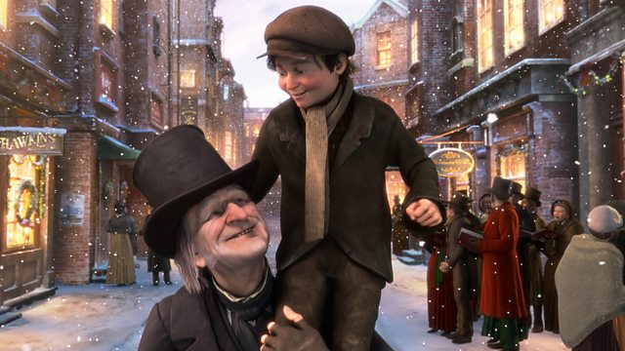
Stave 1
- Who is Marley? What is his relationship to Scrooge? Can you describe their relationship?
________________________________________________________________________________________________________________________________________________________________________________________________

- What impression do you get of Scrooge? What gives you this impression?
__________________________________________________________________________________________________________________________________________________________________________________________

- How do people react to Scrooge? Why?
________________________________________________________________________________________________________________________________________________________________________________________________

- What differences are there between Scrooge and his nephew?
________________________________________________________________________________________________________________________________________________________________________________________________

- Who comes in to visit Scrooge after his nephew leaves?
________________________________________________________________________________________________________________________________________________________________________________________________

- What do the visitors want?
________________________________________________________________________________________________________________________________________________________________________________________________

- What do you think Scrooge might think about poor people? How can you describe his reaction?
________________________________________________________________________________________________________________________________________________________________________________________________
- Think back to context and Dickens’ views of the poor. Why might Dickens be critical of people like Scrooge who think ‘workhouses’ are a solution?

________________________________________________________________________________________________________________________________________________________________________________________________

What does Scrooge think of Christmas? Does this fit the Victorian view of Christmas?
________________________________________________________________________________________________________________________________________________________________________________________________
Stave 1
- How does Scrooge treat his clerk? What do they talk about?
________________________________________________________________________________________________________________________________________________________________________________________________

- How many years has Marley been dead?
________________________________________________________________

- Whose house does Scrooge live in?
________________________________________________________________

- What is Scrooge’s house like? What does this tell us about him?
________________________________________________________________________________________________________________________________________________________________________________________________

- What strange thing happens to Scrooge when he reaches his house?
________________________________________________________________

- How does Scrooge react to the strange occurrence before the vision of the ghost?
________________________________________________________________

- How does Scrooge react when he sees Marley’s ghost inside his house? What gives you this impression?
________________________________________________________________________________________________________________________________________________________________________________________________

8.) Why is Marley dressed in chains? What is Dickens warning about?
________________________________________________________________________________________________________________________________________________________________________________________________

Label this image of Marley and Scrooge with quotations.

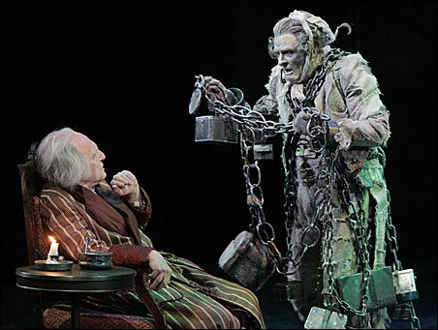

Stave 1
- What does Scrooge do to distract himself from his fear?
________________________________________________________________________________________________________________________________________________________________________________________________

- Can you give a physical and an emotional description of Marley’s ghost?
________________________________________________________________________________________________________________________________________________________________________________________________

- What do you think the chains are a symbol of?
________________________________________________________________________________________________________________________________________________________________________________________________

- What has Marley been doing for the seven years since his death?
________________________________________________________________________________________________________________________________________________________________________________________________

- What warning does Marley give Scrooge?
________________________________________________________________
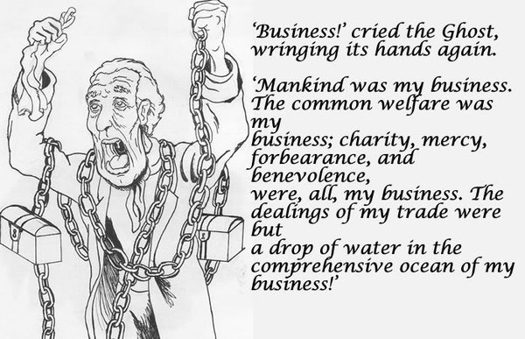
- What does this line tell us about what Marley regrets? How does this fit with Dickens’ message? Think back to context!
________________________________________________________________________________________________________________________________________________________________________________________________

- How does Scrooge feel after Marley’s exit? What does this tell us about him?
________________________________________________________________________________________________________________________________________________________________________________________________

- What reasons can you think of for Scrooge to pause half-way through saying ‘Humbug’?
________________________________________________________________________________________________________________________________________________________________________________________________
Stave 2

- What are the first signs that something strange is happening at the beginning of this Stave?
________________________________________________________________________________________________________________________________________________________________________________________________

2. Label the image with three-four quotations to describe the Spirit of Christmas Past.

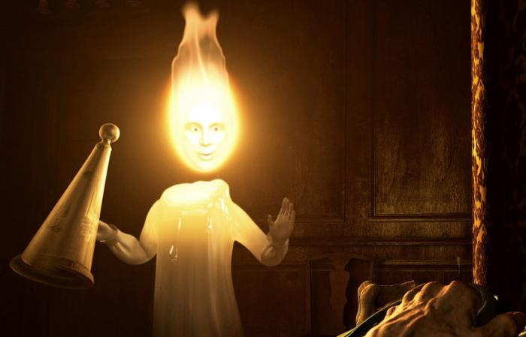

3. When Scrooge is introduced to the first episode in his Christmas past, he cries twice in fairly quick succession. How are they described differently?
________________________________________________________________________________________________________________________________________________________________________________________________

4. What is Scrooge’s response to seeing himself as a boy reading various stories?
________________________________________________________________________________________________________________________________________________________________________________________________

5. What regret does Scrooge express about the day’s earlier events, just after he feels ‘pity for his former self’? What does this show about his character?
________________________________________________________________________________________________________________________________________________________________________________________________

6. In the second schoolroom scene, when Scrooge is visited by his sister Fanny, what impression is given of his home life and relationship to his father?
________________________________________________________________________________________________________________________________________________________________________________________________

7. Which character from Stave 1 is related to Fanny?
________________________________________________________________________________________________________________________________________________________________________________________________

Stave 2

1. Scrooge as apprentice: Describe in one or two sentences how Fezziwig’s office is transformed into a ballroom at 7pm for the Christmas party. ________________________________________________________________________________________________________________________________________________________________________________________________

2. Who is described as ‘one vast substantial smile’?
________________________________________________________________________________________________________________________________________________________________________________________________

3. Who is included in the office party?
________________________________________________________________

4. When does the party end, and what contrast is being made between Fezziwig and Scrooge as employers?
________________________________________________________________________________________________________________________________________________________________________________________________

5. What happens between Belle and Scrooge? Why does this happen?
________________________________________________________________________________________________________________________________________________________________________________________________

6. What does Belle say about Scrooge and what she saw of him?
________________________________________________________________________________________________________________________________________________________________________________________________

7. How does Scrooge react to what Belle says? Why does he react in this way? Support with a quotation.
________________________________________________________________________________________________________________________________________________________________________________________________

Stretch: 8. How do you think Scrooge feels at the end of this stave? What message might Dickens be teaching?
________________________________________________________________________________________________________________________________________________________________________________________________

9. What happens when Scrooge tries to extinguish the light coming from the Spirit’s cap?
_______________________________________________________________________________________________________________________________
Stave 3

- What was different about Scrooge’s reaction to the second spirit? Why do you think this is?
________________________________________________________________________________________________________________________________________________________________________________________________

- Label the image of the Ghost of Christmas present with 3 quotations.

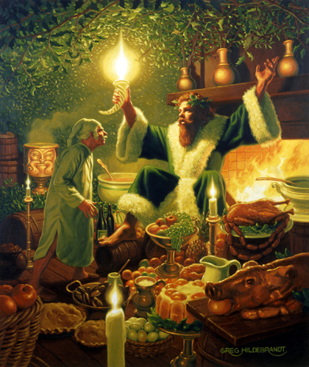

- When Scrooge first sees the street (“The house fronts…”) what impression do you get? Use a quotation to support.
__________________________________________________________
________________________________________________________________________________________________________________________________

- Does this impression change in the next paragraph? How does it do this?
________________________________________________________________________________________________________________________________________________________________________________________________

- What does the description of the street show about the poor people of the city? Can you link to context?
________________________________________________________________________________________________________________________________________________________________________________________________

- Why is the Ghost of Christmas Present showing Scrooge this street?
________________________________________________________________________________________________________________________________________________________________________________________________

- How do you think Scrooge will react to this scene?
________________________________________________________________________________________________________________________________________________________________________________________________

8. What is the Spirit's message?
________________________________________________________________

Stave 3

- What did the Ghost of Christmas Present do with his torch? What was the effect on the people?
________________________________________________________________________________________________________________________________
- What family did Scrooge and the Spirit visit? Why do you think this is?
________________________________________________________________________________________________________________________________

- What impression do you get of their family life? Use a quotation to support your answer.
____________________________________________________________________________________________________________________
________________________________________________________________

- Why did the Ghost of Christmas Present want Scrooge to see the family?
________________________________________________________________________________________________________________________________________________________________________________________________

- What was the family’s reaction to the food? What does this show about how often they have meals of this nature?
________________________________________________________________________________________________________________________________

- When Scrooge asks if Tiny Tim will live, what is the Spirit’s response?
_________________________________________________________________________________________________________________________________________________________________________________

- Why does Scrooge say it ‘with an interest he had never felt before?’
________________________________________________________________________________________________________________________________________________________________________________________________

- Why does the Spirit quote Scrooge’s words about the poor (‘if he be like to die, he had better do it and decrease the surplus population’)?
________________________________________________________________________________________________________________________________________________________________________________________________

- How does Scrooge feel at the end of this section? Give a quotation to support.
________________________________________________________________________________________________________________________________

9. Think back to context. Does Scrooge’s family life contrast to the Cratchit family? How does this link to the Victorian view of family? How do we feel towards him as a result?

________________________________________________________________________________________________________________________________________________________________________________________________

Stave 3

- Who did Bob Cratchit offer a toast to? What does this show about his character?
________________________________________________________________________________________________________________________________________________________________________________________________

- What was the rest of the family’s reaction? Consider Mrs Cratchit and the children. Why did they react in this way? Use quotations to support your answer.
________________________________________________________________
________________________________________________________________________________________________________________________________________________________________________________________________

- Why was Fred laughing?
________________________________________________________________________________________________________________________________________________________________________________________________

- What does Fred think about Scrooge? Support with a quote.
________________________________________________________________________________________________________________________________________________________________________________________________
5. What are the family doing? What do they think about him at the end?
________________________________________________________________________________________________________________________________________________________________________________________________

6. What view of Victorian family is presented in these two family scenes?
________________________________________________________________________________________________________________________________________________________________________________________________

7. What was happening to the Spirit throughout this stave?
________________________________________________________________

8. What do Ignorance and Want symbolise? Why does the Ghost quote Scrooge’s harsh words ‘Are there no prisons? Are there no workhouses?’ back to him again?
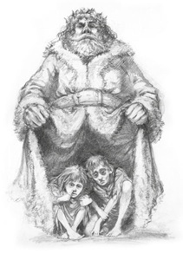
________________________________________________________________________________________________________________________________________________________________________________________________

Stretch - Can you link to Dickens’ message about the poor?
________________________________________________________________________________________________________________________________
Stave 4

- Where does Scrooge go with the Ghost of Christmas Yet To Come?
________________________________________________________________________________________________________________________________________________________________________________________________

2. How does the spirit communicate with Scrooge?
________________________________________________________________

3. How do the villagers talk about the dead man they describe and going to the funeral? Do they show any respect? Support with a quote.
________________________________________________________________________________________________________________________________________________________________________________________________
________________________________________________________________

4. What have Mrs Dilber and Joe done? What does the line ‘Every person has a right to look after themselves, he always did’’ suggest?
________________________________________________________________________________________________________________________________________________________________________________________________

5. What items have they stolen? Which is the most shocking?
________________________________________________________________________________________________________________________________________________________________________________________________

6. Why is it particularly shocking that they have taken down the curtains ‘rings and all with him lying there?’
________________________________________________________________________________________________________________________________________________________________________________________________

7. Why do you think Dickens has included this scene? What does it show about the poor/how people viewed Scrooge and how he treated others?
________________________________________________________________________________________________________________________________________________________________________________________________

8. What is happening to Scrooge? What might he begin to realise? How does he feel?
________________________________________________________________________________________________________________________________________________________________________________________________

Stave 4

1. Who in the Cratchit family has died?
__________________________________________________________

2. What do we learn about the Cratchit family spirit?
________________________________________________________________________________________________________________________________________________________________________________________________
3. What two things does Scrooge say to the Ghost of Christmas Yet to Come at the end of his time observing the Cratchits that makes it clear that there is something important that he has not realised?
________________________________________________________________________________________________________________________________________________________________________________________________
4. How is the gravestone described in the paragraph that begins ‘A churchyard..’. What does this suggest about the grave?
________________________________________________________________________________________________________________________________________________________________________________________________
5. Why does Scrooge tremble as he approaches the grave stone? What "new meaning" does he see in it?
________________________________________________________________________________________________________________________________________________________________________________________________

6. What is Scrooge's hope as he approaches the grave stone? Why does he want to know if they are the shadows of things that ‘Will be or May be?’
________________________________________________________________________________________________________________________________________________________________________________________________

- What is his reaction when he reads his name upon the gravestone?
What does he realise about how he has been living his life?
________________________________________________________________________________________________________________________________________________________________________________________________
8. Why do you think the Ghost of Christmas Yet to Come's hand begins to shake? ________________________________________________________________________________________________________________________________

Stretch: What lesson might Scrooge have learnt that Dickens is keen to teach his readers?
________________________________________________________________________________________________________________________________________________________________________________________________
Stave 5
- What does Scrooge realise about his fate when he wakes up?
________________________________________________________________
- How does Scrooge react to this realisation? Give two quotations to support your answer.
________________________________________________________________________________________________________________________________________________________________________________________________
- Why does Scrooge send a turkey to the Cratchits?
________________________________________________________________________________________________________________________________

- Why does Scrooge begin to love his front door knocker?
________________________________________________________________________________________________________________________________________________________________________________________________

5. How does Scrooge redeem himself from the beginning of the novel?
________________________________________________________________________________________________________________________________________________________________________________________________
6. How does Fred react to his uncle's appearance on Christmas day?
________________________________________________________________________________________________________________________________________________________________________________________________
7. What is a "strait-waistcoat" and why does Bob Cratchit contemplate putting Scrooge in one?
________________________________________________________________________________________________________________________________________________________________________________________________

8. What is Dickens’ message at the end of the novel? Remember to link to context about rich/poor. Consider how Scrooge’s life has been transformed by his generosity and charity. Use quotations to support your answer.

________________________________________________________________________________________________________________________________________________________________________________________________________________________________________________________________________________________________________________________________________________________________________________________________

