AQA English Literature
AN INSPECTOR CALLS
REVISION
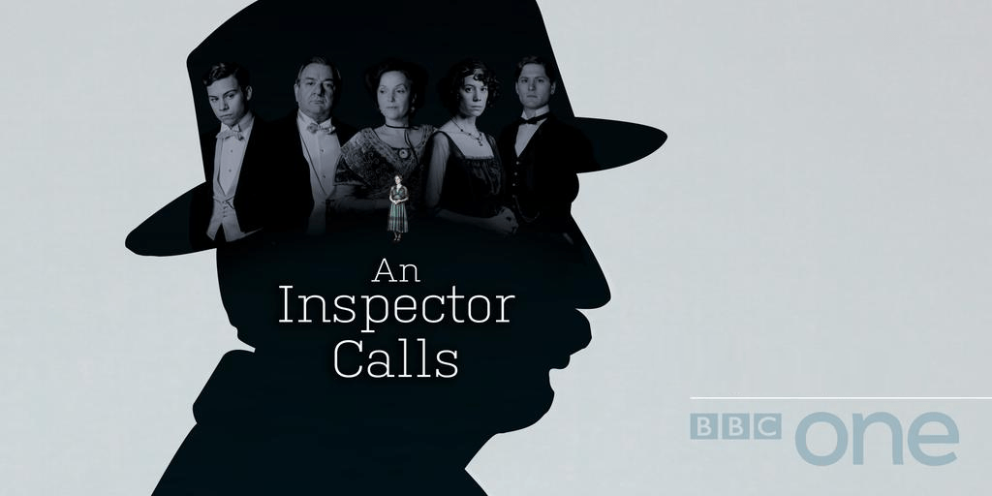

NAME: ___________________

An Inspector Calls Plot Summary
Arthur Birling has convened a dinner for the engagement of his daughter, Sheila, to her boyfriend, Gerald Croft. Eric, Sheila’s brother, drinks heavily and appears mildly upset. Gerald gives Sheila her ring, and Sheila and Sybil leave the room to try on wedding clothes. Eric goes upstairs. Arthur tells Gerald he knows the Croft family considers themselves social superiors of the Birlings, but that’s easily remedied, he says, as he expects a ______________ for his business successes. Eric returns, and Arthur gives the two young men advice about professional life, saying that people ought to ‘____________________________ ____________________’ and dismisses socialism as being mixed up like ‘__________ _____ ___ _____’. Edna, the maid, announces that an Inspector Goole is here to speak to Arthur. This cuts Birling off mid sentence with a ‘_________ ring of the doorbell.’ The Inspector should create an impression of ‘______________. _________________ and ________________’.

The Inspector announces that a girl named Eva Smith has died of an apparent suicide. The Inspector asks Arthur if he knows anyone by that name. Arthur initially denies it, but after seeing a picture, he admits to employing Eva at his factory, and firing her when she incites a failed strike for higher wages. Arthur says he is not sorry for doing so, stating ‘If you don’t come down _______ on ________ __________ they’d soon be asking for the ____________’. Arthur believes that his foremost obligation is to his profits.

When Sheila returns to the room, the Inspector begins interrogating her. It is revealed that Sheila got a girl fired from Milward’s, a local shop, for giving Sheila mean looks as she was trying on clothing. Sheila regrets to hear that the person she incriminated was none other than Eva Smith, and that she and Arthur are responsible, in part, for Eva’s poverty and suicide. She describes herself as a ‘___________, ___________ little creature’. The Inspector turns to Gerald and asks if he knows someone named Daisy Renton. Sheila realizes, from Gerald’s expression, that Gerald knows this name. When all but Sheila and Gerald leave the room, Sheila accuses Gerald of having had an affair with Daisy Renton the previous summer. Gerald admits to this. He asks Sheila to hide this information from the Inspector, but she says it won’t be possible because the Inspector probably already knows. Act One ends.

Act Two begins with the same set. The Inspector questions Gerald about Daisy Renton, and Gerald admits to the affair in front of Sheila and her parents, Arthur and Sybil. Gerald is embarrassed by his indiscretion, but insists his concern for Daisy was authentic and he is ‘rather more _______ by this business than he appears to be’. Gerald tells the Inspector he is going to leave for a walk.
The Inspector moves on to Sybil, who, on being questioned, says that she, as director of a charity, refused assistance to a pregnant woman. The Inspector tells them that the girl Sybil turned away was Eva Smith, or, as Gerald knew her, Daisy Renton. She admits to being ‘_________’ against her case from the start as the girl called herself ____ ___________. She is judgemental and calls her a ‘girl of that _____’. Sybil says she feels no regret, as Eva/Daisy had claimed she was pregnant but was not married to the child’s father. To this, Sybil responded that Eva/Daisy should ask the child’s father for money. Act Two ends.

In Act Three, with the same set, Eric admits to an affair with Eva/Daisy, and to a drinking problem that makes many of the details hazy. The Inspector demonstrates that each member of the Birling family, and Gerald, has played a part in Eva/Daisy’s suicide, and that all should consider themselves guilty. Before he leaves, the Inspector gives a speech that is the direct antithesis of Mr Birling’s previous one. He says that people must look out for one another, and ‘We are all members of ______ ____’. The Inspector departs.

Sheila, wracked with guilt, wonders aloud whether the Inspector is a member of the police force. The family puzzles this out, and when Gerald returns, he says he spoke to a sergeant outside who does not know of any Inspector with the name of Goole, the man who just visited the Birling home. Arthur believes that the family has been hoaxed, and that this is a good thing, since their misdeeds will not now result in public scandal. Sheila resents Arthur’s rationalisation of the family’s behaviour, and she says they are ‘beginning to ________ like _________ has happened’. They are still guilty for Eva/Daisy’s death, even if the Inspector was not a genuine officer. Gerald, however, notes that no family member saw the picture of Eva/Daisy at the same time, and that the Inspector might have conflated the family’s stories by offering pictures of different women, and changing the names from Eva Smith to Daisy Renton.

Sheila wonders whether this would excuse everyone’s behaviour, but it does not, as Gerald still committed his affair, Eric impregnated an unmarried girl, and Arthur and Sybil behaved uncharitably to young girls in need. Arthur calls the hospital and confirms that no self-inflicted deaths have been recorded for weeks. Eric and Sheila challenge their parents’ outdated views. Suddenly, there is a ‘_______ ring of the telephone’ and Arthur answers. He alerts the family that a girl has been admitted to the hospital just now, and that her death is a suicide. As the play ends, they all ‘stare _______ and _____________’.
English Literature Paper 2 - Revision Priorities
Section A – An Inspector Calls
Key Moments:
Act 1:
- The stage directions – ‘fairly large suburban house’ – upper middle class, wealthy family – the dining room is not something a ‘poor’ family would have, so setting the whole play in this room reminds the audience of their wealth throughout – it also shows the size of their house, if the whole stage is just one room!
- Priestley sets the characters and their relationships up in this act – ‘portentous’ (Mr B), Mrs B is his ‘social superior’ – she is old money, their relationship represents the fact that the wealthy upper class had a need to marry their daughters to those like Mr B who were ‘upwardly mobile’ and had the means to make their own money (this saved their families – very selfish!)
- Sheila is set up as ‘too excited’ – perhaps she is meant to be the young girl who has been spoiled as a child, and is very much still seen as a child by her parents – they have control of her!
- Eric is ‘not quite at ease’ – he’s a bit awkward – he’s not very good at business and his father thinks he’s pretty useless as a result - he doesn’t seem to really know where he fits into his family and society – this results in him being quite irresponsible, drinking too much (squiffy) and going out and sleeping with women – could this be seen as a reaction to his overbearing parents and needing to feel important/wanted?
- Notice that 1 child is set up as very naive (Sheila) and the other as not quite knowing where he fits in – this is Priestley demonstrating how the younger generation are mouldable and impressionable – they can change! Sheila calling her mother ‘mummy’ and Mrs Birling educating her on how to be a good wife (‘men with important business…’) also set her up to be quite immature, but as having the potential to change.
- We see Mr Birling bragging about his ‘knighthood’ to Gerald, and sounding very self-righteous about all things historical – the Titanic being ‘unsinkable’ and there not being a ‘chance of war’ – this shows the ignorance of the upper middle class, wealthy Capitalists (Priestley believed these were the people to blame with many of the issues in society – the poor treatment of the lower classes, right through to the cause of the wars)
- We learn that Gerald is a ‘Croft’ – a very wealthy family who are Mr B’s ‘rivals in business’ – it starts to make sense why they are so keen to impress his parents, marrying your daughter off into a family with a good reputation was extremely valuable to a man like Birling.
- The Inspector arrives and the light changes to ‘harsher’ – this is a signal to the audience that the action is really about to start – it’s a dramatic device! Mr Birling tries to name drop to get rid of the Inspector – ‘Alderman’ and ‘Lord Mayor’ – again, Priestley making Mr Birling embody everything that is wrong with the wealthy Capitalists in society – pride comes before a fall!
- Mr Birling is questioned – his priority is to ‘keep labour costs down’ and we see a glimpse of Sheila’s potential coming through when she replies that ‘they’re not cheap labour, they’re people’ – quite unusual for a young woman to speak back to her father, and he isn’t too happy about it, but it is a hint from Priestley that Sheila is not quite the same as her parents!
- Sheila realises that she had a part to play and is ‘hysterical’ – she cries, a lot! One interpretation is that this is another childish/immature reaction, but this could also be seen as her caring!
- We get more of an insight into the type of man Gerald is, as we start to consider what he was up to while he was ‘at the works’ all the previous summer – clearly having an affair! This could well be Priestley commenting on how many of the younger men from Capitalist families treated women as possessions/considered only their own wants and needs (Gerald is a contrast to Eric – he is just a bit older, but is well embedded into the ways of the wealthy Capitalists. This allows us to feel more empathy for Eric later on, as his behaviour somehow doesn’t feel t be as abhorrent as Gerald’s – Eric makes mistakes, but Gerald seems far more arrogant and generally unlikable). The act ends on this dramatic note.

Act 2:
- Opens with the Inspector ready to question Gerald – Sheila again comes across as wiser and more independent than her family give her credit for – ‘then I’m staying’ – she doesn’t want to just be the silent ‘good wife’ that he mother is, she wants to hear Gerald’s excuses.
- Sheila also starts interrupting her mother – ‘cutting in’ – the younger generation are starting to find their feet and speak out, despite their parents attempts to silence them – ‘please don’t contradict me like that’
- Mrs B speaks to the Inspector ‘rather grandly’ – she is asserting the authority she feels comes with her class and family reputation. Gerald does not react well to being interrupted by Mrs B – ‘cutting, rather impatiently’ – he is not too comfortable with the constant boasting of Mr and Mrs B, and is more worried about trying to get himself out of the situation (at this point, he is about to be questioned about the affair)
- Sheila is conscious that she doesn’t want to get her brother into trouble (for drinking too much) but is aware they must ‘stop these silly pretences’ – Mrs B doesn’t want to accept this and is ‘staggered’, but Gerald is very quick to confirm that he ‘drinks pretty hard’ – is this another sign that Gerald is willing to make anyone look bad, if he thinks it might make himself look better?
- Mrs B and Mr B (the older generation) try constantly to silence Sheila, but she is aware that the Inspector is ‘giving us the rope so that we’ll hang ourselves’ – this is a metaphor for the Inspector asking just enough and just the right questions so that they’ll have to tell the truth – she is aware that it’s no use trying to blame or discredit the Inspector, as everything he is saying is true.
- Gerald wanted to play the ‘knight in shining armour’ for Daisy and plays on this – ‘gave me a glance that was nothing less than a cry for help’ (he makes out that Alderman Meggarty was trying to push her into doing something she didn’t want to – this is also Priestley hinting at the idea that Capitalist men in high places were often corrupt and not quite what they seemed on the surface!) He uses lots of emotive language to play on her weak state, trying to make what he did sound better (keeping up appearances/trying to get himself out of trouble!) – ‘hungry’, ‘miserable’, ‘desperately’, ‘rather shaken’
- Gerald apologises to Sheila, but follows with the beginnings of an excuse – he comes across as insincere
- The Inspector snaps at Birling for treating Sheila like she should be left out of the business because she is ‘young and unmarried’ – ‘your daughter isn’t living on the moon. She’d here in Brumley too.’ – metaphor for the fact that she’s just as responsible as the rest of them.
- Towards the end of the act (when the Inspector mentions trying to find Eric), Mr & Mrs B ‘exchange bewildered and rather frightened glances’ – are they scared about what they have done, or are they more scared about their reputations, and that of their son?
- The Inspector speaks ‘severely’ in his dialogue with Mrs B – her reaction to the fear she is starting to feel is to get more pompous and officious with the Inspector – like Gerald, she wants to get herself out of trouble, though she seems to genuinely believe that what she did was right, whereas Gerald, at least, accepts that the affair was wrong!
- Mrs B uses phrases such as ‘gross impertinence’, ‘she had only herself to blame’, ‘not a good case’ and ‘impertinently’ to first blame the girl herself for her death, and for the committee not giving her the money – Priestley demonstrates how middle-upper class women took on charitable roles seemingly to do good, but realistically to boost their social standing and appearance – they believe that it was the fault of the lower classes that they had ended up in these situations, and that they should be grateful to even be listened to.
- The Inspector can see the effect he’s having on Mrs B and Sheila here – Mrs B is rude and snappy with him ‘Inspector, you’re quite mistaken’ – she is demanding and thinks she could ‘bear investigation’ because she has done ‘nothing she’s ashamed of. The Inspector speaks very emotively – ‘this was the end’ (short sentence – reflects the ‘end’) – Sheila is clearly horrified ‘horrible-horrible!’, but Mrs B carries on and tries to blame the father (ironic, seeing as it is her son – we know this, but she doesn’t! Preistley wants to embarrass Mrs B for her disgraceful behaviour).
- Even when the Inspector appeals to Mrs B as a mother ‘you’ve had children’, this does not work – Priestley perhaps demonstrates here that she hasn’t really been a mother to the children – they have been raised by staff. Mrs B comes across as unfeeling and cold here, but most of all, like her husband, extremely self-involved – when he worries again about reputation (‘this won’t look good’), she decides to blame him saying he ‘started’ it all!
- The act ends with Sheila, and the audience, realising that Eric is the father – this is the ultimate embarrassment for Mr & Mrs B.
- The Inspector gets angrier with the Birlings – ‘don’t stammer and yammer at me man, I’m losing all patience with you people’ – this time, they don’t answer back – MRs B is ‘rather cowed’ (like a child who has been told off!)
- Eric returns looking ‘pale’ and the curtain falls – again, a very dramatic end to a scene which would have the audience eagerly anticipating the next act!
Act 3:
- The act opens with the Birlings arguing amongst themselves – Eric speaks ‘bitterly’ to his mother, and Mr & Mrs B both continue to try to silence their children – is this turning into desperation now?
- Mr B accuses his children of having no ‘loyalty’ – of course, he means to the family reputation – Priestley demonstrates that ‘loyalty’ to those who have done wrong is in fact irresponsible
- The Inspector interrogating Eric is more quick-fire than with the others – Eric is very blunt and to the point, he does not over-explain things like MRs B, Birling and Gerald, as he is well aware he has done wrong and so focuses on the facts – there is a contrast to Gerald’s interview here, as Eric wastes far less time using emotive language to describe Eva’s condition, purely to make himself look better.
- We find out Eric stole the money from his father – interestingly, we don’t seem to dislike Eric for this – perhaps because Priestley has set Birling up as someone so heinous, and Eric seems to be trying to do the right thing (a bit of a Robin Hood sort of situation?!) – he also admits it is wrong, which we know Priestley is trying to tell us is what can make the difference – repenting for sins and wrongdoings/taking responsibility for your actions.
- Eric ‘nearly at breaking point’ shrieks at his mother that she ‘killed her’ and ‘her own grandchild’ – the Inspector has broken Eric, as he has realised the enormity of the truth. He ‘almost threatens’ his mother – this would be shocking for an audience, but, again, we quite like this, as by this point in act 3, as an audience we’re desperate for someone to bring Mr & Mrs B down a peg or two!
- The Inspector ‘takes charge, masterfully’ – he forces the Birlings to ‘remember’ what they did – remember, he controls the entire play – he asks the questions that force them to tell the truth, he stops them all seeing the image at the same time and he delivers Preistley’s messages about society and responsibility – he is Priestley’s voice and a dramatic device all rolled into 1!
- The Inspector’s final speech – ‘millions and millions’ of ‘Eva Smiths and John smiths’ contrasts with the ‘thousands’ that Birling is wanting to pay – again, a Capitalists idea of solving an issue is exactly what Priestley is fighting against – these short term ‘fixes’ really fix nothing, and in fact often make the issues in society worse. ‘We are members of one body’, ‘ if man will not learn his lesson, then they will be taught it in fire and blood and anguish’ – reference to the wars – Priestley suggests that the wars were caused by the ignorance that he warns against in his play (remember it is set in 1912 but written in 1945 as a warning not to go back to the days of class division)
- Mr & Mrs B have changed in no way – Mrs B is still demanding things from the maid – ‘I’ll ask Edna to wait up and make us some tea’ – all they are concerned about is themselves and their own reputations – Birling doesn’t even want to tell Gerald ‘we needn’t bother him’ – he still wants Sheila to marry him, despite all of this!
- Gerald comes up with the idea that the Inspector wasn’t real – he, Mrs B and Mr B are delighted that they think everything is now fine – ‘we’ve been had’ (Gerald) – they’re convinced it makes ‘all the difference’, when, of course, Priestley’s message is that is doesn’t at all – they all still did what they did, which Sheila & Eric recognise – ‘(bitterly) I suppose we’re all nice people now’ – her sarcasm here has shown her maturity, and how much she has grown up throughout the course of the play. Eric recognises that ‘the girl’s still dead, isn’t she?’. Again, the older characters and Gerald start to try to say that this is not necessarily true – but the audience, and Sheila and Eric appreciate that this makes absolutely no difference, and if you have done something awful to another person, you must make up for this, regardless of the consequences.
- The phone ringing at the end is the final dramatic device used by Priestley. The telephone itself is a symbol of their wealth, and telephone conversations have played an important role throughout in revealing key information/delaying information to create suspense. The stage direction ‘they stare guiltily and dumbfounded’ is Priestley demonstrating that, as the audience, Sheila and Eric have already realised, you cannot escape punishment for things you have done wrong – we must take responsibility for our mistakes, otherwise others in society suffer. The real Inspector has to come as the older generation have still not learned, so Priestley is showing that people must learn, no matter how that happens – they cannot escape the truth.
Key Revision points:
- The main messages – taking responsibility, Capitalists abusing power, the effect of our actions on others (mainly of the middle/upper class on the lower in Edwardian society), that we should embrace the time of political change in 1945 and vote labour – socialists would fight for equality, that the younger generations need to take charge and break away from the constraints of their parents views, that we should be punished for our mistakes, if we do not learn from them – personal consequences in powerful people have far reaching consequences in society
- The Inspector – as a dramatic device, as social commentator/the voice of Priestley
- Eric – he is a contrast to Gerald – also a young man from a Capitalist family, but he doesn’t quite understand where he fits – he is no good at business, his father doesn’t respect him, so he resorts to drinking and going out – he does change, though!
- Gerald – as a younger Capitalist, accepts some responsibility but appears insincere, still expects Sheila to marry him, thinks he can take whatever he wishes with no repercussions, lives off the reputation of his family name
- Eva and Edna – only 2 working class characters – how are they treated? Why? Eva is the same age as Sheila – what is the contrast between the two? Why?
- Mr Birling – don’t forget about him! What does he represent? Why is he there? He is supposed to be the grown up and is often portrayed as a similar age as the Inspector – why?
- Mrs Birling – from upper class originally, snooty/snobbish and ignorant woman, key role in charity purely for her own gain, completely obsessed with appearance and reputation, rude when challenged by authority, blames everyone but herself – genuinely feels that what she did was not wrong, and refuses to change this belief – happy to carry on just as before, once she feels the family reputation is safe
Themes:
- Responsibility – they all fall into this one! Individual responsibility, collective responsibility etc
- Social class – the divide, the treatment of the lower by the upper, the consequences of this treatment/abuse of power etc
- Abuse of power – all of the Birlings and Gerald abuse their positions of power and trust!
- Morality – the moral and religious lessons we should learn
- Greed – the impact on others
- Wealth/money – mistreatment of it, link to social class, how is money used throughout the play?
- Gender/treatment of women – who is treated poorly? Why? How? By who? Does it depend on class? Think about Sheila and Eva in particular!
- Older generation vs. younger generation – what are the differences in their attitudes, behaviours, feelings?

Context AIC - Life in 1912
Workers
19th century Britain saw a huge population increase accompanied by rapid urbanisation stimulated by the Industrial Revolution. The large numbers of skilled and unskilled people looking for work kept wages down to a barely subsistence level. Available housing was scarce and expensive, resulting in overcrowding. These problems were magnified in London, where the population grew at record rates. Large houses were turned into flats and tenements, and as landlords failed to maintain these dwellings slum housing developed.
Women
At the start of the Twentieth Century, women had a very stereotypical role in British society. They were subservient to men and had very few rights. If married, they stayed at home to look after the children while their husband worked and brought in a weekly wage. If single, they did work which usually involved some form of service such as working as a waitress, cooking etc. Many young women were simply expected to get married and have children.
Advances in technology
Titanic was an example of this. It had advanced safety features such as watertight compartments and remotely activated watertight doors, but there were not enough lifeboats to accommodate all of those aboard due to outdated maritime safety regulations. It was said that the builders and owners of Titanic claimed she was 'unsinkable'. The claim actually made was that she was 'practically unsinkable', close enough, but nevertheless an unfortunate statement and one which would haunt both builder and owner for years.
Social equality
There were strong distinctions between the upper and lower classes. The rich were rich and the poor were poor. The rich set wages and set labour costs to a minimum.
Life in 1945
Women
World War I proved to be the turning point for the campaign for women’s rights.. As men went to fight, women proved how indispensable they were in the fields and armaments factories.. Men had to acknowledge the fact that women were just as capable as them. As a result of this, many women enjoyed a newfound freedom that working and earning money allowed them.
By 1918, no government could resist and the Representation of the Peoples Act allowed women over 30 the right to vote following the suffragettes campaign. It would take a further 10 years to abolish the age qualification and put men and women on an equal footing.
Desire for social change
1945 general election. Churchill's role in the Second World War had generated much support for him amongst the British population, he was defeated in the 1945 election. Many reasons for this have been given, key among them being that a desire for post-war reform was widespread amongst the population.
The greatest factor in Labour's dramatic win appeared to be the policy of social reform. The Beveridge Report, published in 1942, proposed the creation of a Welfare State. It called for a dramatic turn in British social policy, with provision for nationalised health care (NHS), expanded state-funded education (free education for all), national insurance and a new housing policy. The report was extremely popular, and copies of its findings were widely purchased, turning it into a best-seller. The Labour Party adopted the report eagerly. People wanted to feel more equal.
Social equality
The war was over and social classes had blended. During the war, evacuation of people of all classes, food and clothing rations for all and a mix of classes fighting in the army and helping at home meant that social class was not as clearly defined. There was a stronger sense of equality and people wanted this to continue.

An Inspector Calls – Writer’s Purpose
Why did Priestley choose to write about his characters and themes?
Use these comments in your introductions!
The Inspector
Priestley uses the Inspector as his own voice (he is a device), to deliver his socialist message. Priestley was extremely angry about the widespread social inequality that existed in Britain after the wars, and wanted to force his audience to consider their own part in changing the society to make it better. With the general election looming in 1945, he wanted Labour to get in to drive change for the lower classes.
Mr Birling
Priestley uses Arthur Birling to represent the arrogant, ignorant, Capitalist upper classes. He is a factory owner who treats his workers appallingly, which Priestley uses to anger the audience and turn them against Birling and men like him (many of the audience would have either been workers in a factory like that, or have had family who worked in one). He is obsessed with status and reputation, like many men like him in 1912.
Mrs Birling
Priestley uses Sybil Birling to represent privileged, stubborn, superior women in the upper classes. She is the head of a charity, purely because it makes her look good to her peers – she looks down on the lower classes and judges them as though their poverty is their own doing. Again, Priestley makes her behave in such a heinous manner as he wants his audience to dislike her and challenge behaviour such as this in the 1945 society. IT also reminds those members of the audience like Mrs Birling of the consequences of their actions.
Sheila Birling
Priestley uses Sheila Birling to represent the children of the wealthy upper class and the privileged upbringing they had. However, he also shows how the younger generation had started to become tired of their parents’ stuffy Capitalist ideas, and were impressionable and ready for change. The message is to the younger members of the audience that many of the older generation will be stubborn, and will need their fresh young minds to drive the social change.
Eric Birling
Priestley uses Eric Birling to represent the children of the wealthy upper class and the privileged upbringing they had. Eric does not fit in to the capitalist ways – he is not good at business and is clearly uncomfortable with his life, as he drinks to console himself. He also represents how the young had been brought up to believe that they can use their position to get what they want/abuse their positions. The message is to the younger members of the audience that many of the older generation will be stubborn, and will need their fresh young minds to drive the social change. Eric does something awful to Eva, but we still forgive him, as he repents for what he did and is horrified with his own behaviour – we detest Gerald so much by the end that our respect grows for Eric even more.

Gerald Croft
Gerald begins the play with a similar status and background to Eric and Sheila, however, he has become too indoctrinated into the capitalist way of life to be truly changed. He apologises for what he did to Sheila, but the audience find him insincere and quite detestable by the end – like the older generation, he thinks that if his reputation is safe then he can go back to how he was before. Priestley’s message here to his audience that some people in society, regardless of age, will disappointingly not hear the crucial messages.
Eva Smith/Daisy Renton
Priestley uses Eva to represent all working class young women and how they were treated. He shows how desperate she becomes when every door is shut to her by the middle and upper classes. She is treated poorly by her employer, a lover, a customer in a shop and, possibly worst of all, a charity – a message to the audience that it is everyone who can have an effect on everyone else.
Responsibility
Priestley’s message is all about responsibility – he thinks we need to take collective responsibility for society and all work together to improve it – no one can do it alone.
Age/Generation Gap
Priestley demonstrates how many of the older generation were stubborn and refused to change – this is one of the things that angered him the most. He showed his younger audience members that they needed to break free from their capitalist families and drive change.
Socialism vs. Capitalism
Priestley was a socialist – he believed in equality for all, no class system and, most of all, that the wealthy needed to understand their impact on those who were poorer than them. The inspector represents this, and turns Eric and Sheila towards his ideologies by the end. The real inspector has to come at the end to warn the stubborn capitalists who have been refusing to change that they will be forced to eventually.
7 Deadly Sins
Priestley does link his play to religion, with messages about the consequences of greed (Mr B), pride (Mrs B & Mr B), lust (Gerald and Eric) and envy (Sheila).
Gender/Treatment of Women
Priestley demonstrates how poorly particularly working class women were treated. They were even lower than working class men and the only thing left to them if they were desperate was to sell themselves (prostitution). Sheila represents how young women were starting to change (perhaps she was a budding suffragette) as she refuses to do as the men tell her when they tell her to leave the room etc.
Dramatic Irony
Dramatic irony is where the audience is aware of something that the character is not – in An Inspector Calls, it is used to make the audience laugh at Mr and Mrs Birling and make them look ignorant to the world around them (Mr Birling and his comments about the Titanic, and Mrs Birling when she says they should blame the father, not realising it is Eric).

An Inspector Calls Essay Planning
Possible Topic | Revision Ideas – key words, quotes, scenes, characters
The Inspector
How is the Inspector’s arrival described and who lets him in? Why is this significant?
Why is it significant that he cuts Birling off mid speech?
What adjectives are used to describe him in the stage directions?
How does he speak to the Birlings?
What are 2 quotes from his final speech? How does he channel Priestley here?

Responsibility

Younger Gen:
How does Sheila take responsibility for her actions before and after the Inspector arrives? How does she challenge her parents?

Older Gen
How do they respond to the Inspector challenging them? What quotes can you use for Mr and Mrs Birling?
How do they not learn their lesson when they discover the Inspector is not real?

Inspector
What is his message in his final speech?

Women

How does Sheila change throughout the play?

How do Mrs Birling’s used as a criticism of how outdated views can impact women?

Men
How do the male characters treat women?

How is Alderman Megarety described? What is Priestley’s message about how rich, upper class men think they can treat women?

How do Eric and Gerald treat and talk about women?

How does Birling treat Eva and Edna?

How does the Inspector challenge their views and model how a male should care and respect females in society?
Unfairness / Inequality
What is Priestley’s message about the social divide?
How does he use Birling as an example as someone who exploits the lower classes and a selfish individual?

How does Priestley present Sheila as someone who starts to challenge unfairness?

What is the Inspector’s message about unfairness during his speech?

Social Class
How are the older generation used as a warning to the 1945 audience not to go back to a time when there was a huge social divide in society?

How do Sheila and Eric begin to challenge their parents’ out dated views on social class?

How is the Inspector used as a vehicle to challenge the Birling’s narrow minded and insular views on class (think about the points he arrives)?

Generational differences

How do both groups respond differently once the Inspector leaves and they realise he is not real? Consider the stage directions for Sheila and Eric. How do they challenge their parents? How are they shown as visions of hope for the future?
What does the real Inspector calling at the end teach the older generation?

SENTENCE STARTERS
Priestley introduces the character as…
Perhaps Priestley wanted to…..
Priestley uses…
Priestley wants to….
Priestley communicates…… / highlights / praises / criticises / reinforces
Priestley intends to….
Priestley decided to start with….
Priestley presents _____ as…
The play closes/opens with….
Priestley wants to audience to think that…..
The character is presented as…..by Priestley to…..
Priestley uses negative language because he wants to show……
Priestley want the audience/reader to understand….
The character embodies/ represents/ symbolises….
Priestley illustrates the idea through…
The idea of….is presented by Priestley through….
The concept is explored through the use of….
When Priestley uses……..he wants to convey the idea that……
X is portrayed as…….
A sense of………….is created by Priestley by…….
The entrance of X symbolises…..
We already know that……..because…..
The audience is aware of…
When the audience discovers
The use of imperative/ questions / repetition / imagery suggest….
This character is first presented as…. / used as a symbol for….
This is a turning point because……
Priestley may be trying to/ could be trying to show…
Priestley is influenced by….
The reader may interpret this as….
Priestley challenges his readers to….
The concept of…..

An Inspector Calls VIQs – You must know these 12 as a minimum!
Opening stage directions | ‘a rather cold woman’ (Mrs B)  ‘a rather portentous man’ (Mr B)
Sheila (about ring) Act 1 | ‘Look mummy, isn’t it a beauty’
Sheila about Eric Act 1 | ‘You’re squiffy!’
Mr B (about socialism) Act 1 | ‘All wrapped up together like bees in a hive’  ‘Community and all that nonsense’
Mr B (about workers) Act 1 | ‘If you don’t come down sharply on some of these people, they’d soon be asking for the earth’
Inspector Act 1 | ‘It’s better to ask for the earth than to take it’
Gerald Act 1 | ‘I don’t come into this suicide business’
Mrs Birling Act 2 | ‘I consider I did my duty’  ‘Girls of that class’
Inspector Act 3 | ‘then he will be taught it, in fire and blood and anguish’  ‘We are all members of one body’
Gerald to Sheila Act 3 | ‘What about this ring?’ (Trying to give it back to Sheila)
Eric Act 3 | ‘And I say the girl’s dead and we all helped to kill her – that’s what matters’
Mr B Act 3 | ‘just a lot of moonshine’

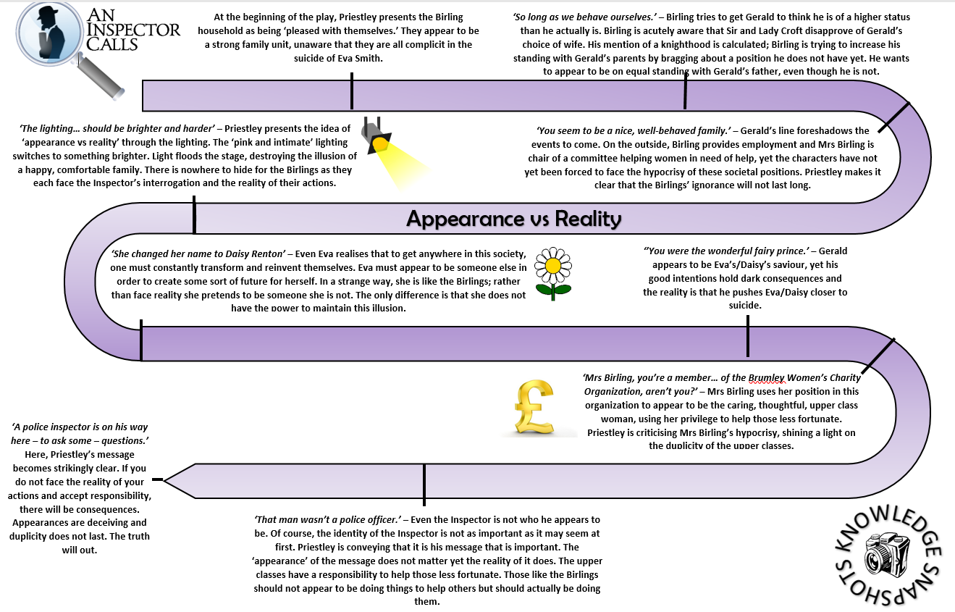
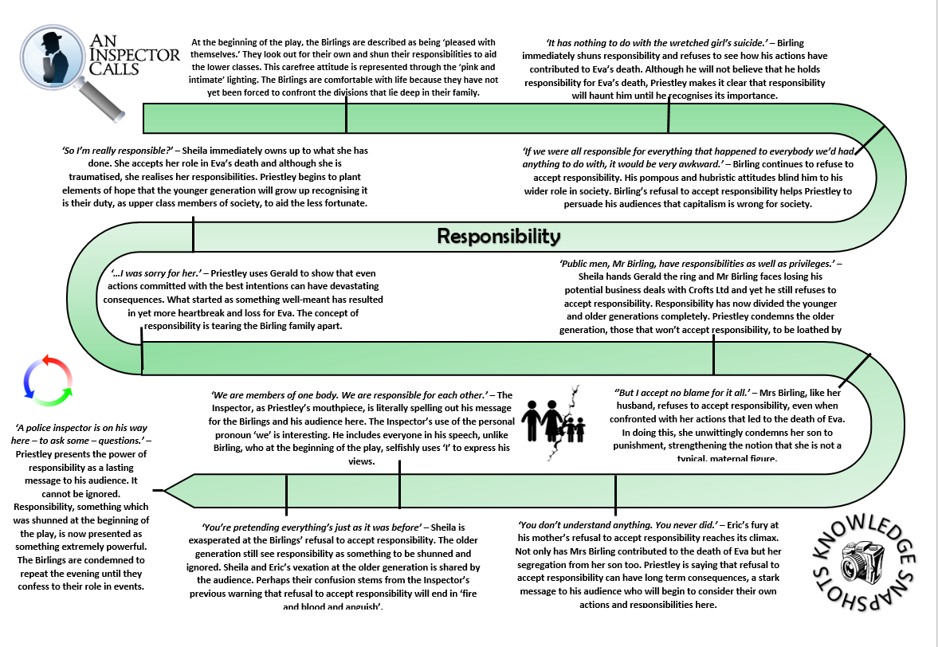
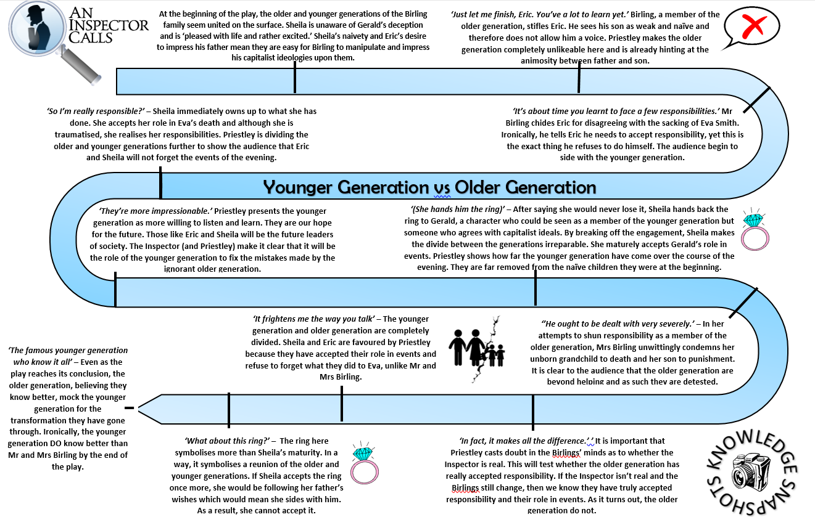
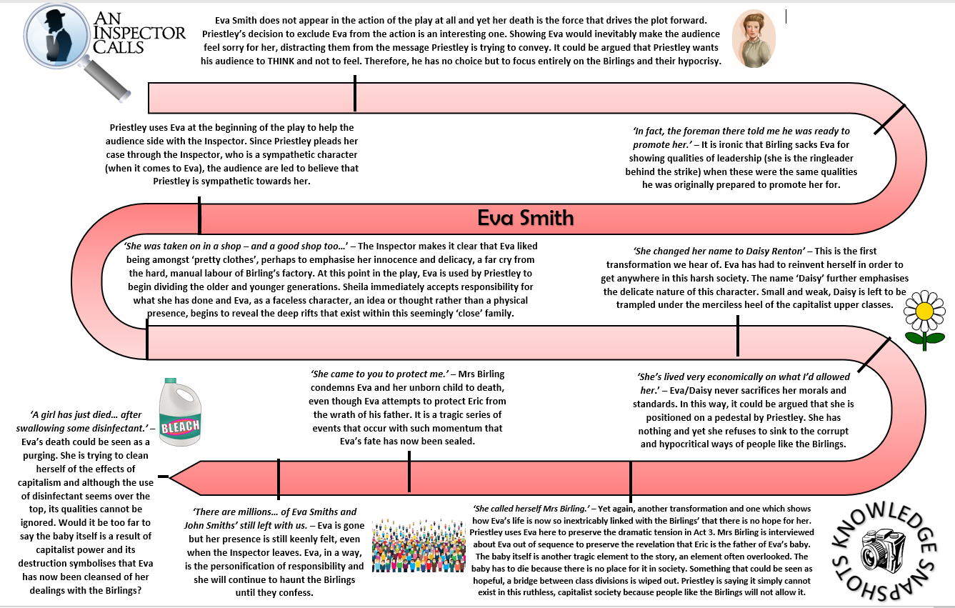
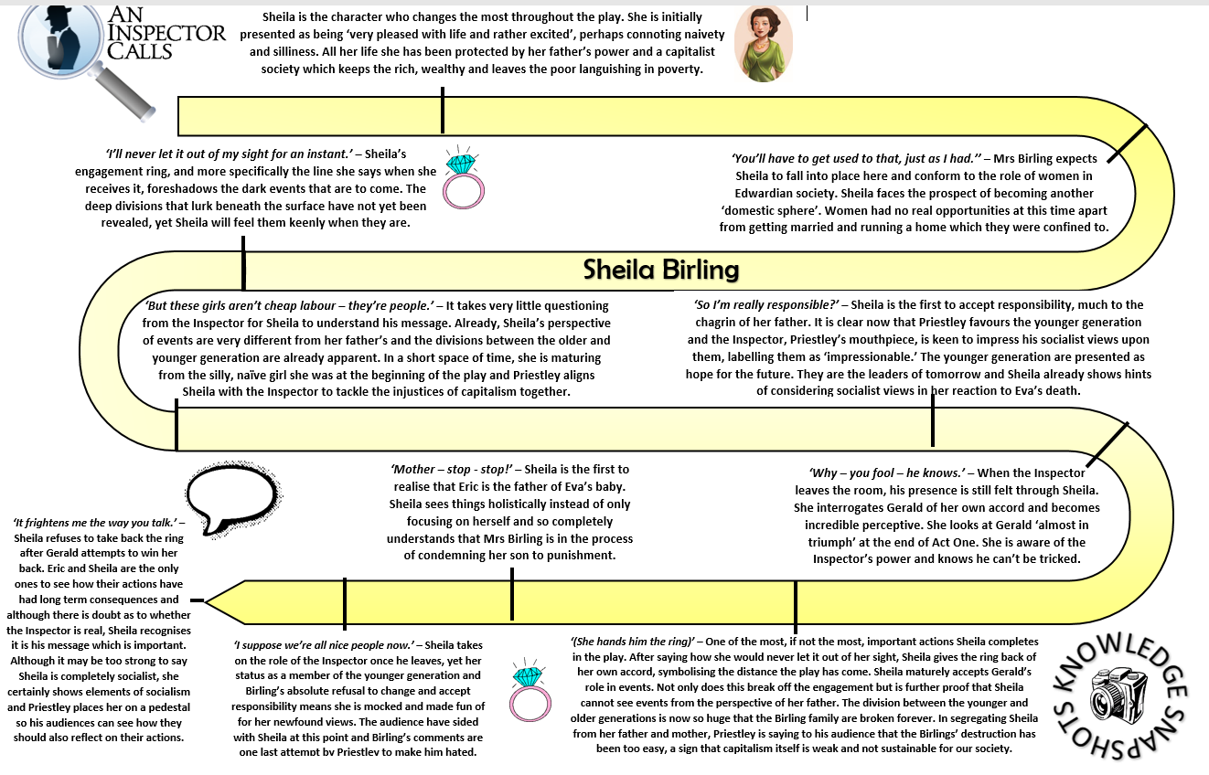
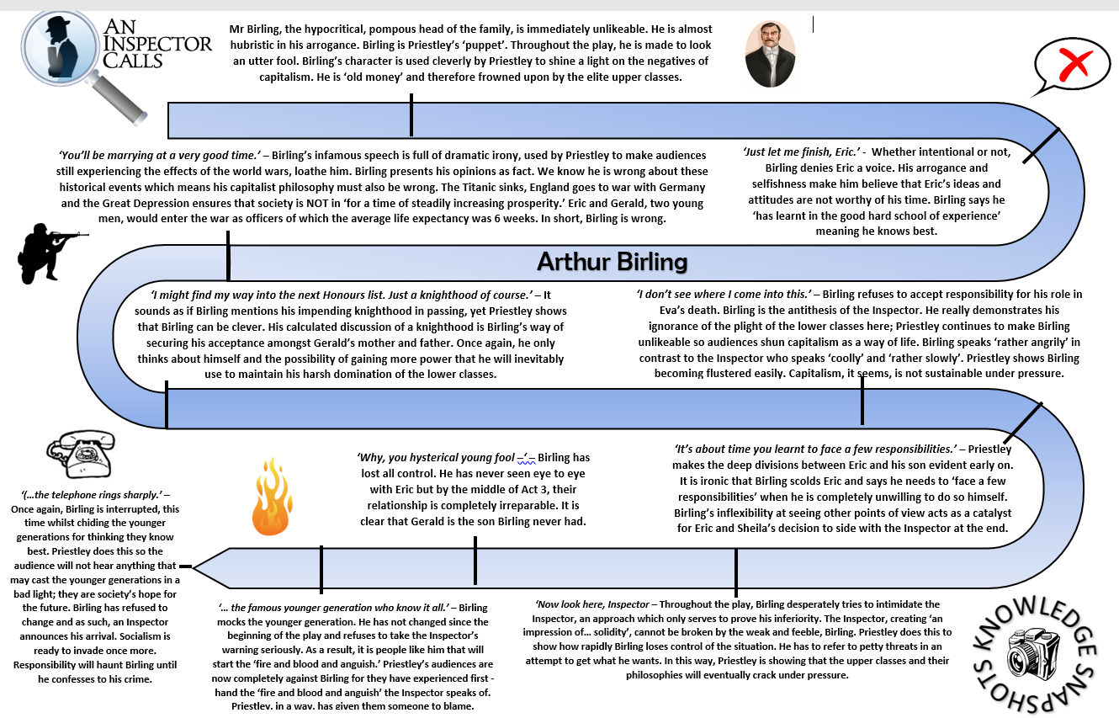
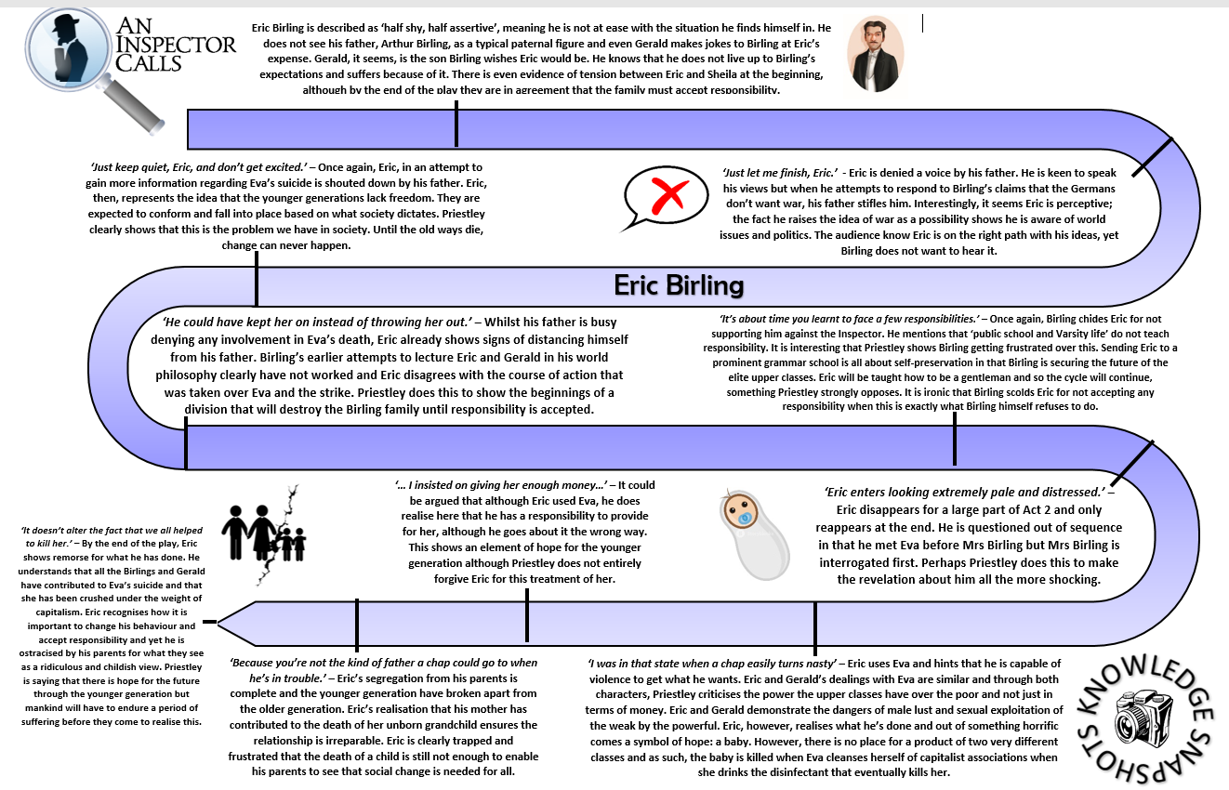
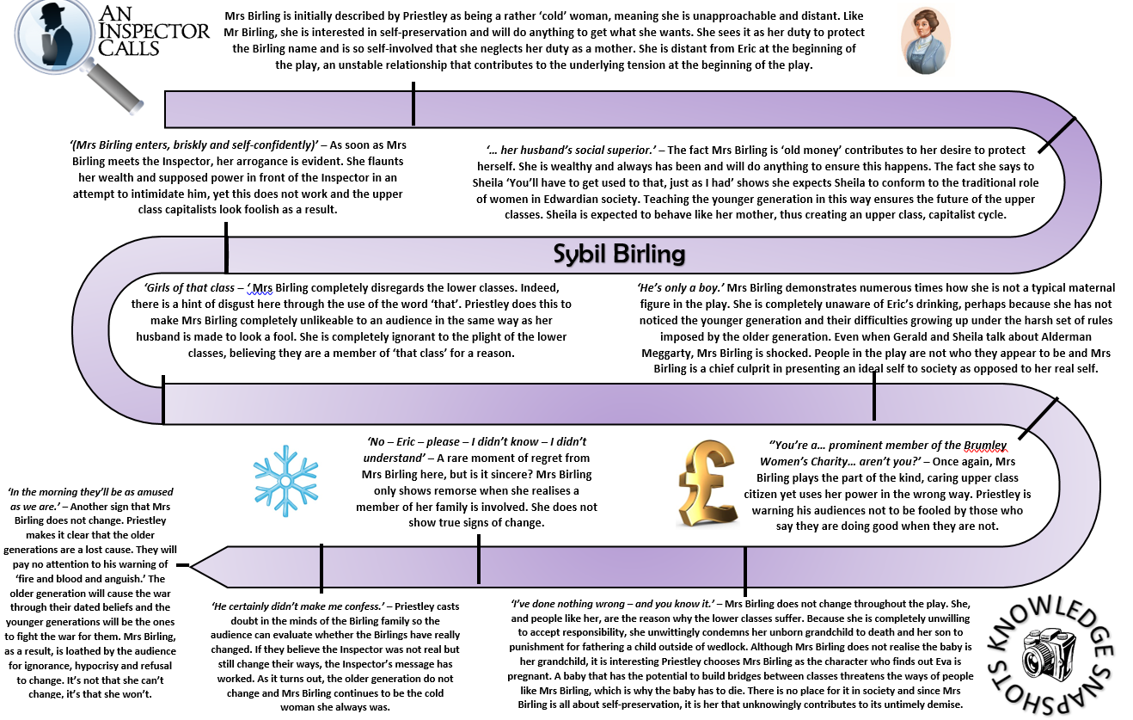
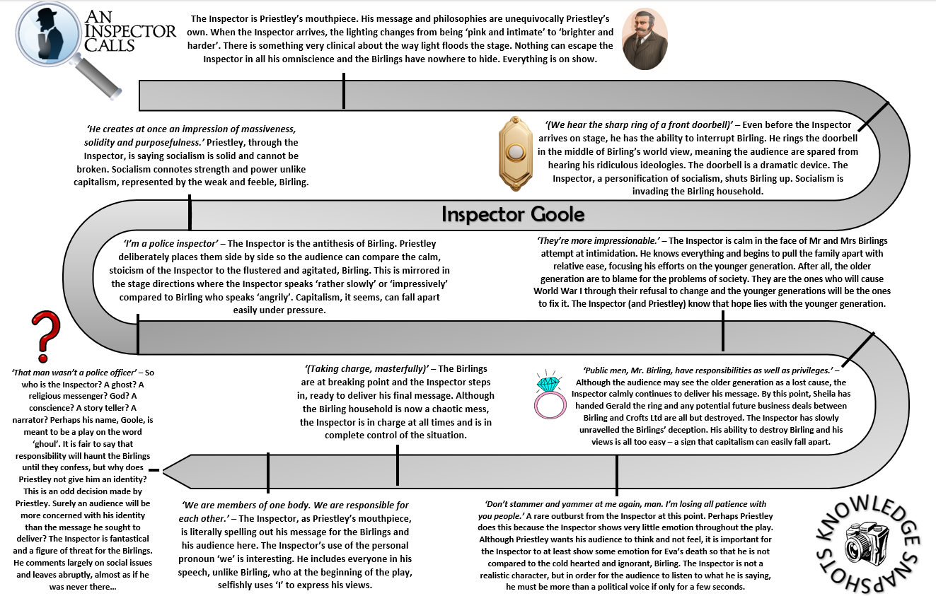

Essay Questions
1) How does Priestley show his ideas about gender inequality in An Inspector Calls??
Write about:
- Priestley’s views on gender inequality
- How Priestley presents gender inequality

2) How does Priestley present ideas about guilt in An Inspector Calls?
Write about:
- How Priestley presents the different characters reactions to guilt
- How Priestley presents the theme of guilt by the way he writes

3) How does Priestley present different ideas about blame and taking responsibility in An Inspector Calls?

Write about:
- the different ideas about blame and taking responsibility in An Inspector Calls.
- how Priestley presents these ideas by the ways he writes.

4) How does Priestley use Sheila’s change throughout the play to present his ideas?
Write about:
- How Sheila responds to her family and to the Inspector
- How Priestley presents the change in Sheila by the way he writes

5) How does Priestley use his play to comment on the issues greed & obsession with money created in society?
Write about:
- the different ideas about greed and obsession with money in the play
- How Priestley presents these ideas by the way he writes

6) ‘Sometimes a man has to look after himself and-‘
To what extent does Priestley present Mr Birling as a selfish individual?
Write about:
- the way Birling speaks and behaves in the play.
- how Priestley presents these ideas by the ways he writes.

7) How does Priestley show the different attitudes between two characters in An Inspector Calls?
Write about:
- the different attitudes of two different characters
- how Priestley presents these ideas by the ways he writes.

8) ‘An Inspector Calls is written as a warning to society’
To what extent to you agree with this statement?
Write about:
- how the characters and ideas are a warning to society
- how Priestley presents these ideas by the ways he writes.

9) ‘The conflict between the Inspector and the Birlings is central to An Inspector Calls’
To what extent to you agree with this statement?
Write about:
- how the conflict between the Birlings & the Inspector is/is not central to the play
- how Priestley presents these ideas by the ways he writes.

10) How does Priestley use Eva Smith to comment on the exploitation of the lower class, in An Inspector Calls?
Write about:
- how Eva Smith is exploited in the play & how else we see the lower classes exploited
- how Priestley presents these ideas by the ways he writes.

