Comparison Bar Graph for groyne survey
Clear comparison between North and South side drops of the groyne. Easy to show effect of groyne and also longshore drift direction Additional graph to show average of results could be created

Radar graph used for Bipolar Survey Results. Clear visual representation of results. Easy to compare between, and evaluate the success of, the three different engineering types. Larger area within the star shows a higher rating.
Located scaled cross-profiles for beach profiles. Shows line graph scale of each beach profile taken in relation to the groyne position. Allows located data to show influence of groynes. Surface/area graph with all profiles overlaid onto each other is easier to compare results
Location Where did you go and why?
- Hornsea, Holderness Coast, East Yorkshire
- Accessible to all students, nearby for coach travel. Hard engineering methods in place
RISKS: Tides (check with coastguard before visit).
Weather (Advised to wear sensible clothing)
Falls (Advised on footwear)
Method What data collection techniques did you use? Describe what you did and how they help to answer your question
Primary (data that is collected first-hand):
- Beach Profiles – 4 beach profiles carried out between 2 groynes using clinometers and tape measures. Measured change in slope up the beach from the sea. Allowed us to see change in beach morphology (shape) as it affected by the groynes and longshore drift. Systematic sampling. Quantitative data of angles and distances produced
- Groyne survey – Height of the drop on north and south sides of four groynes measured using tape measure and compass. Allowed us to see the impact of the groynes in trapping sediment and determine the direction of longshore drift. Systematic sampling used to cover selected area. Quantitative data produced
- Bipolar Survey – Three sea defences (sea wall, groynes, rock armour) rated across 8 categories (erosion protection, flood defence, aesthetics, accessibility, disruption, lifespan, natural disturbance). Quantitative data produced
Secondary (After original investigation from existing sources)
- Aerial Photo. From Google Earth to show wider impact of groynes
Geographical Enquiry: Key Question Describe the geographical theory/concept underpinning the enquiry
Hard Engineering protects the beach at Hornsea

Evaluation of data presentation: List the ways you presented the data, why did you use these? What did they show?
Include possible alternatives
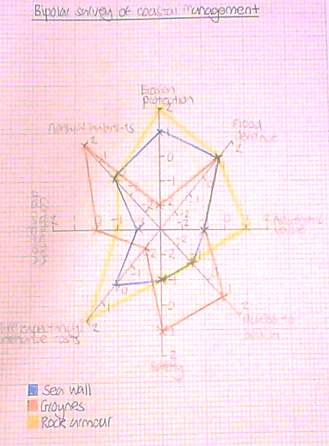
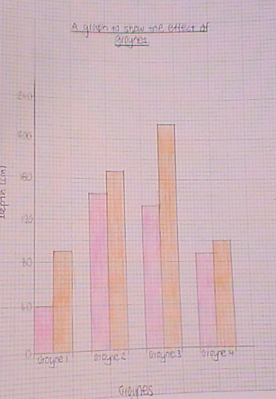
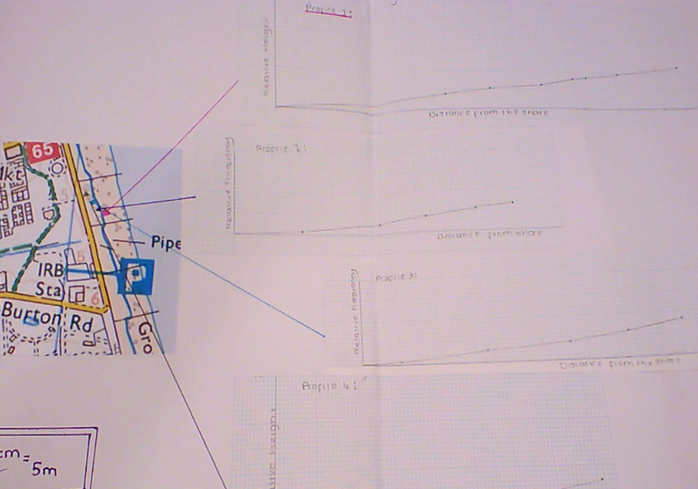
Analysis: Did you use any manipulation of data, such as range, %, mean, Spearman? If so why and what were the outcomes?
Range – of depth on the groyne surveys: difference from highest drop (south side) to lowest drop (north side) was 180cm. of height on the beach profiles: difference from largest beach profile height (Profile 1 furthest from the active groyne) to the smallest beach profile height drop (Profile 4 just south of a groyne) was 0.75m
% - 62% of results of the bipolar survey showed neutral or positive results for sea walls, 50% for groynes and 50% for rock armour. 100% of the groynes showed a difference between North and South sides
Mean – the mean average difference between north and south sides of the groyne was 121cm, with the mean average drop on the south side (longshore drift moving sediment away) was 143cm and the collected side (north side) was 22cm.
The use of data manipulation gives clear evidence to support the hypothesis as it allows direct comparison of the bipolar results rather than only visual based on the graph. It allows numerical evidence to show that groynes are affecting the shape of the beach and sediment trapped.

Conclusion:Hard Engineering does protect the beach at Hornsea with the evidence for the effect of the groynes being most evident in the results. The beach profiles show the beach has built up on the north side of the groyne, and lowered on the south side showing the groynes are preventing longshore drift. The groyne surveys support this with an average difference of 121cm between north and south sides. (Some groynes had no drop on the north side as they were ‘full’ of sediment) Challenge: To what extent can this conclusion be considered valid? Have you collected enough data to prove the beach is protected?
Evaluation of data collection: List each data collection technique and describe how you would improve it
- Beach Profiles. Shows change in beach morphology due to groyne influence. Easy to compare between profiles. Only a small area sampled so an extended survey area past the sea defences would be beneficial. Limited by accuracy of clinometer use – a laser measure could be more accurate, or repeat angles to take an average
- Groyne Survey. Only cheaper equipment needed to complete. Easy to complete accurately. Time consuming to walk distances between the groynes and measure accurately, only a small sample taken. Larger sample would improve accuracy, as well as taking into account the distance along the groyne measured.
- Bipolar Survey. Evaluates the different techniques on the same criteria so easy to compare – no equipment needed. Opinion based only – would need additional secondary data to fully evaluate effectiveness. Could have combined range of opinions to create an average.
Secondary (After original investigation from existing sources)
Aerial Photo. Larger scale area effects shown from above of groynes. Only fixed point in time, doesn’t show continual protection or change

Fieldwork Mastery Sheet – Physical/Human Crossover

