Geographical Enquiry: Key Question Describe the geographical theory/concept underpinning the enquiry
What impact has the regeneration of Kelham Island had on the locality?

Radar graph used for Environmental Quality Survey Results. Clear visual representation of results. Easy to compare non-regenerated and regenerated areas. Larger area within the star shows a more positive EQS score.
Annotated photographs/fieldsketch.
Highlight changes in physical characteristics of areas. Easy to compare. Static point in one place, could be geo-located
Evaluation of data presentation: List the ways you presented the data, why did you use these? What did they show?
Include possible alternatives
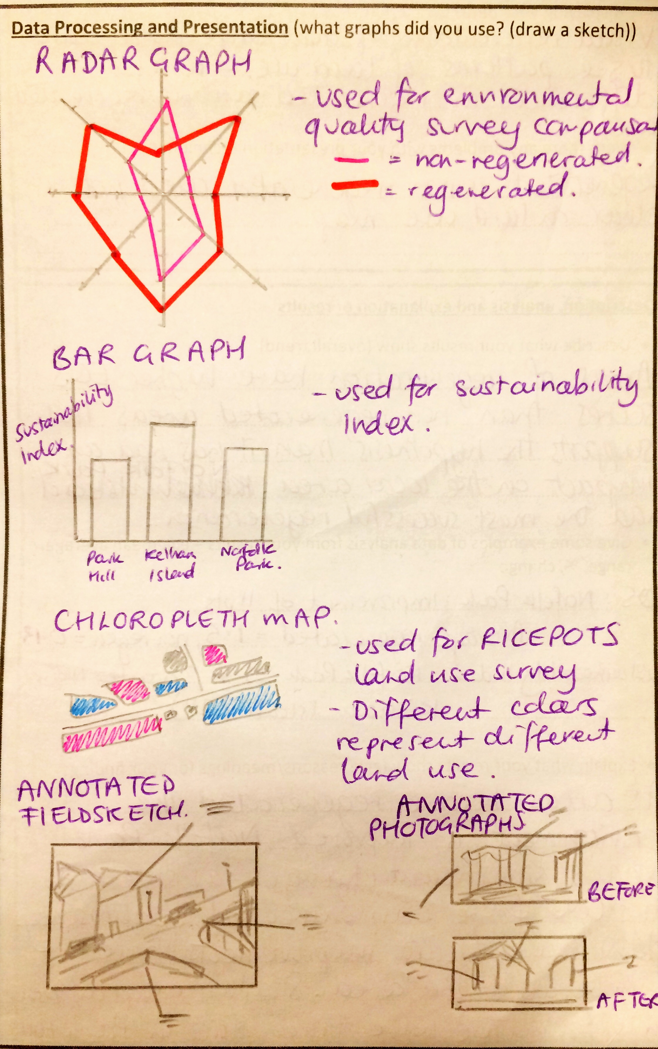

Analysis: Did you use any manipulation of data, such as range, %, mean, Spearman? If so why and what were the outcomes?
Range – in the EQS, the range in results was 3 for the non-regenerated area (-2 to +1), whereas for regenerated area it was 1 (+1 to +2).
% - 50% of results of the EQS in the non-regenerated area were negative. 75% of results of the EQS in the regenerated area were +2.
House prices secondary data. Over the past 5 years property values in Kelham Island have risen by 21.5% (Zoopla) with sold prices having been up 4% in 2017 compared to 2016 (Rightmove)
Mean – the mean average for the non-regenerated area EQS was -0.375, the mean average for the regenerated area EQS was 1.75.
The use of data manipulation gives clear evidence to support the hypothesis as it allows direct comparison of the EQS results rather than only visual based on the graph.
% could have been applied to the land use survey to calculate the number of buildings of each type of land use. This could be extended to then compare in regenerated to non-regenerated areas to see how it compared.

Conclusion: Areas of regeneration in Kelham Island have improved environmental quality with less vandalism, higher attractiveness and more vegetation. Land use has changed with a lower number of empty and derelict buildings and a higher number of residential properties. House prices have risen alongside this with a 21.5% in property values over the last 5 years.
Challenge: To what extent can this conclusion be considered valid? Have you collected enough data to prove these effects are down to regeneration?
Chloropleth map used for land use survey. Visual representation of qualitative data by using a key for the RICEPOTS classification. Allowed easy view of spatial patterns to see differences in regenerated and non-regenerated areas. Not easy to define regenerated and non-regenerated areas. Could produce a pie chart to show % of each land use type in each area
Method What data collection techniques did you use? Describe what you did and how they help to answer your question
Primary (data that is collected first-hand):
- Environmental Quality Survey – carried out in a regenerated and non-regenerated area on the same 8 factors (Vandalism, Litter, Air pollution, Noise pollution, Paving Quality, Building Attractiveness, Street planning, Vegetation). Allowed us to see clear impacts and any differences due to regeneration. Random sampling. Quantitative data produced
- RICEPOTS Land Use survey – Classified land use of the ground floor of each building (e.g. Residential, Industrial, Open Space). Allowed us to look at patterns of land use in Kelham Island and link to changes in land use in regenerated areas. Systematic sampling used to cover selected area. Qualitative data produced
- Photographs/Fieldsketch – Annotated to show visual differences in environment
Secondary (After original investigation from existing sources)
- House Prices. Use data from Rightmove online property website to look at change in house prices in Kelham Island.

Location Where did you go and why?
- Kelham Island, Sheffield
- Accessible to all students, nearby for coach travel. Evidence of recent and on-going regeneration
RISKS: Traffic (use crossing points and pavements).
Getting lost (Emergency contact number, arranged meeting points and times)
Evaluation of data collection: List each data collection technique and describe how you would improve it
- Environmental Quality Survey. Easy to use with no specialist equipment, allowed comparison between regenerated and non-regenerated areas. Based on opinion and visual evidence only. Specialist equipment such as CO₂ detectors, decibel meters could increase repeatability and accuracy. Set categories for qualitative measures could reduce personal bias (e.g. 4 or more trees in set area = +2 for vegetation).
- RICEPOTS Land Use survey. Set categories produced as a standard measure. Difficult to judge exact use if no clear signs, would need to survey property owners to be more accurate. Only covers ground floor of multi-level properties.
- Photographs/Fieldsketch. Visual evidence to allow direct comparison. Fieldsketch allows annotation at the time. Would need to repeat visit on the same site to see regeneration differences. Bias difficult to overcome.
Secondary (After original investigation from existing sources)
House Prices. Allows comparison over a longer period of time with historical data. Monitor the same properties within regenerated and non-regenerated areas.

Fieldwork Mastery Sheet - Human

