COMPONENT 2:

Christianity

Beliefs and teachings
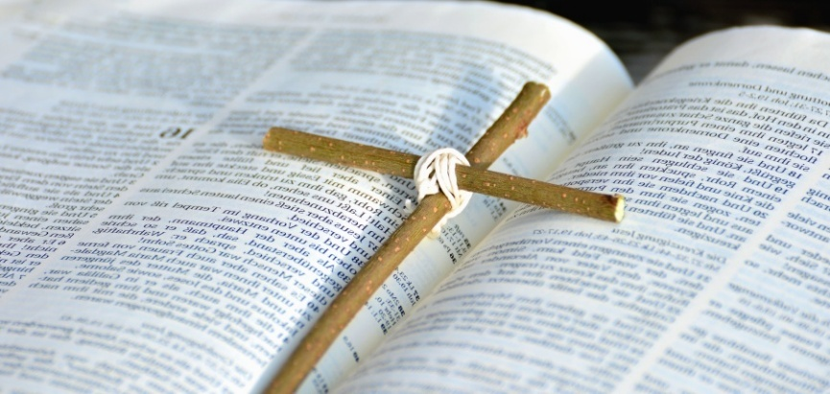

Use this revision guide as a tool to revise for Component 2 – Christianity.

All the content in this revision guide could appear on your exam paper.

Learn the 8 key concepts below – these could be any of the 2 marker questions.

KEY CONCEPTS

Omnipotence- the belief that God is all powerful
Omnibenevolence- the belief that God is all loving
Trinity – The Three persons of God – God the Father, God the Son and God the Holy Spirit
Incarnation- the belief that God came to Earth in a human form as Jesus
Resurrection- coming back to life in the same body e.g. Christians think Jesus was resurrected
Atonement- making up for the things you have done wrong e.g. praying to be forgiven
Sacraments – an outward sign of an invisible and inward blessing by God E.g. Baptism
Evangelism – preaching the gospel to others with the intention of converting others to Christianity

BELIEFS
The Nature of God

KEY CONCEPTS:
Omnipotent - the belief that God is all powerful
Omnibenevolence- the belief that God is all loving

When discussing the nature of God, we are discussing what it is that God is like for Christians and how they see Him. Christians are monotheists which means they only believe in one God.

When Christians refer to the ‘Nature’ of God they are talking about what God is like. What qualities he possesses etc.

Below is a list of key Christian beliefs about God:

- God is ETERNAL, beyond time and space
- God is the CREATOR of the world and everything in it.
- God is perfectly good and perfectly loving.
- God is OMNIPRESENT. He is not limited by a physical body therefore he is able to be everywhere at all times.
- God is OMNIPOTENT or all powerful
- God is OMNISCIENT or all knowing
- God is OMNIBENEVOLENT or all loving
- God is TRANSCENDENT. This means that he is outside of time and space. He is above and beyond human beings.
- God is however also IMMANENT. This means that he can God is able to work through time and space through miracles for example. This enables humans to get closer to God and to know what God is like.
- God is SELF-EXISTING. This means that God does not need anything to have caused him to exist.
- God is NECESSARY. This means that God cannot not exist.

The Bible also contains other beliefs about what God is like.

Exodus 7-11  Where God sends 10 plagues  (shows God’s omnipotence) | Quote is too long so here is an overview!  The Plagues of Egypt, also called the ten biblical plagues, were ten calamities that, according to the biblical Book of Exodus, Yahweh inflicted upon Egypt to persuade the Pharaoh to release the ill-treated Israelites from slavery.
Exodus 14:21  (shows God’s omnipotence) | ²¹ And Moses stretched out his hand over the sea; and the Lord caused the sea to go back by a strong east wind all that night, and made the sea dry land, and the waters were divided.
Psalm 86:15  (shows God’s omnibenevolence) | ¹⁵ But you, Lord, are a compassionate and gracious God,  slow to anger, abounding in love and faithfulness.
John 3:16  (shows God’s omnibenevolence in sending Jesus to atone for human sins) | ¹⁶ For God so loved the world that he gave his one and only Son, that whoever believes in him shall not perish but have eternal life.
Romans 8:37-39  (shows God’s omnibenevolence) | ³⁷ No, in all these things we are more than conquerors through him who loved us. ³⁸ For I am convinced that neither death nor life, neither angels nor demons,^{[a]} neither the present nor the future, nor any powers, ³⁹ neither height nor depth, nor anything else in all creation, will be able to separate us from the love of God that is in Christ Jesus our Lord.

The Trinity

KEY CONCEPT:
Trinity - The Three persons of God – God the Father, God the Son and God the Holy Spirit

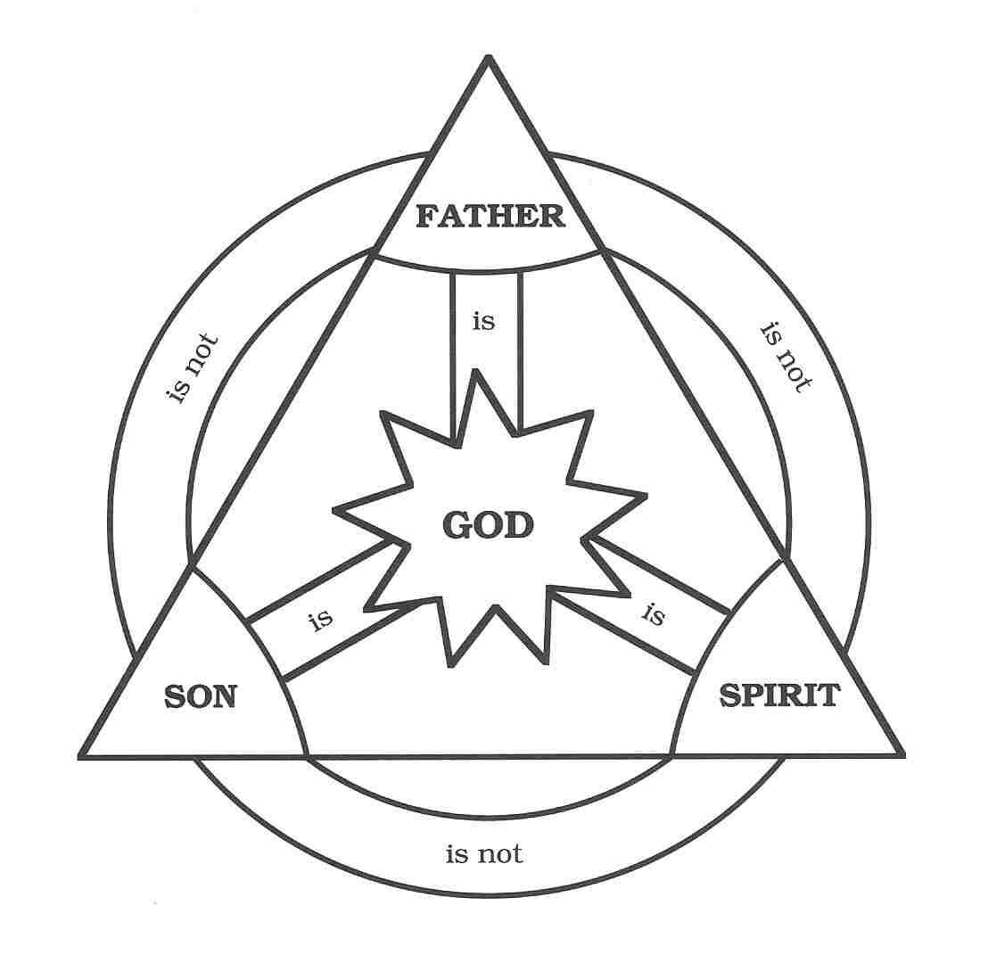
One of the ways that Christians try to express what God is like is through the DOCTRINE OF THE TRINITY (doctrine means teaching). This belief tries to express how God can be understood in three different ways: as God the father, as God the son and as God the Holy Spirit. This does not mean that there are three different Gods as Christians are monotheists and just believe in one God. The doctrine of the trinity shows how Gods relationship with humanity works in different ways.

God the father
Calling God, the father is a way of showing belief that God created and sustains everything. It is also a way of showing a close and loving relationship, where the father cares about his children and they can rely on him. Some Christians also talk about God as a ‘mother’, to show that God is not limited to being either male or female.

God the son
Christians believe that Jesus of Nazareth was the son of God (God incarnate). They believe that God chose to come to earth as a man, to teach people the right way to live and to sacrifice himself so that people could be forgiven for doing wrong. They believe that after Jesus was crucified, he rose from the dead (the resurrection) and showed that God has power over death. Christians believe that the death and resurrection of Jesus made it possible for them to have salvation.

Christians therefore believe that the death of Jesus made it possible for man to get back closer to God again. This is called atonement – Jesus atoned (paid for) for the sins of mankind.

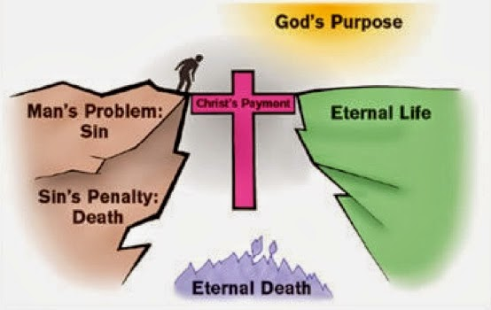
God the Holy Spirit

Christians believe the H.S guides Christians in their daily lives giving them strength and guidance. Shows God’s immanence. Christians believe that before his resurrection Jesus told the disciples he would send a ‘comforter’ or guide.

This happened when the disciples were gathered for Pentecost. After Jesus rose from the dead and went back into heaven (the ascension), God sent the Holy Spirit to live on in the world in the lives of Christians, giving them courage, comforting them, inspiring them and guiding them in their decisions. At Pentecost (as recorded in Acts 2:1-4 in the Bible), the disciples were gathered after Jesus had ascended (gone up) to heaven they received the H.S. This is described as like tongues of fire on their heads. Once this had happened the disciples went out and spoke to people of all nations in tongues.

Christians today sometimes believe that they can also share in the gift of the spirit and speak in tongues. Many feel the H.S can work through people today to heal, guide etc. (esp. The Pentecostal Church). An example: Toronto blessing – people at a church gathering started rolling around on the floor, laughing etc. as they were overcome with the Holy Spirit. The Christian St Paul said that there are ‘fruits of the spirit’ that show the spirit works in people. The fruits are joy, peace, love etc. (Galatians 5:22-23). Christians believe it inspires and gives them charismatic gifts such as the ability to heal and preach and speak in tongues like disciples did. (esp. The Pentecostal Church).

In Christian art, the Holy Spirit is often shown in the form of a dove, a symbol of peace and hope.

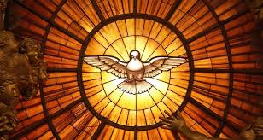

Christian Views on Creation


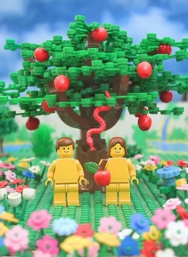
Genesis 1
ORIGINS OF THE WORLD
Genesis 2
ORIGINS OF HUMANITY
Genesis 3
THE ORIGINAL SIN/THE
FALL OF MANKIND

There are two accounts of creation in the Bible: the creation of the world and the creation of man.

Genesis 1:
In the story of the creation of the world in Genesis 1, God creates the world in 6 days and rests on the seventh. On day one he creates light and darkness, on day two the sea and sky, on day three the land and plants, on day 4 the sun and moon, on day five the fish and birds, on day 6 animals and humans. On day 7 God rests, looks at his creation and says it is good.

Genesis 2:
The second account is the creation of man in Genesis 2. God took some clay from the ground and made the shape of a man. Then He breathed gently into the shape. The man's eyes opened, and he began to live. God called him Adam. The Lord made a beautiful garden for him to live in. The garden, called Eden, was full of many wonderful things. God had made the man in His image to keep Him company and look after the world. That night, God took a rib from Adam's side and made a woman. When Adam awoke the following morning, he found a wife, Eve, lying asleep beside him. God told the man and woman that it was their job to take care of their new home. God blessed them.

Genesis 3:
This is the story of how Adam and Eve disobeyed God in the Garden of Eden by eating the fruit off of the Tree of Knowledge of Good and Evil.

What did God say would happen to Adam and Eve if they ate the fruit from the tree in the middle of the garden? | He would surely die
Who tempted Eve to eat the fruit off of the tree? How did they tempt Eve (what did they say?) | Serpent – said surely God did not say you will surely die?
Who ate the fruit off of the tree first? Second? | Eve and then she gave it to Adam
What did Adam and Eve realise straight after they ate the fruit and what did they do as a result? | they were naked
What did Adam and Eve do when they heard the sound of the Lord God as he was walking in the garden? | hid as they were ashamed and embarrassed, they were naked.
What did God say to them? | Who told you that you were naked? Did you eat of the tree?
Who did Adam blame? Who did Eve blame? | Adam blamed Eve and Eve blamed the serpent
What punishments did God give to:  Adam? Eve? The serpent? | Adam – toil the ground  Eve – pain in childbirth  Serpent – crawl on his belly
What was the ultimate punishment that Adam and Eve got as a result of their actions? | Clue: Romans 5:12 (new living translation) ‘When Adam sinned, sin entered the world. Adam's sin brought death, so death spread to everyone, for everyone sinned.’

The Fall refers to when Adam and Eve fell from God’s grace after the disobeyed him in the Garden of Eden by eating the fruit off the Tree of knowledge of Good and evil in the Garden of Eden.

The ‘original Sin’ refers to the sin which Eve (and Adam) brought into the world when she picked and ate the fruit from the Tree of the Knowledge of Good and Evil in the Garden of Eden. God had told them not to do this. It was therefore the first sin of humankind.

Liberal and Fundamental/literal Christian’s interpretations of the creation story
Liberal Christians believe that Genesis is a story with a deeper meaning, they believe that science and religion do not have to necessarily disagree about how the world was created. Liberal Christians believe that:
- Genesis is a story which tells us about Gods love for creation. It tells us WHY there is something rather than nothing however it does not tell us HOW the world was created.
- They therefore believe that God could have created the Big Bang. They could also believe that God created the process of evolution and that it was part of his/her plan for humans to develop in this way.
- A day could referred to a literal 24-hour period or it could be translated to mean an unspecified longer period of time. Therefore, liberal Christians may believe that each ‘day’ in Genesis is really meant to represent a much longer period of time than 24hours.

Fundamental /Literal Christians believe that the world was created as it states in Genesis.
They believe that Genesis is a literal and therefore historical account of how the earth was created.


GRADE BOOST - Some use the story of the creation of Adam and Eve to justify the claim that men are more superior than women since Adam was created first and Eve was created to be Adam’s ‘helper’.

What do these stories tell us about: God, humans and the world?
God
- God is the sole and omnipotent creator
- God is the source of everything in the universe an sustains it
- God created the universe and it was ordered not chaotic
- Every aspect of God’s creation was good: that it, it fulfilled His purposes for it.

Humans
- Human beings are created in God’s image, so they reflect God’s capacity for creativity. Humans therefore have potential. All human lives are of value, regardless of their physical, mental and intellectual capacity.
- Human beings are given authority over the rest of the world God created. We should treat it responsibly – as stewards.

The World
- The universe does not exist by chance and gives human lives meaning and purpose

The Role of Word and Spirit in Creation

During the creation of the world, God is seen as the main creator. However, the Bible also indicates that the other members of the Holy Trinity were present at creation in the form of The Word and The Spirit.

“The Word Became Flesh 1In the beginning was the Word, and the Word was with God, and the Word was God. 2He was with God in the beginning. 3Through him all things were made; without him nothing was made that has been made. 4In him was life, and that life was the light of all mankind. 5 The light shines in the darkness, and the darkness has not overcome it”. (John 1:1-5)

The Word: God speaks in order to start the creation process (‘Let there be light’). Christians believe the world was created ex-nihilo (out of nothing), until God commands things to come into being. Jesus is seen as the Word (Jesus is referred to as logos which means word in Greek) so Christians believe that Jesus was directly involved in creation.

The Spirit: By the Spirit, we mean the Holy Spirit. In Hebrew, the word for Spirit means ‘wind’, or ‘breath’. In the Bible it says ‘In the beginning God created the heavens and the earth. The earth was without form, and void; and darkness was on the face of the deep. And the Spirit of God was hovering over the face of the waters’. From this we can infer that the Holy Spirit was also present at the start of the world and involved in creation.

In Genesis 1 we also have reference to the Spirit of the Lord hovering over the waters. If Christians believe in the Trinity, then they would believe this existed before creation. This shows the spirit part of God in action – creating - transforming chaos into order.

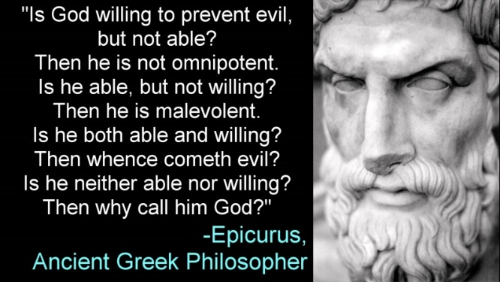
The Problem of Evil
As Christians believe that God is omnibenevolent and omnipotent, evil raises a problem. Why does God let bad things happen if he is omnibenevolent & loves humans, he should stop the bad things from happening? If God is omnipotent then he should be stopping suffering, so either God is not omnipotent or maybe God does not exist.

Christian responses to this problem:
- God is transcendent, therefore there is a reason that God allows suffering, but we might never fully understand why. For Christians they believe that they should trust God.
- We are being punished for the sin of Adam and Eve in the Garden of Eden as we are descended from them. (St Augustine believed this and it is therefore referred to as the Augustinian theodicy. Augustine said that humans are ‘seminally present in the loins of Adam’ therefore we are all born with the stain of their sin on our souls and deserve punishment.
- We are not put on this earth to experience maximum pleasure and minimum pain but to grow spiritually, it is a process of ‘soul making’. Suffering helps to do this. It helps us to get stronger and show we are ready or ‘fit’ for heaven. This idea was put forward by St Irenaeus and is referred to as the Irenaean theodicy.
- Some claim that evil doesn’t exist! Perhaps suffering is an illusion. Diseases for example don’t have the primary aim of causing suffering, rather they are fulfilling their purpose to grow and thrive.
- FREE WILL - evil has to exist in order for people to choose to do good over bad as without this God would not know who is worthy of heaven and hell.
- Suffering is part of Gods plan – we as humans do not understand this but just have to accept it.

The story of Job:
The Bible tells the story of a man called Job who is described as a good man who loves God. Satan challenges God, saying that Job is only good because he has a happy life. God allows Satan to put Job’s faith to the test by causing him to suffer.
First, Job loses his livestock, his servants and all his children. He is devastated, but he remains faithful and praises God. Then he suffers horrible weeping sores all over his body. Job’s wife tells him to reject God and to accept that he is dying, but Job refuses.
Eventually, God appears to Job. He asks impossible questions that show Job how little he can understand about God’s ultimate plan. Job is humbled by this encounter, and at last appreciates that God’s unlimited power cannot be fully understood by human beings.
Job never learns why he suffered, but God restores his health and gives him twice as much property as before, more children and a very long and prosperous life.

The Bible
The Bible is a sacred text or scripture for Christians. It is split into two sections comprising of 66 books; the Old Testament which contains the creation stories in the book of Genesis, the Commandments that God has set for humanity to live by and the history of the Jewish people. The second half of the Bible is called the New Testament, this contains the Gospels (Matthew, Mark, Luke and John) which record the life of Jesus and his teachings; and the development of early Christianity.

There are different interpretations of the bible.
- Literalist or Fundamentalists believe that is the direct word of God with some believing it is God’s actual words. This would mean that when science seems to contradict the bible (e.g. creation stories), they would believe the biblical account over the scientific one. For Fundamental Christians, the bible is the most important source of authority.

- Others, such as liberal Christians believe that authors were divinely inspired by God to write the words they did but accept that the stories may contain some minor errors due to humans not being perfect. They would also argue that the bible was written in a specific time and culture, and some teachings may therefore need adapting to apply in modern society.
For all Christians, the Bible is a book of revelation. This is because they believe that through the Bible, God is revealed, and they can know more about him. Christians also believe that the Bible is a record of divine law – the rules and law of God by which Christians choose to live. So, the Bible is a source of authority for all Christians who turn to it for advice about how to live their lives. In particular, the teachings of Jesus help inspire Christians to live good lives. Many Christians read the Bible on a daily basis, and a reading is present in every Christian service.
The Bible is also important to Christians because of the way in which it enables Christians to live the best Christian life. The Bible is a collection of teachings and rules which inform people how they should behave, for instance they could follow the guidance in the Ten Commandments indicating that stealing and killing is wrong. In addition to this the Bible can also provide Christians with information about the history of their religion and it can also teach Christians about the nature of God, for example God being all loving is demonstrated in through the crucifixion of Jesus as God gave His only son so that the sins of the world could be forgiven.
GRADE BOOST - Some may argue that the Bible should not be the ultimate source of authority for Christians as it was written over 1,000 years ago and might not be relevant in the 21st century. Additionally, there are contradictions within the Bible which may provide conflicting advice e.g., ‘Man should lie with a man as he does with a woman, it is an abomination’ and then later ‘Love your neighbour.’

The Life of Jesus

KEY CONCEPTS:
Incarnation – God becoming human in the form of Jesus
Resurrection – The belief that Jesus rose from the dead on Easter Sunday, conquering death.

Arguably the most important person in all of Christianity, Jesus’ earthly life was cut short with his crucifixion at the age of just 33. Although we know a lot about the last parts of his life, his first 30 years are largely unaccounted for. His life can be split into four main stages: Incarnation, Crucifixion, Resurrection and Ascension.

Key terms:
- Miracle worker - Performed miracles such as the feeding of the 5000, walking on water, healing of a blind man etc. shows his divine as well as human nature.
- Teacher - Jesus was regarded as a moral guide. He used parables and spoke to people in the Sermon on the Mount.
- Crucifixion - The death of Jesus upon the Cross
- Saviour - (Christianity) Jesus Christ regarded as The Saviour of men from sin
- Atonement - To make amends - the belief that Jesus’ death on the cross healed the rift between humans and God
- Ascension - Jesus going up to heaven after his resurrection (occurring 40 days after the resurrection)
According to Christianity, Jesus was God incarnate. He is believed to have been a miracle worker and moral teacher, helping to guide people in the right way to act and ultimately to get closer to God.
Christians believe that he came to earth to atone for human sin and restore the relationship between mankind and God (which was destroyed through the original sin). He did this through his death and resurrection – offering salvation for all mankind.
After his resurrection, Jesus ascended to heaven. Christians believe that God then sent the Holy Spirit to comfort and guide them in their daily lives.

Incarnation

What Is It? | What Happened? | Why is it Important?
God coming to Earth in the human form of Jesus. | - Angel of the lord visited Mary and told her that she would become pregnant and name the child Jesus  - She asked how this could be as she was a virgin  - The angel said that the holy ghost would come upon her  - Joseph, on finding she was pregnant, left her quietly  - Then he had a dream where the angel of the lord told him that she was pregnant by the holy ghost and he should marry her and call the child Jesus  - Baby born in Bethlehem in a stable  - Shepherds in nearby fields visited by angel who tells them a saviour is born. They visit him to pay respects and then spread the word  Commonly known as the Nativity story. Mary became pregnant by the power of the Holy Spirit despite still being a virgin (known as the Immaculate Conception). She gave birth to Jesus (Virgin Birth) in a stable in Bethlehem. | Shows God’s clear love for the human race (his omnibenevolence) and the fulfilment of his promise to send a Messiah (promised one) to save humanity from sin. Jesus was a role model, showing people how to live a good life, and also as a sacrifice.

Crucifixion

What Is It? | What Happened? | Why is it Important?
Roman method of execution, common form of the death penalty used throughout the Roman Empire.  Jesus nailed to a cross and died as punishment for his ‘crimes’ on Good Friday. | Jesus was arrested by the Jewish authorities who were threatened by his growing popularity with the common people.  They took him to the Roman authorities (at the time, Palestine was part of the Roman Empire). The leader of the Romans, Pontius Pilate, agreed to crucify Jesus.  The soldiers mock Jesus and put a crown of thorns on his head.  He is crucified at a place called Golgotha  Two criminals are crucified with him.  Jesus is mocked by people in the crowd who claim that if he is the Messiah then surely he could save himself.  Jesus prays whilst on the cross as says ‘father forgive them for they know not what they do.’  Before he dies, he says: ‘Eli, Eli, lema sabachthani’ which means ‘my God, my God, why have you forsaken me?’ (This echoed the huge amount of sin and sacrifice Jesus went through to take away humanities sin. He was experiencing a broken relationship with God via human sin and separation)  Jesus was crucified on a hill next to other criminals and died. | Christians believe that through Jesus’ death, all sin was able to be forgiven and people are able to go to Heaven.  Jesus is considered to be a Saviour through this act of atonement. Jesus suffered a human death which supports the Christian belief that he was both fully human and fully divine.

Salvation & Atonement

KEY CONCEPT:
Atonement – the Christian belief that the death of Jesus Christ brought about reconciliation between God and humans. Jesus was the saviour or redeemer of the world.

Salvation – deliverance (escape or rescue) from sin and its consequences, believed by Christians to be brought about by faith in Christ.

- The relationship between man and God was destroyed by original sin (Adam and eve). This introduced sin into the world. The relationship between humans and God was broken as a result of this disobedience.
- Original sin means that without redemption a person has no hope for eternal life in heaven with God.
- Christians, therefore believe that God sent Jesus to earth to repair the broken relationship and that through his death Jesus paid the price and ‘atoned’ for human sin.
- This offers humankind salvation, which means they can live on for eternity with God I heaven after death.
- Before Jesus they used animal sacrifices to ‘atone’ or make up for sins that they had committed.
- Jesus became the sacrificial Lamb of God, taking upon himself the sins of the world. Therefore, animal sacrifice was no longer needed.
How is this remembered today?
The last supper was the last meal that Jesus shared with his disciples.
They were celebrating the Jewish festival of Passover.
During this meal he told his disciples that the bread they are eating represents his body and the wine his blood.
He predicts his death and says that through his sacrifice human sins will be forgiven.
This last supper is celebrated in churches today and is referred to as the Lord’s Supper, Holy Communion, and Eucharist, mass.
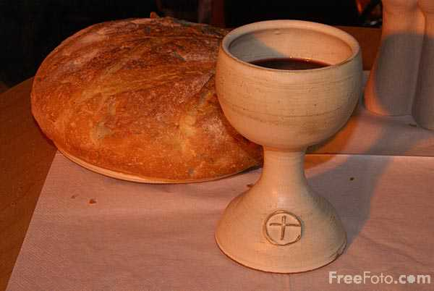

Resurrection

What Is It? | What Happened? | Why is it Important?
Jesus coming back from the dead on Easter Sunday. | Christians believe that three days after his death, Jesus was resurrected. This is because a number of women went to his tomb to properly embalm his body and instead were spoken to by angels who told them Jesus was resurrected. Later, many early Christians including Cleopas, Simon and Thomas were visited by Jesus. | This is proof that Jesus was God’s Son and there is eternal life and that they have a responsibility to share this good news with others.  Supports the belief that God is omnipotent (all powerful) as nobody else is able to resurrect from the dead.  It is seen as the greatest Christian miracle as it is evidence that Jesus was God incarnate.

Ascension

What Is It? | What Happened? | Why is it Important?
Jesus rising up to Heaven 40 days after the resurrection, his body and soul to reunite with God. | After Jesus’ resurrection he was seen by many people over the course of forty days.  Jesus spoke to this followers, instructing them to carry on his work and to spread the word of God:  ¹⁵ He said to them, “Go into all the world and preach the gospel to all creation. ¹⁶ Whoever believes and is baptized will be saved, but whoever does not believe will be condemned.’ Mark 16:15-16  At the end of this, he went up into Heaven to rule over it with God the Father. | For many Christians, the ascension is important because it meant that the responsibility to spread the message of Christianity turned away from Jesus and towards his early disciples, and all Christians that followed.  This is additional proof that Heaven exists. Christians believe that when they die, they will be reunited with Jesus in Heaven because of the ascension.

Salvation & Sin

Sin – an immoral or bad act that goes against divine law
Salvation – Escape or rescue from sin and its consequences, believed by Christians to be brought about by faith in Jesus.

Original Sin
One idea is that Christians are born with original sin, brought into the world when Adam and Eve disobeyed God and were banished from the Garden of Eden. Adam’s sin has been passed down from generation to generation. It is original sin that causes humans to do things in their lives that goes against God’s laws and separates them from God.

Sin and Salvation
Christians generally believe that salvation is achieved by having faith in Christ and following bible teachings such as the 10 commandments (Exodus – Old Testament), the Beatitudes (Matthew) or teachings of Jesus such as the Sermon on the Mount (Matthew 5-7)

Christians believe that Jesus’ death allowed humans the chance of salvation. It did this as:
- Jesus was a sacrifice that paid for human sin.
- Jesus paid the ransom for human sin, which released humans from the desire to reject God and allowed them to be saved.

Different Christian denominations have different ideas about how they should also act to receive that salvation.

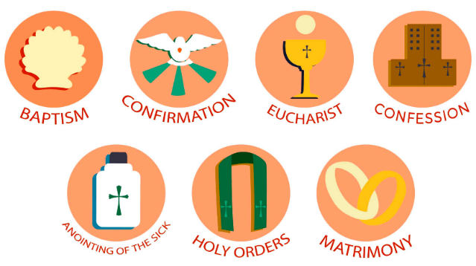
Roman Catholics believe that there are 7 sacraments (an outward sign of an inward belief), through which God can communicate his grace (his saving energy). It is through following these 7 sacraments that Catholics believe they can achieve salvation.

Protestants follow the sacraments of baptism and Holy Communion. Many Protestants believe that they must have faith in Jesus and repent their sins to achieve salvation.

The gift of forgiveness is called God’s Grace and is only possible when you accept God into your life. However, you have to actually be sorry in order to be given God’s Grace and achieve salvation. Saying sorry isn’t enough and you have to atone (make up) for what you have done wrong. Christians can do this by converting (if you weren’t already Christian) and becoming baptised, by charity work, by confessing their sins, by teaching others about how to live a better life and by living a better life in the future.

Salvation is important to Christians as it is the ultimate illustration of God’s love for us and serves as an opportunity for us to show our commitment to Him. It is also important because without accepting God’s Grace and achieving salvation we will never be able to enter Heaven.

Grace and the Holy Spirit

What is ‘Grace’?
Love and mercy given to humans by God through the death of Jesus.
(Christian teaching is that grace is the love and mercy given to us by God because God desires us to have it, not necessarily because of anything we have done to earn it)

- Christians believe that God’s love for humans was shown through his offer of salvation as a free gift to all who believe in Jesus as the son of God.
- They refer to this as ‘salvation through grace and Spirit’ and claim that this was made possible through the atoning death of Jesus.
- In order to help them live a good life, Christians believe God sends the Holy Spirit to bring Grace.
- This supernatural gift of Grace means Christians are able to pray for help from God, to turn away from sin and live good lives.
- The gift from God of the Holy Spirit is recorded in Acts 2:1-6, in the Bible. (See next page)

The receiving of the Holy Spirit: Acts 2:1-6 (Pentecost)

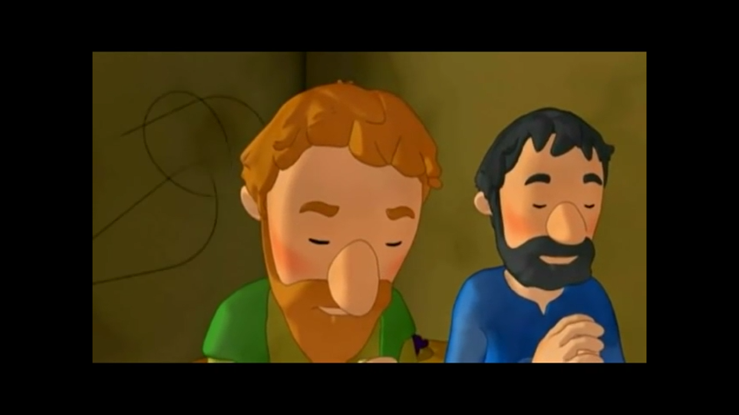
The Holy Spirit Comes at Pentecost
2 When the day of Pentecost came, they were all together in one place. ² Suddenly a sound like the blowing of a violent wind came from heaven and filled the whole house where they were sitting. ³ They saw what seemed to be tongues of fire that separated and came to rest on each of them. ⁴ All of them were filled with the Holy Spirit and began to speak in other tongues as the Spirit enabled them.
⁵ Now there were staying in Jerusalem God-fearing Jews from every nation under heaven. ⁶ When they heard this sound, a crowd came together in bewilderment, because each one heard their own language being spoken.

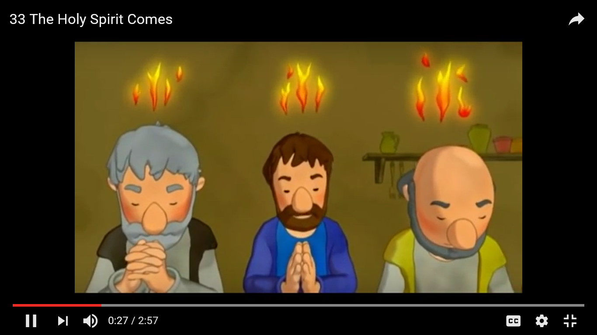

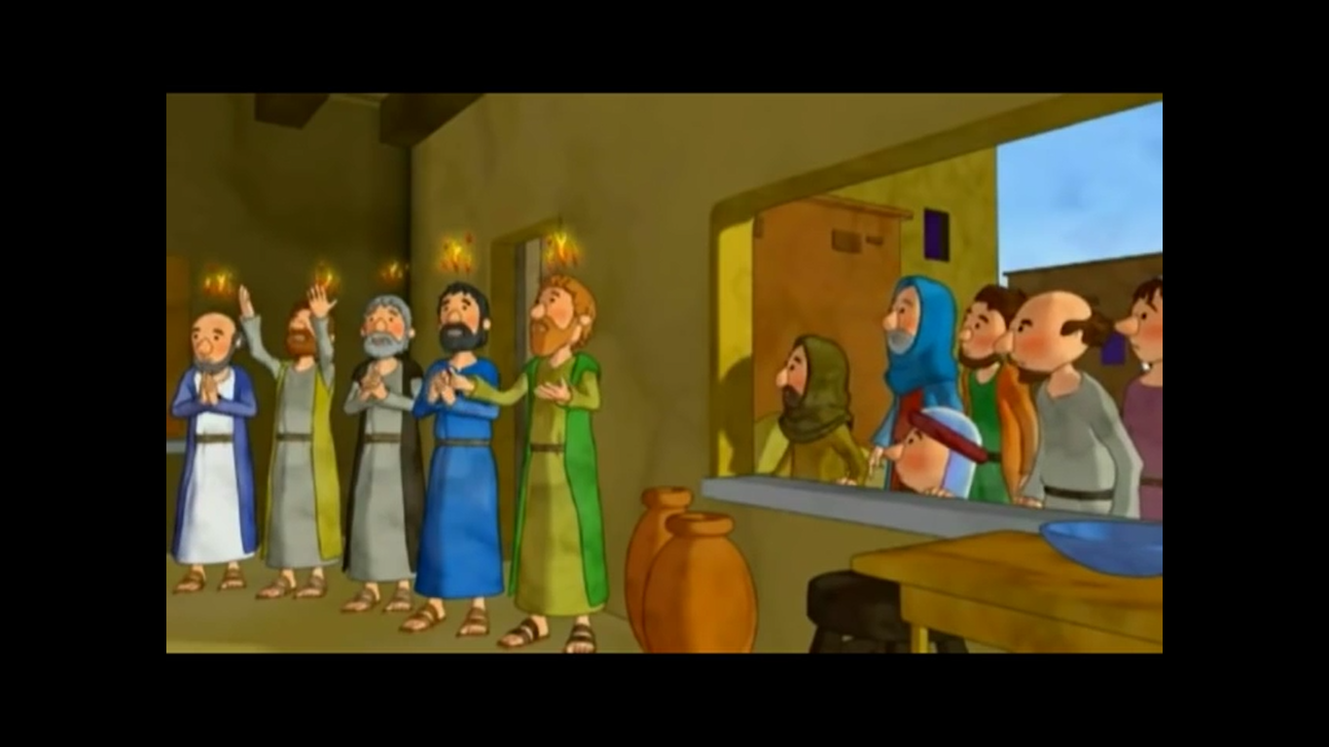

Evangelical Christians

Evangelical Christians believe strongly in the gospel and teaching of salvation by grace through faith in Jesus Christ's atonement.

The role of the Holy Spirit is very important in Evangelical worship. Worshippers are encouraged to be moved by the Holy Spirit. This means that they believe that the Holy Spirit is present and influences them in their prayers; they often shout out and praise god.
Some feel that they are moved to speak in tongues (glossolalia), which they consider a gift from the Holy Spirit. Some believe in acts of ‘faith healing’ which may take place in religious services, where the Holy Spirit works in miraculous ways to heal people.

Afterlife

Eschatology
Beliefs about ‘last things’. (From two Greek words meaning "last" and "study“.)
Therefore, it is the study of death, judgement, and the final destiny of the soul and of humankind (heaven and hell).
Eschatological Beliefs: Christian beliefs about death, judgement, heaven and hell.

All Christians believe in life after death. People are judged by God and sent to Heaven or Hell. The resurrection of Jesus shows that anyone who believes can also be resurrected and enjoy an eternal afterlife with God in Heaven. Timing of death is up to God and entry to Heaven depends on how a person responded to Jesus’ teachings and how they behaved.

Judgement:
To gain entry to Heaven there are two things needed:

- How a person responds to Jesus and his teachings 'For God loved the world so much that he gave his only son so that whoever believes in him may not be lost but have eternal life.’ (John 3:16)
- How a person responds to those in need on earth ‘anything you did for any of my people here, you also did it for me…Come and receive the kingdom prepared for you.’ (Matthew 25;34,40).
  - The parable of the sheep and the goats in Matthew shows how Jesus will separate those who are going to heaven from those who are going to hell, just like the shepherd in the parable who separates the sheep from the goats.
  - The parable of the rich man and Lazarus (Luke 16) shows that there is a clear divide between those who will be rewarded in heaven and those punished in hell, and the afterlife is only achieved by faith and good actions in this life, regardless of success or wealth in an earthly life.
  - People are therefore judged according to their actions on earth. The apostle’s creed states God ‘shall come to judge the living and the dead.’

Some Christians believe that this judgement will happen when they die. Others believe that there will be a Day of Judgement at the end of time, when everybody will be judged at the same time. Some believe that judgement will happen in two stages: an initial personal judgement when you die, followed by the definitive judgement at the end of time.
Some Christians (RC/ orthodox) believe in the Second Coming (Parousia) - the anticipated return of Jesus Christ from Heaven to Earth. This will herald the general resurrection of the dead, the last judgement of the dead and the living, and the full establishment of the Kingdom of God on Earth. People will be bodily resurrected on this day, but they will be transformed into some glorified state. Illness, pain and death will no longer exist and the world will be purified of sin.

Resurrection:
Resurrection of Christ is crucial to Christian belief. Christians believe that three days after Jesus was crucified, he rose from the dead and came back to life. Both the Apostles creed and the Nicene Creed (which are statements of Christian faith), express this belief: ‘I look for the resurrection of the dead, and the life of the world to come.’
This explains why the story of Jesus’ crucifixion and resurrection is so important to Christians, because it provides them with evidence that death is not the end and that, although physical bodies die, the immortal souls live on and can join with God in Heaven when they die. The cross is important in Christianity because it is symbolic of both death and resurrection.
John 14:2-7
2 My Father’s house has many rooms; if that were not so, would I have told you that I am going there to prepare a place for you? 3 And if I go and prepare a place for you, I will come back and take you to be with me that you also may be where I am. 4 You know the way to the place where I am going.”
Jesus the Way to the Father
5 Thomas said to him, “Lord, we don’t know where you are going, so how can we know the way?”
6 Jesus answered, “I am the way and the truth and the life. No one comes to the Father except through me. 7 If you really know me, you will know[a] my Father as well. From now on, you do know him and have seen him.”
John 11:25-26
(The raising of Lazarus from the dead)
²⁵ Jesus said to her, “I am the resurrection and the life. The one who believes in me will live, even though they die; ²⁶ and whoever lives by believing in me will never die. Do you believe this?”

Heaven and Hell (and Purgatory):

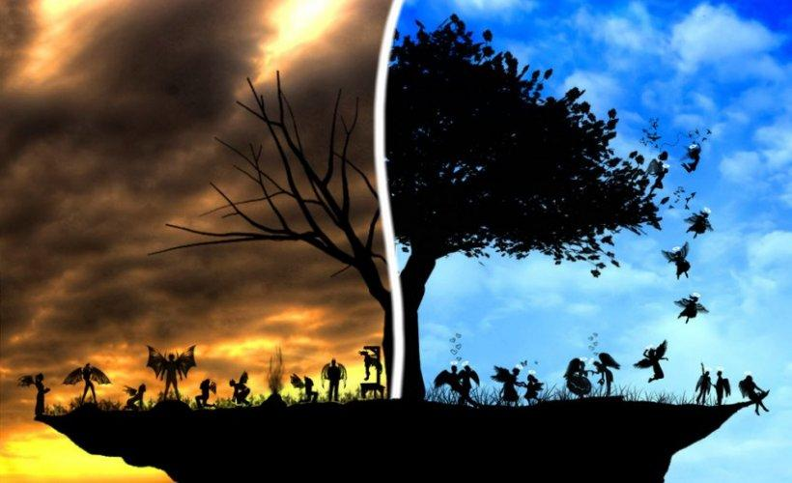
There are numerous references in the Bible to heaven but there are not many descriptions of it which explains why Christians believe different things about it.
Most Christians believe that it is where people go if they have the right to go there and it is where the angels and God are located.
Some Christians believe that it is a physical place others believe that it is a spiritual dimension (more of a state or condition)
There are also different Christian beliefs about Hell but whatever it is, many see it as a place of suffering.
Most believe that the real torment in hell is separation from God. To be in Hell is to not be in the presence of God.

General Christian beliefs
- Teaches that the soul lives on after death (immortality of the soul). After death, your soul will go either to heaven, or to Hell – depending on how you lived your life on earth.
- Heaven is portrayed as a place of great beauty and serenity, a paradise where you will spend eternity with God – as long as you’ve lived a good life and followed the teachings of Jesus.
- Hell, on the other hand, is a place of torment and pain – the final destination of those who have lived bad lives.
- Some believe that even those who live sinful lives may find salvation thanks to God’s saving power.
- The idea that there is literally a heaven in the sky and Hell underground is a very traditional view.
- Not all Christians believe that heaven and hell are real places - Many modern Christians (Contemporary beliefs) believe that they are states of mind. In heaven you’ll be happy and know God – in Hell you’ll be unable to know God’s love. Pope John Paul II said that hell was a metaphor for how people who have rejected God will feel.
- Some Christians, e.g. Roman Catholics, believe going to hell means they will lose their connection with God forever.
- Some Christians believe that God would not punish people forever and instead they will be annihilated (Destroyed)
- Some believe that God wouldn’t let anyone go to hell (because God is omnibenevolent)
Denominational view - Roman Catholic
- Roman Catholics also believe in a place called Purgatory meaning ‘purification’. Here sins are punished before the soul can move to heaven. This is where they undergo a process of cleansing and purification before eventually securing entry into heaven.
- On judgement day all of those held in purgatory will go to heaven.
- Catholics believe that it is important to pray for the souls of the dead and those in purgatory.
- This concept is not in the Bible, so Protestants reject it.
- However, they use passages in the Bible such as 2 Maccabees 12:45 to point to the idea of Purgatory:
But if he was looking to the splendid reward that is laid up for those who fall asleep in godliness, it was a holy and pious thought. Therefore, he made atonement for the dead, so that they might be delivered from their sin.
GRADE BOOST - Heaven and Hell can raise some questions as to if God is all loving (omnibenevolent) and is able to forgive then would God not forgive everyone, therefore meaning no one would go to Hell forever. With the decline in the number of people in Britain believing in Christianity, it is also valid to raise the question whether Heaven and Hell has any relevance in the 21st century anymore.

Christian Practices

Christian Worship

Worship is any way a person expressed love, shows respect and devotion and praises God. This can be as simple as going to church, praying, reading the Bible or attending a Christian music festival.

Within Christianity, there are three main types of worship:
- Liturgical- when worship follows a set pattern or structure & is more or less the same every time (e.g. going to a church service such as the Eucharist)

- Informal- worship that doesn’t have a set structure and is more spontaneous than liturgical worship. Services in Evangelical worship are often more informal than traditional worship. (e.g. singing religious songs in church)

- Individual- personal/private worship. Takes place in addition to worshipping together in a church. Christians believe that it is important to form a personal relationship with God and worshipping alone is often part of this. (e.g. painting a piece of art to show devotion)
Liturgical worship

- Anglicans, Catholics and Orthodox Christians have a set form of worship. It is a formal ritual based around the sacraments, particularly Holy Communion. This type of worship is called liturgical worship.
- Follows a set pattern and has established rituals as part of public church worship. E.g. a set pattern of prayers, the use of a set service book.
- In the Church of England, liturgical worship is rooted in Thomas Cranmer’s Exhortation and litany of 1554. It was the first service book written in English and outlined how church services should take place.
- Most denominations include the Lord’s Prayer in their services. The Lord’s Prayer is important to Christians as it was taught to the disciples by Jesus (Matthew 6:9-13).
- Most Christian churches have some form of liturgical worship. A good example of liturgical worship is the Eucharist, which is also known as the Holy Communion or Mass. In the Catholic Church for example, the Eucharist service would contain:
- The liturgy of the Word: this consists of reading from the Bible, a homily (sermon), a public profession of faith and prayers of intercession (prayers for those in need).
- The liturgy of the Eucharist: in this part of the service the altar is prepared with the bread and wine. The Eucharist prayer and the Lord’s Prayer are said, and people then share in the bread and the wine. The service ends with prayers and a blessing from the priest.
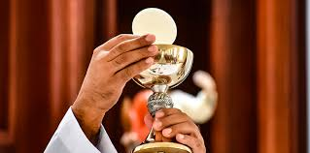
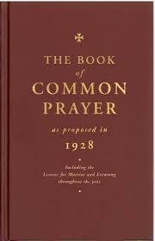

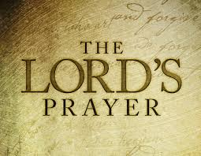

Individual worship

- Many Christians believe that a personal relationship with God is possible and important, so individual worship is important to them.
- Therefore, many Christians worship informally at home (not just on Sundays). This can be anything from saying Grace before a meal to singing worship songs with family, to reading the Bible or praying.
- When people worship together it is known as communal worship, and it is this gathering of worshippers that usually makes up the church. However, in recent times many pray alone or with their families rather than going to church.
- Lots of Christian’s worship both publicly and privately as they feel both are supported by the Bible. E.g.
- Public worship (Matthew 18:20 ‘where two or more are gathered in my name, I am there with them.’)
- Private worship (Matthew 6:5 ‘go to your room, close the door and pray to your father who is in heaven.’)
- Attendance at Church of England services declined to its lowest ever level in 2016.
Informal worship

- Other Christian churches practice non-liturgical worship, e.g. Baptists and Quakers (Society of friends).

QUAKER WORSHIP:
Quaker worship tends to be informal and often private. It will involve meditation and contemplation on God so that they can feel God’s presence who is omnipresent (everywhere). When Quakers gather to take part in a service, they do not have set prayers which they follow. Instead, they will sit in silence and stillness, providing them with the opportunity to reflect on God. As this will be carried out by everyone present it allows them to not only feel closer to God but also the community. The service is not led by a priest or vicar and thus it will often be silent throughout, however from time to time, if one feels the urge to speak through the power of the Holy Spirit, then they are encouraged to do so - this is referred to as ministry.

EVANGELICAL WORSHIP:
Worship in Evangelical Churches (e.g. Pentecostals) is often spontaneous. Worshippers believe they’re inspired by the Holy Spirit – this is called ‘charismatic worship.’ It might inspire them to clap, pray, dance, shout. Sometimes they ‘speak in tongues.’ Evangelical services tend to be longer in length and are led by a pastor. Although this type of worship seems modern, it is in fact similar to the worship offered by Christians in the first decades of the Church, before rituals and traditions had been established.

METHODISTS:
Methodist services don’t have to follow a set structure, but there is a ‘Methodist worship’ book with suggested liturgy for parts of worship e.g. the Eucharist.

The nature and importance of prayer

- Prayer is a way of mentally or vocally communicating with God.
- Prayer was at the heart of Jesus’ life so following in his example, Christians believe it is an essential part of their faith
- Christians believe that they should worship God and the Spirit in truth. This means that worship should not be superficial but that they should worship God with all of their thoughts, actions and words.
‘Yet a time is coming and has now come when the true worshippers will worship the Father in the Spirit and the truth, for they are the kind of worshippers the Father seeks’ (John 4:23)
- Worship involves prayer. There are many types of prayer and reasons why a Christian may pray to God. Some of these can be remembered with the acronym ACTS:

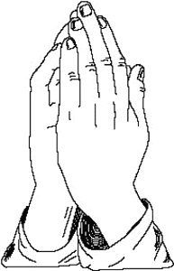
ADORATION – praising God for his greatness
THANKSGIVING – thanking God for all his good gifts. Christians believe that everything comes directly, not indirectly, from God.

CONFESSION – Christians believe that they are sinners who ask for God’s forgiveness before they pray.

1 John 1:9 ⁹ if we confess our sins, he who is faithful and just will forgive us our sins and cleanse us from all unrighteousness.
SUPPLICATION – praying for yourself and for others (your own needs)

Why is prayer important?
- Prayer was at the heart of Jesus’ lifestyle. Christians therefore believe it is an essential part of their faith.

- Believers draw comfort from the fact that God is listening to them. They also listen to what HE is saying to them – many believe prayer helps them to find out what God wants them to do in life. There is evidence in the Bible that God answers prayers. For example, when Moses led the Israelites he prayed to God for Israel’s victory. Jesus also bought Lazarus back to life using prayer (john 11 - ⁴¹So they took away the stone. Then Jesus looked up and said, "Father, I thank you that you have heard me. ⁴²I knew that you always hear me, but I said this for the benefit of the people standing here, that they may believe that you sent me.").
These are both examples of the power of prayer.

- For protestants, individual prayer is incredibly important. One of the main principles of the Reformation (which led to Protestantism) was the belief that each Christian is in their own way a priest. This means that Protestants believe that all Christians have direct access to God through Christ – and not through a priest.

- Believers can find tremendous spiritual support from praying together as they are following in the teachings of Christ.
‘When two or more are gathered in my name, I am there with them’ (Matthew 18:20)

The Lord’s prayer

Jesus did not give his followers much guidance on how to pray but the guidance he did give comes in the form of The Lord’s Prayer. The Lord’s Prayer is very important. It covers key themes – e.g. the idea that God is ‘our father’ and he provides for people’s physical needs.
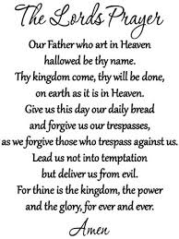

This means there are lots of different types of prayers that people can follow. These are:

Set prayers
- One way of praying
- Allow Christians to learn and repeat prayers they have a significant meaning for them.
- They allow people to recite prayers together so that when Christians recite the Lord’s Prayer together for example, their single voice becomes a communal voice.
- Lord’s Prayer is a set prayer often recited as it is based on the words of Jesus used when he told his disciples how to pray.
- Set prayers are part of the tradition and ritual of worship that goes back hundreds of years.
- Many Protestant denominations in Britain use the set prayers in the Book of Common Prayer.

Informal prayers:
- A simple prayer that could take any form.
- These also tend to be individual and can take place anywhere.
- Informal prayers are beneficial because they are more personal and can be adapted to almost any situation one finds themselves in.
Extemporaneous prayers:
- Prayers that are spontaneous and do not have any structure.
- They are said without prepared words. An example of this might be after someone has heard some bad news, they will say a prayer for those who are involved. Some Christians believe this type of prayer to be more heartfelt as they are not ‘arranged’. Some Christians believe that when they pray in this way their choice and use of words are influenced by the presence of the Holy Spirit.
- Some Christian denominations reject set prayers (except the Lord’s Prayer). This is because they believe that the meaning is lost when you just repeat set prayers.
Sacraments

KEY CONCEPT: SACRAMENT - An outward sign of an invisible and inward blessing by God e.g. Baptism or Eucharist

Sacraments are special moments in the life of a religious person. Sacraments are often described as being ‘outward signs of inward grace’ which means they are visible symbols of the commitment to God and the gifts from God.

Roman Catholics acknowledge 7 sacraments in total:
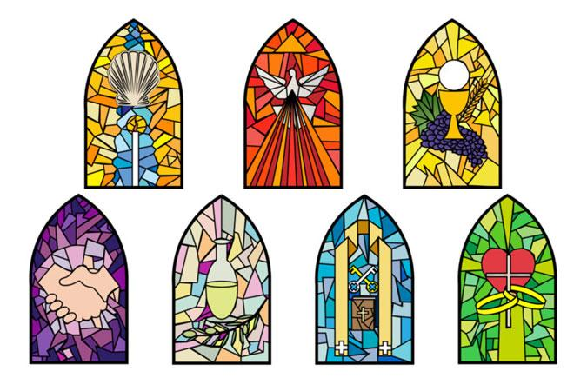
- Baptism (joining the church)
- Confirmation (young teenagers confirm the choice of their parents in baptism)
- Marriage (joining a man and women together in union)
- Ordination (becoming ordained as a priest, bishop or deacon)
- Anointing the Sick (used to be called ‘last rites’. A priest prays for a dying person and takes confession)
- Eucharist (also known as mass - sharing bread and wine in remembrance of Jesus)
- Reconciliation (confessing your sins to a priest, having these ‘absolved’ (freed) and making up for what you’ve done wrong through your actions e.g. praying or fasting).

MOST PROTESTANTS
Most Protestants celebrate only two of these sacraments: Baptism and the Eucharist because these were the only two sacraments practised by Jesus in his lifetime.

QUAKERS AND SALVATION ARMY
Some Christian denominations, such as Quakers and the Salvation Army, don’t even believe in these two sacraments. They both believe that sacraments are an inward spiritual experience and that there is no need for external services or rituals. They believe that some people might get caught up in the external rituals that they forget the important inwards grace they receive from God. These churches believe that it is possible to live a holy life without the need of the sacraments.

EVANGELICAL CHRISTIANS
Many evangelical Christian churches carry out rituals like baptism, but don’t believe they are especially sacred so don’t consider them sacraments.

Sacraments – Eucharist
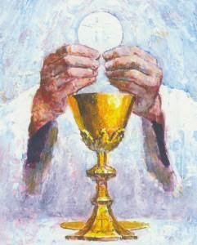
The Eucharist (also known as Mass or Holy Communion) is the church service that remembers the events of the Last Supper the evening before Jesus was crucified, when Jesus breaks the bread, saying ‘Take, eat, this is my body’, and blesses the wine, saying ‘Take, drink, this is my blood.’ Jesus instructed his disciples to ‘do this in memory of me.’

Different denominational views:
Catholics believe the bread and wine actually become Jesus’ Body and Blood (known as transubstantiation - meaning to change substance) and therefore every mass is a reenactment of Christ’s sacrifice. They believe that they receive the saving power of Jesus themselves through the bread and the wine.

Lutherans, Methodists and Anglicans however, believe that the Holy Communion is more of a commemoration of the last supper, a reenactment. They believe there is a real presence of Christ in the bread and wine. They call this CONSUBSTANTIATION.

Baptists do not believe that Christ is present in the bread and wine but the ritual is simply an act of remembrance. This is called MEMORIALISM.

Why is the Eucharist important?
The Eucharist is an important church service as it reminds Christians of the sacrifice that Jesus made for them. It is a symbol of God’s promise of eternal life to all those who believe in God. It brings Christians closer to God and helps them understand their faith. For many Christians, it reminds them of what it means to be a good Christian. Christians take part in the eucharist as they are following the commands of Jesus to ‘do this in memory of me’. Many Christians may take part in the eucharist on a daily basis so they receive a part of Jesus and have him with them for the remainder of the day.
The word Eucharist means ‘thanksgiving’ and is therefore an act of thanks for the life and death of Jesus, who atoned for human sin.

Sacraments - Baptism

Baptism is a service when someone joins the Church and is officially given their name which makes it the sacrament of initiation. Sometimes the word Christening is used instead but they both refer to the same sacrament. In most denominations the person being baptised is a baby, but there is no age limit. When a baby is baptised, it is often referred to as an ‘infant baptism’ and when an adult is baptised it is often referred to as a ‘believers baptism’.

Infant Baptism – (takes place in many denominations including Anglican, Catholic and Methodist)
Babies are brought to the Church by their parents. Friends or relatives who are called Godparents also take part. The parents and Godparents promise that they will bring the child up to believe in Jesus and follow his teachings. A candle is lit and passed to the baby’s godparents as a symbol of the rejection of sin, the movement from darkness to light and from death to new life in Jesus. Babies that have been baptised will often have a confirmation service when they are early teens or young adults to reconfirm the promises their parents made for them when they were a baby.

Believers Baptism - In the Baptist Church, babies are not baptised. This is because this group of Christians think that someone being baptised should be old enough to make promises for themselves. The person has to go to classes to learn all about the teachings of Christianity. They are then usually baptised by total immersion (their whole body is put under the water). They then make promises that they are sorry for things they have done wrong, and they declare their belief in Christianity. Some people may choose to be baptised in a river or even the River Jordan as this was where Jesus himself was baptised.

Regardless of what age you are baptised, there are some similarities in the ceremonies and the symbols used:

- Wearing of white - represents purity and starting a new life without sin
- Holy Water - symbolises the washing away of sin and Original Sin
- Oil - shows the person is chosen by God
- Candle - given to the person being baptised as a reminder that Jesus is the light of the world.

Why is baptism important?
- Jesus was baptized by John the Baptist. After his resurrection he told his disciples to go out and baptize people: ‘….go and make disciples of all nations, baptizing them in the name of the father and of the son and of the Holy Spirit.’ (Matthew 28:19)
- Jesus said ‘no one can enter the kingdom of God unless they are born of water and the spirit.’ (John 3:5). In Christianity baptism is seen as a gift of the Spirit. The Baptised Christians become united with Christ, including his death and resurrection. Through being baptized they are able to enter heaven and life eternally with God after death (see quote above).
- Baptism makes someone a member of God’s family and welcomes them into the church.
- Some Christians believe that baptism cleanses people of the original sin that everyone is born with.
- Gives an opportunity to publically proclaim their personal faith.
- Seen as the first sacrament between humans and God.

GADE BOOST - Baptism is one of the ways a Christian can achieve salvation and reunite with God in Heaven. However, Christians believe that just being baptised is not enough - you must act and live a good Christian life as well.

Pilgrimage

A pilgrimage is a special journey to a place of significance, this is usually religious but secular people may also go on their own pilgrimages.
Christians may choose to go on a pilgrimage because they want to feel closer to God, walk in the footsteps of someone special to their religion and show dedication to their religion. However, people may experience barriers to go on pilgrimage such as cost, time off work and medical issues.

There are many places around the world a Christian may choose to go on a pilgrimage too including Taizé (France) and Walsingham (England).

Walsingham
This is a town in Norfolk, England in which a replica of Jesus’ house was built for people who were unable to go on a pilgrimage in the Holy Land after the Virgin Mary appeared to a girl called Richeldis de Faverches in 1061 & asked her to build a replica of the house in Nazareth where the announcement of the birth of Jesus took place.

Whilst on a pilgrimage to Walsingham, Christians may visit the spot where the replica church was originally built (it has since been destroyed), take part in a candle-lit service, walk barefoot in procession around the site and celebrate the eucharist. It is the most popular place of pilgrimage in Britain with Christians from different denominations visiting every year. A daily service called the ‘Sprinkling of the well’ takes place as they believe that the water of the well has special qualities that can bring about individual blessings.
GRADE BOOST - Despite there being many places for Christians to visit on a pilgrimage, some people believe that it is an old-fashioned practice and no longer relevant in the 21st century. They may point to the fact that the 2021 British census indicates that 46% of the population believe in Christianity or that there are more effective and less demanding ways of showing dedication/praise to God.

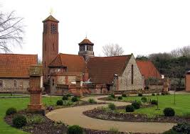
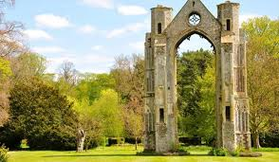
The Shrine Church in Walsingham – built in 1930’s

The ruins of Walsingham priory, the East window arch

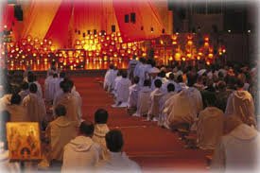
Taizé
What is it?
This is a community of monks in France in which Christians can go to meet other Christians who lead a simple monastic life. The men who become monks at Taizé are from different Christian denominations. This is unusual and is what makes it an ‘ecumenical’ monastic community.

Why do Christians go there?
The community today has become one of the world’s most important sites of Christian pilgrimage for young people. It is estimated that over 100,000 young people make pilgrimages to Taizé each year. There are many reasons Christians go to Taize today including; curiosity, acts of religious devotion, historical relevance, acts of atonement, acts of supplication (asking God for something), meeting new people, adventure or having a new experience.
Taizé encourages the practices of forgiveness, reconciliation and promoting community. Taizé is generally considered a more informal setting for a pilgrimage and is popular with younger Christians who visit in their tens of thousands every year.

What do Pilgrims do whilst there?
When the pilgrims arrive, they join in the life of the monastic community by participating in the set times of prayer in the ‘Church of Reconciliation’. They also spend time in private prayer, attend Bible-study discussion groups led by the monks and share in the communal work. The services are world famous for the use of chants and music, and Taizé chants have become popular in many churches. During the church services the monks wear white robes and all the pilgrims who visit Taizé are required to attend the monastic church services three times each day.

KEY WORD:
Ecumenical – Representing or promoting unity between different Christian churches.

More info:
http://www.bbc.co.uk/religion/religions/christianity/priests/taize_1.shtml (Taize)

https://youtu.be/BtDKkgIFIAU (Video with information about Walsingham)

Celebrations

Christmas
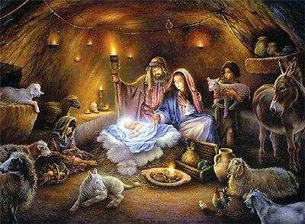
Christmas is the celebration of Jesus’ birth (the incarnation) which is celebrated on the 25th December. Christians don’t necessarily believe he was born on this day – it is a day in the Christian calendar to focus on the incarnation. (Orthodox Christians mark the birth of Christ as being the 7th January).

The Christmas season begins with Advent which starts four Sundays before Christmas Day. During Advent a candle is lit each week to mark the countdown to Christmas Day. Advent calendars are often used by children to countdown the days until Christmas.

In the run up to Christmas Christians celebrate in a number of different ways. These include:

- Nativity plays are acted out at schools and churches to remember Jesus’ birth.
- Nativity or crib scenes are placed in houses and churches
- Christingle - an orange with a candle is used to represent Jesus being the light of the world.
- Carol Concerts where special Christmas hymns are sung.
- Christmas cards with religious images or words are exchanged.
- Advent wreath decorations are put up
- Midnight Mass - a special service on Christmas Eve during which the eucharist will take place.
- On Christmas day many may attend a church service, gather with friends and family and exchange presents.
On Christmas day:
- Christians may attend church services
- Family meal and exchange of gifts - this symbolizes Jesus was God’s gift to the world, and to remember the magi (wise men) presented him with ‘gold, frankincense and myrrh.’ (Matthew 2:11)
- Christmas is also celebrated by non-Christians who see it as more of a ‘wintertime’ festival rather than a religious one.
GRADE BOOST - Whilst Christmas is considered one of the major festivals in the Christian calendar, it has received criticism for losing its true meaning in recent years. The lead up to Christmas begins earlier than ever before, with some Christmas items appearing on shop shelves in August. Many people no longer attend church services or have religious decorations in their houses at Christmas. Companies use Christmas as a time to make as much money as possible instead of focussing on the meaning of the festival.

Easter

Easter is the most important festival for Christians and reminds them of the death and resurrection of Jesus.

Lent
The celebration of Easter begins 40 days before Easter Sunday with the period known as Lent. The day before lent starts is Shr0ve Tuesday – also known as pancake day. This is an opportunity for Christians to use up foods that they would be giving up during lent. On Ash Wednesday (the first day of lent) ash is put on believers foreheads to show they are sorry for their sins. Some Christians fast (eat less/give up certain foods) during lent to remember the time when Jesus fasted in the desert, praying and resisting temptation. The stop fasting on Easter Sunday.

Holy Week
Easter week (known as Holy Week) begins with Palm Sunday one week before Easter Sunday. Palm Sunday remembers Jesus arriving into Jerusalem where palm leaves were waved and placed on the floor for him to travel on as a sign of respect. During Palm Sunday, palm leaf crosses are made and displayed in houses and churches and the story of Jesus’ arrival into Jerusalem is retold.

The next major event in Holy Week is known as Maundy Thursday. It is on this day that Jesus celebrated his Last Supper with those closest to him (disciples). During this Last Supper the basis for the sacrament of the eucharist was set. During the Last Supper Jesus predicted his betrayal and death, washed the feet of his disciples to show humility and led his disciples to pray in the Garden of Gethsemane where he was later betrayed by Judas. Nowadays Christians will celebrate the eucharist on the evening of Maundy Thursday, the priest will re-enact the foot washing and the story of the Last Supper will be retold.

The following day is known to Christians as Good Friday. On Good Friday Jesus was sentenced to death by crucifixion alongside two other criminals. Jesus was nailed to his cross and was ridiculed and humiliated until, at 15:00 he died. It is believed that when he died the sky turned black, an inexplicable wind appeared and the curtain in the Temple was torn in two. On this day now, Christians will attend a solemn (sad) church service at 15:00, Stations of the Cross will be celebrated to mark the events of the day and many Christians will not eat meat as a sign of respect.


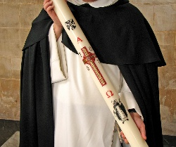
Three days later, Easter Sunday is celebrated. Easter Sunday remembers the resurrection of Jesus. It is the most important day in the Christian calendar. Special services are held in the Church on the Saturday night and on Sunday morning (early on Sunday morning remembers how Mary Magdalene went to the tomb of Jesus, and it was empty. It also symbolizes Jesus raising from the dead in the same way the sun rises). The paschal candle (a large candle blessed and lit on Holy Saturday and placed by the altar until Pentecost) is lit during services in the Anglican and Catholic Churches. Worshippers light their own candle from its flame, which represents Jesus is the light of the world. Eggs are shared as a symbol of new life. Easter cards maybe exchanged with family and friends along with visiting cemeteries to leave flowers for deceased family and friends.
GRADE BOOST - It may be argued that Christmas is more important than Easter as without the birth of Jesus the events of Easter would not have been possible. However, it could be argued that Easter is more important as it is the events of Easter that allow Christians to achieve salvation and enter Heaven.
Christianity in Britain

The changing religious landscape in 21st C Britain
Christianity is the official state religion of Christianity even though many people in Britain today consider themselves atheist (belief that there is no God) or agnostic (unsure whether to believe in a God or not due to lack of evidence). Attendance at church services across Britain has declined in recent decades and some religious buildings have closed and been repurposed for secular use in some cases.

In the 2011 UK census, Christianity remained the largest religion in England and Wales with 59% of the population stating they believed in Christianity. However, in the 2021 census this number dropped to 46%, the first time in history this number has been below 50%. Given the results of the census data, many people argue that Christianity is no longer relevant in Britain today.
RELIGION | PERCENT/POPULATION NUMBER | NUMBER
Christianity | 59.3 % of the population | 33.2 million
Islam | 4.8 % of the population | 2.7 million
Hinduism | 1.5% of the population | 840, 000
Sikhism | 0.8% of the population | 448, 000
Judaism | 0.5% of the population | 280, 000
Buddhism | 0.4% of the population | 224, 000
Other religion | 0.4 % of the population | 224, 000
No religion | 25.1% of the population | 14.1 million
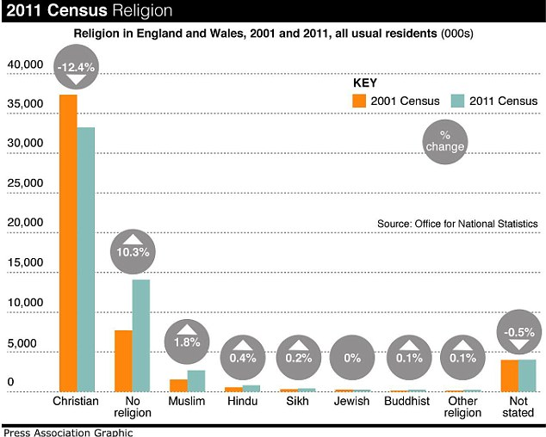
2001-2011 Census Data

2011 Census Data

Difference between 2001 and 2011 census
- Between 2001 and 2011 there was a decrease in the numbers of people who identify as Christian (from 71.7% to 59.3%)
- There was an increase in those reporting NO RELIGION (14.8 %to 25.1 %)
- There were increases in other main religious groups, with the number of Muslims increasing the most (from 3% to 4.8%)

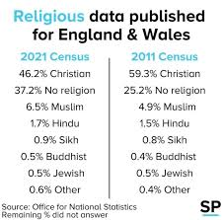
Difference between 2011 & 2021 census
- Drop in 13.1% people identifying as Christian

- Christianity has dropped below 50% for the first time ever. (71.7% in 2001, 59.3% in 2011, 46.2% in 2021. 25.5% decrease in 20 years)

- Rise of 12% in people declaring no religion

- Percentage increase of people identifying to other major world faiths including Islam by 1.5%, Hinduism 0.2%, Sikhism 0.1%, Buddhism 0.1% and other by 0.2%
GRADE BOOST - Although the numbers indicate a decline in British Christianity, there are some doubts over the validity of the census data. The question regarding religious belief is an optional question on the census which means we may not have a true and accurate reflection of belief in this country if we base it solely on the census results.
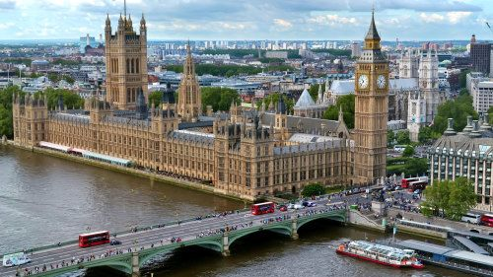
UK Laws, Traditions and Festivals

Christianity was introduced to the UK by the Romans almost 2000 years ago. This means that many of the laws, festivals and traditions of the UK are Christian.
The Church of England is the ‘established’ religion of England. This means it has links to the government and other official bodies such as the court system.
In the 16th century King Henry VIII broke away from the Catholic Church and the authority of the Pope and made himself head of the Church of England.
Today, as well as being the Head of State, the monarch is the Supreme Governor of the Church of England. All monarchs are crowned by the Archbishop of Canterbury.

Three parts of British life are the most closely connected with Christianity: laws, traditions and festivals.

Laws
- UK parliament makes all UK laws by passing Acts of Parliament.
- It is made up of two houses:
- the House of Commons (made up of MP’s who are elected)
- The House of Lords (not elected and contains members of two types: Lords Temporal are appointed by the monarch, but the Lords Spiritual are 26 of the most senior Church of England Bishops.)
- For laws to be passed they must be approved by both Houses of Parliament. So the Church of England has a direct role in shaping UK law.
- Meetings of both Houses of Parliament open with Christian prayers, and many of the Laws of the UK reflect the teachings of some of the Ten Commandments (for example ‘do not kill,’ ‘do not steal.’)

Traditions
Many UK customs have their basis in Christianity. For example:

- ‘Keep the Sabbath day holy’ is one of the Ten Commandments. Traditionally Christians go to Church on Sunday, and it was seen as a ‘day of rest.’ As a result, the hour shops can trade on Sunday are restricted.

- In a UK Law court, witnesses giving evidence are asked to swear they are telling the truth. They often do this on the Bible. However, if they are from a different religion they can swear on their own holy book or if they are non-religious, they can make a ‘witness affirmation’ where they promise to tell the truth (without any reference to a Holy Book).

- Christian hymns and reading are often made at public events, for example, the National Service of Remembrance, held each year to commemorate the Armed Forces personnel who have died in action from WW1 onwards.

- Public and national ceremonies have a religious element such as the Remembrance Day service in November. The UK national anthem begins with the words ‘God save our gracious King’.

Festivals
- The Christian calendar influences UK public holidays – Christmas and Easter being the two major ones as both are Bank Holidays in Britain. School holidays fall over these periods and many businesses are closed.
- However, as seen in the 2011 census, the UK has many different religions which are practiced. Today people from other religions may take time off work to celebrate their own festivals. E.g. the biggest celebration of the Muslim festival Eid al-Fitr happens in Birmingham, where 75, 000 people gather to celebrate the end of fasting during the month of Ramadan. Here there are games, entertainment, food stalls and people of all religious traditions are welcome to come and celebrate.
- There are many other festivals celebrated in the UK such as Bonfire Night (remembers the Gunpowder plot when they attempted to blow up the houses of Parliament).
- Some non-Christian festivals such as the Notting Hill Carnival that happens each summer in London, celebrate the diversity of modern Britain with no specific focus on religion.
- Non-religious groups such as humanists might recognise World Humanist Day in June or Human Rights Day in December, however, these are not widely celebrated in the UK.

Religion and Education
- In the UK around 1/3 of state funded schools are religious.
- All pupils must, by law, be taught religious education and all schools should provide a daily act of worship.
- Religious education should reflect the fact that the traditions in the UK are mainly Christian.
- For state schools without a religious character, more than half of the acts of worship should be Christian.
- However, many schools celebrate a variety of different religious traditions throughout the year.

The Church in the Local Community

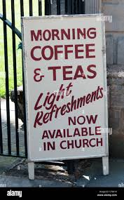
Although Christianity may be on the decline in Britain, its churches still provide a wide range of meaningful services and facilities for both Christians and non-Christians alike.

Christians may find uses for their churches through things such as weekly church services, access to sacraments such as marriage, access to a priest/ vicar, special ceremonies like funerals, meeting other religious people and running study groups.

Non-Christians might also benefit from church buildings by church halls being used for community functions like bingo, exercise clubs, craft clubs, creche facilities for young mothers, coffee mornings for the elderly or family and community centres. The church may also be the home of various charity hubs such as food banks or clothing swap shops.

Aside from the buildings themselves, the Church may also run lots of charity projects to help improve the local community such as counselling, fundraising and improving the local environment.

The Church Worldwide

KEY CONCEPT:
EVANGELISM: preaching of the gospel to others with the intention of converting others to the Christian faith

Many Christians believe that a part of living the best Christian life involves sharing their faith with others. This can be done on a local, national or even international level in different ways.

Mission – what is it?
- At the time of Jesus, it was important that the early Christians had a mission to convert Jews and others to the new religion of Christianity.
- It is still the mission of the church today to tell the Christian message of salvation.
- Many Christians see it as their mission to convert other people to Christianity

When working internationally to convert people to Christianity, Christians may undertake a mission and complete missionary work. Missionary work usually involves going to poorer and more disadvantaged countries and providing them support via education or healthcare and trying to convert them to Christianity in the process. The Church of Jesus Christ of Latter Day Saints (Mormons) live this out by expecting their members to complete missionary work at least once during their lives.

Evangelism
Christians may partake in evangelism – this is a way of spreading the word of God by telling people about Jesus’ message in the hope they can be converted to the Christian faith. Many Christians believe they should be prepared to do the same as In Mark 16:15 Jesus told his disciples to “Go into all the world and preach the gospel to all creation.”
For many Christians this is best done through the way they live their lives in accordance with God’s commands. However, denominations such as Jehovah’s Witnesses may take a more active method of evangelism by knocking on people’s doors or by handing out leaflets in an effort to convert others to their religion.
Others take a different route such as:
- Gideons give copies of the Bible to hotels/schools etc.
- Salvation Army help people by providing hot meals for homeless people. They also attend emergencies such as floods.
GRADE BOOST - Use your knowledge from the Human Rights section of Paper 1 (Philosophy and Ethics) as everyone has a human right to be able to express their religion in whichever way they choose and some Christians believe that by undertaking evangelism they are doing this.

Church Growth
- There has been a decline in church attendance – in Jan 2016 it was reported that weekly attendance at Church of England services was at its lowest ever level (below 1 million). Many churches are closing because of low attendance – debates then take place about what should happen to these sacred spaces.
- However, some churches are thriving such as EVANGELICAL CHURCHES, which have become popular recently. Some Christians have decided to leave their own denomination and join a more evangelical church. Evangelical churches have a focus on the bible, singing, preaching etc. There is no formal liturgy, and services are spontaneous as people are moved by the Holy Spirit. Some evangelical Churches have been involved in ‘CHURCH PLANTING’. This is the process of establishing new nontraditional churches and has been successful in many areas. This happens when groups from an existing church break off and go to a new area to establish a church.
- THE ICTHUS FELLOWSHIP (started in London in 1974) aims to spread Christian values by church planting. They have established new churches across the UK and abroad.
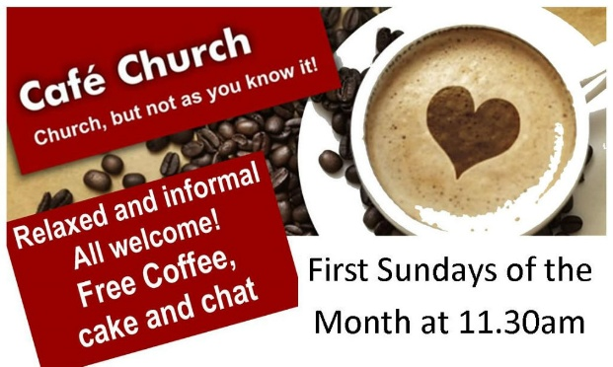
- FRESH EXPRESSIONS – refers to a movement in C of E to change the way some congregations meet and worship. It attempts to attract people to the church that wouldn’t normally go. They meet in less traditional settings and are more informal. One type of fresh expression is a CAFÉ CHURCH. These might take place in a café linked to a church or in a commercial café. People meet there to talk about their faith. Other locations for fresh expressions include workplaces, gyms and even a beach!
- WORLDWIDE CHURCH GROWTH – Christianity is a world religion and is spreading successfully in other parts of the world such as Asia, South America and Africa. The Pew Research Center estimates that by 2050, four in ten Christians will live in Sub-Saharan Africa.

Christians believe that growing the worldwide Church is important because it is following the commands of Jesus whose Great Commission was ‘Go forth and make disciples of all nations…’.


Tearfund

Tearfund is a Christian charity Tearfund is a Christian charity whose aim is to put Christian beliefs and Jesus’ command to ‘love your neighbour’ (Mt 19:19), into action .
They work in over 50 of the world’s poorest countries, providing emergency aid when there are natural disasters and carry out long term projects to support local communities. They have built more than 75,000 churches, helped 17 million people through community projects and helped more than 7.6 million people to prepare for, and recover from, natural disasters. Tearfund is an example of a missionary charity who offer support to those in need whilst also encouraging (but not forcing) people to convert to Christianity. Ultimately the work of Tearfund if to help others whilst carrying out missionary work aiming to convert (not force) others to join Christianity.

Why is Tearfund important?
- It raises public awareness of social issues such as poverty and discrimination in the world.
- It campaigns against the causes of poverty worldwide
- It gives practical help in how to apply the teachings of Jesus in helping others.
- It encourages self-help for individuals and communities.

Example of Tearfund in action: Columbia
- Tearfund works with children and teenagers in Columbia
- They have set up 30 sports clubs here where children can come for football training.
- These clubs provide spaces for young people at risk of joining gangs, to come and socialize. They also offer mentoring to help them with life skills

Challenges to the Worldwide Church - Persecution

Key term: Persecution: persistently cruel treatment, often due to religion or belief.

For centuries, people have been unfairly targeted and punished for what they believe in, this is called persecution.
- The word martyr is used to describe someone who has died for their religious beliefs.
- Jesus himself was a martyr and he warned his disciples they would be persecuted for their faith; most of them were eventually martyred. Christians believe that they were given a divine instruction form Jesus to spread the Gospel and this may be in the face of personal danger.
- Christian persecution continues into the 21st century in a number of countries throughout the world. In some parts of the world Christians are treated unfairly/unjustly where the Christian faith is a minority religion. E.g. terrorist organizations like Islamic State in the Middle East have targeted Christians, forcing them from their homes and subjecting them to violent attacks.
- Evangelical Christian organizations, such as CHRISTIAN FREEDOM INTERNATIONAL and OPEN DOORS, seek to help persecuted Christians.

Open Doors
- Open doors was established in 1955 when Brother Andrew, a Dutch missionary, smuggled Bibles into the Soviet Union. Under the communist system in the Soviet Union Christian churches were persecuted. Today Open Doors still supports persecuted Christians by:

- Distributing Bibles to people that may not have access to them or may have had them taken away from them
- Training Christians and church leaders to deal with the trauma they may face maintaining their faith.
- Providing practical support for Christians who have been the victims of disasters.
- Speaks on behalf of persecuted Christians to raise awareness of their situation and gather support, for example, by lobbying MP’s in the UK government. (to ‘lobby’ is to influence, try to persuade)

Examples of Christians fighting against persecution include bishops from the Church of England sending a letter to the government to encourage them to give more help in the 2015 refugee crisis, Christians such as Desmond Tutu fighting against apartheid in South Africa.

Christians may be influenced to stand up against persecution from passages in the bible such as Matthew 5:44 ‘But I say to you, Love your enemies and pray for those who persecute you’

Reconciliation

Key terms:
Reconciliation: the idea that people should make up after an argument and move on.
Ecumenical: representing a number of different Christian Churches
Ecumenism: the movement or tendency toward worldwide Christian unity or cooperation.

There are many Christian denominations in the world. Sometimes the differences between these denominations has led to conflict. In an effort to bring Christians together and to strengthen the worldwide Church, most Christian denominations actively encourage reconciliation - making up after an argument or disagreement. This is really important to Christians because of quotes like ‘forgive and you will be forgiven’ and ‘love your enemies and pray for those who persecute you’.
GRADE BOOST - Use your knowledge from Good and Evil in Paper 1 (Philosophy and Ethics) to give examples of Christians who have promoted reconciliation and forgiveness such as Gee Walker.

There are two important organizations that work for Christian reconciliation in the world today:
- THE ECUMENICAL MOVEMENT
- THE WORLD COUNCIL OF CHURCHES

THE ECUMENICAL MOVEMENT

- Ecumenical means relating to a number of different Christian denominations. The word "Ecumenism" comes from the Greek (oikoumene) which means "the whole inhabited world”. The Ecumenical movement is therefore an attempt to bring the different Christian denominations closer together and promote Christianity throughout the world.
- Began in 1910 with the World Missionary Conference. The aim of this conference was to unify the Protestant denominations of the world.
- It is based on the important Christian teaching of reconciliation, which is the idea that people should make up after an argument and be restored in their relationship.
- As a result to the Ecumenical movement, there is much more cooperation between different Christian denominations. E.g. sharing a common building, holding joint ecumenical services.

Ecumenism
Ecumenism is a key Christian concept which means bringing different Christian denominations together and encouraging them to work together. There are a number of different ecumenical movements within the global church such as the World Council of Churches. Their goal is Christian unity which can lead to reconciliation and a greater increase in Christianity worldwide.

THE WORLD COUNCIL OF CHURCHES

The world council of churches is….
‘A worldwide fellowship of churches seeking unity, a common witness and Christian service.’ The aim of these churches is to be a visible sign ….deepening communication….sharing the Gospel together…..making connections.’

- The World Council of Churches aims to bring the different Christian denominations together. It tries to unite people who share the same faith, regardless of their denomination.
- Some of the work that the World Council of Churches does is to bring churches together following tragedies, and to help respond to world problems, such as helping with the arrival of asylum seekers.
- Each year the World Council of Churches holds a special week of prayer for Christian unity. It brings together fellowships in more than 100 countries.
- The Roman Catholic Church is NOT a member of the WCC but does take part in some national and local ecumenical organisations.
- At a local level ‘Churches Together in England’ grew out of the work of the World council of Churches and is a practical attempt to focus locally on the fellowship of those who share the Christian faith. The aim today is to offer practical ways of achieving greater unity.
Galatians 3:28
There is neither Jew nor Greek, there is neither slave nor free, there is no male and female, for you are all one in Christ Jesus.

The bible can be seen to support unity among denominations in Galatians:

Christian Beliefs and Teachings
Key Quotes
You don’t need to know them all and you don’t need to know them off by heart but know the general meaning. You also don’t need to refer to the verse or chapter – or even the book in the Bible. Learning some of these will be great as they help ensure you include a SOW/SOA

Topic | Reference | Quote | What you should try and remember
The nature of God  The Trinity | Exodus 7-11  Exodus 14:21  Psalm 86:15  John 3:16  Epicurus  (Greek Philosopher)  Job 1:8  John 10:30  John 14: 6-7  Acts 2:1-6 (on the day of Pentecost) | Quote is too long so here is an overview!  The Plagues of Egypt, also called the ten biblical plagues, were ten calamities that, according to the biblical Book of Exodus, Yahweh inflicted upon Egypt to persuade the Pharaoh to release the ill-treated Israelites from slavery.  ²¹ And Moses stretched out his hand over the sea; and the Lord caused the sea to go back by a strong east wind all that night, and made the sea dry land, and the waters were divided.  ¹⁵ But you, Lord, are a compassionate and gracious God, slow to anger, abounding in love and faithfulness.  ¹⁶ For God so loved the world that he gave his one and only Son, that whoever believes in him shall not perish but have eternal life.  "Is God willing to prevent evil, but not able? Then he is not omnipotent. Is he able, but not willing? Then he is malevolent. Is he both able and willing? Then whence cometh evil? Is he neither able nor willing? Then why call him God?"  ⁸ The Lord said to Satan,^{[a]} “Have you considered my servant Job? There is no one like him on the earth, a blameless and upright man who fears God and turns away from evil.”  ³⁰ The Father and I are one.”  ⁶ Jesus said to him, “I am the way, and the truth, and the life. No one comes to the Father except through me. ⁷ If you know me, you will know^{[a]} my Father also. From now on you do know him and have seen him.”  “Suddenly a sound like the blowing of a violent wind came from heaven …. They saw what seemed to be tongues of fire that separated and came to rest on each of them. ⁴ All of them were filled with the Holy Spirit and began to speak in other tongues as the Spirit enabled them.” | In Exodus in the Bible, God’s omnipotence is shown when he inflicts the 10 plagues upon Egypt in order to persuade the Pharoah to release the Israelites from slavery.  In Exodus in the Bible, God’s omnipotence is shown when he enables Moses to part the Red Sea, subsequently saving/freeing the Israelites from slavery.  In Psalms in the Bible, God is described as being ‘compassionate and gracious.’ This shows his benevolent nature.  In the Bible God’s omnibenevolence is shown through the sending of Jesus to atone for human sin.  Epicurus said that if God is not able or willing to prevent evil, then he cannot be called God.  In the book of Job in the Bible, God and Satan have a wager, where suffering is inflicted upon Job in order to test his faith. Whilst Job cannot understand why his is suffering, since he is a righteous man, he maintains his faith in God. (suffering is a test of faith)  In the Bible, Jesus says that he and the father are one, that no one comes to the father except through him. This supports the doctrine of the Trinity.  The Bible records how the disciples received the Holy Spirit after Jesus ascended to heaven. It is described as tongues of fire on their heads and enabled them to speak in tongues. Many Christians believe that the holy Spirit continues to work in this was in the world today….
Creation | Genesis 1  Genesis 1:26  Genesis 2:7  Romans 5:12 | “In the beginning God created the heavens and the earth”  ²⁶ Then God said, “Let us make humankind^{[a]} in our image  Then the Lord God formed man from the dust of the ground,^{[b]} and breathed into his nostrils the breath of life; and the man became a living being.  (Genesis 3 – the fall/original son) ‘When Adam sinned, sin entered the world. Adam's sin brought death, so death spread to everyone, for everyone sinned.’ | In Genesis 1 in the Bible, it states that God created the heavens and the earth. Christians believe that his did this ex-nihilo or out of nothing.  In Genesis, in the Bible, it says that humans are made in the image of God. This for Christians shows the importance of humans.  In Genesis 2, it says that man was made from the dust of the ground. God breathed the breath of life into his nostrils, which many believe is the soul.  Romans 5:12 in the Bible supports the idea that through the original sin, sin and death entered the world.
Jesus Christ | Incarnation: John 1  Luke1:28-33  Crucifixion: Matthew 27:31 | “The Word became flesh and made his dwelling among us. We have seen his glory, the glory of the one and only Son, who came from the Father, full of grace and truth.”  “you will conceive in your womb and bear a son, and you will name him Jesus.”  ³¹ After mocking him, they stripped him of the robe and put his own clothes on him. Then they led him away to crucify him. | John 1 in the Bible teaches Christians that God (the Word) came to the earth to spread God’s message (in the form of Jesus)  The incarnation is recorded in the New testament where Mary is told that she will bear a son, whom she will name Jesus.  Matthew 27 records he crucifixion of Jesus…
Salvation | Salvation and Atonement: Matthew 26:26-29, | The Last Supper: “Drink from it, all of you; ²⁸ for this is my blood of the^{[a]} covenant, which is poured out for many for the forgiveness of sins.” | The last supper, which is recorded in the book of Matthew in the Bible, explains how Jesus blood and body will be sacrificed for the forgiveness of sins.
Resurrection of Jesus | 1 Corinthians 15:22  Luke 24:1-9,  Ascension: Luke 24:50-53 | For as in Adam all die, so in Christ all will be made alive.  “They found the stone rolled away from the tomb, ³ but when they went in, they did not find the body.”  Luke 24:50-53 The Ascension of Jesus  ⁵⁰ Then he led them out as far as Bethany, and, lifting up his hands, he blessed them. ⁵¹ While he was blessing them, he withdrew from them and was carried up into heaven. | In the Bible it says that Jesus’ death and resurrection atoned for the original sin.  In the Bible it says that when the women went to the tomb, they found that the stone had been rolled away and there was no body inside.  In the Bible it described how Jesus ascended up to heaven after his resurrection.
The afterlife:  Judgement  Resurrection | Matthew 25:31-46  The apostle’s creed  John 11:25-26  (The raising of Lazarus from the dead)  1 Corinthians 15:42-55  2 Maccabees 12:45 Purgatory (RCC only) | The Judgment of the Nations  The parable of the sheep and the goats:  “When the Son of Man comes in his glory, and all the angels with him, then he will sit on the throne of his glory. ³² All the nations will be gathered before him, and he will separate people one from another as a shepherd separates the sheep from the goats,  States god/Jesus ‘shall come to judge the living and the dead.’  ²⁵ Jesus said to her, “I am the resurrection and the life. The one who believes in me will live, even though they die; ²⁶  at the last trumpet. For the trumpet will sound, and the dead will be raised imperishable, and we will be changed.”  But if he was looking to the splendid reward that is laid up for those who fall asleep in godliness, it was a holy and pious thought. Therefore, he made atonement for the dead, so that they might be delivered from their sin. | The Parable of the sheep and goats:  in Matthew shows how Jesus will separate those who are going to heaven from those who are going to hell, just like the shepherd in the parable who separates the sheep from the goats, according to their actions in this life.  The apostle’s creed states that Jesus/God will come to judge the living and the dead.  Christians believe that when they die they will be resurrected. In John, Jesus illustrates this through the raising of Lazarus from the dead. He says that those who believe in him will never die.  Some Christians believe that Jesus will return to earth in a ‘second coming.’ This belief is known as the ‘Parousia’. This will mark the end of human existence on this earth. All will be judged and will be physically resurrected, according to their deeds. This is described by the Bible writer Paul in Corinthians, where he says: at the end of time a trumpet will sound and the dead will rise up  Roman Catholics believe that when they die, most people will end up in purgatory where they are purified of sin.

