
Subject: Geography
Year:7 Term: 1
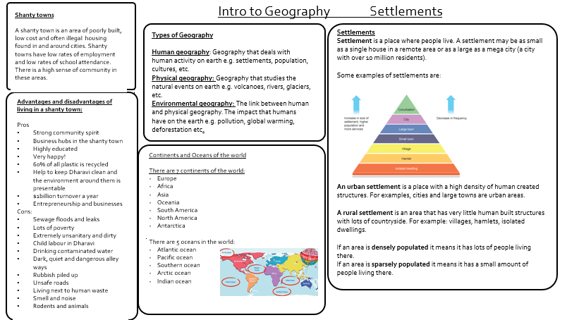
Site factors that were looked for by early settlers such as the Romans:
River/Lake = a water source for drinking/growing crops/ defence
Woodland= a fuel source/shelter
Flat land= for farming
Top of a hill= to see the enemy coming and be ready for battle.

